**Meetings of the Council during the 46th session**

**Information note for NGOs**

***(Latest update: 23 February 2021 – Subject to change)***

Contents

Introduction 1

NGO Liaison Office 1

1) Dates and important information 2

2) Plenary meetings 2

3) Accreditation to HRC46 2

4) Oral statements and lists of speakers 2

4.1. Online registration system 2

4.1.1 Ad-hoc modalities for NGOs participation in general debates 3

4.2 List of speakers on HRC Extranet 3

4.3 Confirmation of speaking slots 3

4.4 Access to Assembly Hall 3

4.5 Video-messages for HRC46 3

Recommended technical specifications for video messages 5

5) Side events 6

6) Reprisals 6

7) Programme of work, additional information and useful contacts 6

# Introduction

The purpose of this document is to provide information to civil society representatives participating in the plenary of the forthcoming 46th session of the Human Rights Council. This is based on information available at this moment and will therefore be revised and updated in the coming days and weeks.

**IMPORTANT: This document is subject to change.**

# NGO Liaison Office

**Due to the COVID-19 situation, the NGO Liaison Office of the Human Rights Council Secretariat will be closed. The Office will be available for any queries through the usual e-mail address:** [**hrcngo@ohchr.org**](mailto:hrcngo@ohchr.org)

**Due to the COVID-19 context, there will be no distribution of documents in the meeting rooms. Likewise, distribution of any material or document in the meeting rooms, at the tables and boards outside meeting rooms or elsewhere in the Palais des Nations is not permitted.**

# Dates and important information

**The 46th session of the Human Rights Council is scheduled to take place from 22 February to 23 March 2021.**

Taking into account the current health context and the host country’s rules governing in-person meetings, which limit the participation in public meetings to a maximum of five persons, **no in-person participation by NGO representatives will be possible during this session.**

Consequently, NGOs in consultative status with the ECOSOC and active Designations with UNOG wishing to participate in the session are invited to submit **pre-recorded** **video-statements** **for** **all debates, including general debates**. However, please note that this exceptional option would be allowed only for the duration of the limitations on public in-person meetings.

**IMPORTANT:** in order to balance the importance of inclusivity and what is feasible in terms of time and resources, the list of speakers for NGOs for each of the general debates would be set in line with the average number of NGOs that participated in each of the general debates in the previous three March sessions of the Council. Moreover, NGOs would be provided the opportunity to indicate their priority when making their registration in order to ensure placement in their preferred general debates.

# Plenary meetings

In the context of the current COVID-19-related restrictions implemented by the host country, public meetings with more than five participants are not allowed until at least 28 February. Therefore, the plenary meetings will take place only through remote participation.

# Accreditation to HRC46

Access to UNOG premises will be restricted and no NGO representative will be allowed to access Assembly Hall in person. Nevertheless**, NGO representatives will have to register through INDICO to the 46th session in order to deliver video-messages.**

Accreditation to the session is **required through INDICO** at the following link: <https://indico.un.org/event/33586/>. The registration opened on 1 February*.* As mentioned above, **this requirement also applies to those participating through video-messages.**

When submitting an accreditation request, delegates are requested to indicate if they already possess an annual or temporary grounds pass at UNOG. Please indicate whether you are already in possession of the grounds pass and, if so, upload a picture of your grounds pass in relevant field in INDICO platform.

It is mandatory, for all participants, **to provide a valid phone number**, possibly mobile phone.

# Oral statements and lists of speakers

## 4.1. Online registration system

The online registration system for the 46th session can be found on the usual website: <https://ngoreg.ohchr.org>. The credentials used for registration to debates cannot be brought forward from the previous sessions. NGOs are therefore reminded that they need first to create a new account in the platform as soon as registrations are open for a new session, and afterwards proceed with the request. The system opened **on Thursday, 18 February** **at 2 PM.**

**IMPORTANT:** The registration to all debates will close **one day before the meeting** in which the respective debate/dialogue is scheduled to start.

### 4.1.1 Ad-hoc modalities for NGOs participation in general debates

Inscription for the lists of speakers for general debates for the 46th session of the HRC should be made on the online system <https://ngoreg.ohchr.org> **as from Wednesday, 24 February at 2 PM Geneva time**.

For ease of reference, the average number of NGOs that participated in each of the general debates in the previous three March sessions of the Council is as follows:

|  |  |
| --- | --- |
| ​​General deba​te under I​tem 2 | **​51** |
| ​General debate under Item 3 | **​113** |
| ​General debate under Item 4 | **​124** |
| ​General debate under Item 5 | **48​** |
| ​General debate under Item 6 | **​34** |
| ​General debate under Item 7 | **​30** |
| ​General debate under Item 8 | **​49** |
| ​General debate under Item 9 | **​60** |
| ​General debate under Item 10 | **32​** |

## 4.2 List of speakers on HRC Extranet

The lists of speakers for the 46th session will be made available on the HRC Extranet on a weekly basis. All the posted lists are constantly updated**.**

## 4.3 Confirmation of speaking slots

As per usual practice, all NGOs are requested to confirm their speaking slots. Due to the new procedures implemented for this session, their participation will be confirmed once the video-statement is uploaded on the online registration system as per the deadline set. Please note that the speaking slots of those NGOs that will not upload the video-statement before the deadline will be removed from the list. For the deadline, see point 4.5.

## 4.4 Access to Assembly Hall

As mentioned above, no access to Assembly Hall will be granted due to the limitations imposed by the host country.

## 4.5 Video-messages for HRC46

In the light of COVID-19 pandemic and the limitations imposed by the host country, NGOs in consultative status with ECOSOC, with active designations in Geneva, will have to deliver video-statement for all debates, including general debates. Please note that this will apply only until the current measures are in place.

**Video-messages will have to be uploaded directly through the online registration system** at <http://ngoreg.ohchr.org/>.

After registering for a debate, **NGOs can upload the video-message at a later stage**. It is not necessary to upload it at the moment of registration.

**The deadline to upload the video-message is at 6PM on the day prior to the debate.** If the debate is scheduled to take place on a Monday, please make sure to upload your video-message **by** **Friday**. Video-messages received past this deadline will not be displayed.

When selecting “By video-messages”, NGOs will have to enter the name of the speaker and upload the following files:

1. The transcript of the statement in accessible format (Word or Accessible PDF);
2. A scanned copy of the passport of the speaker;
3. The letter requesting the accreditation of the speaker;
4. The video file.

As mentioned above, the video and the accompanying files can be uploaded at a later stage. Please note that the video file has to **adhere strictly** to the speaking time limits shown below:

|  |  |
| --- | --- |
| General debates | 1 minute and 30 seconds |
| ​Interactive dialogues | ​​​​​​​1 minute and 30 seconds ​​​ |
| Panel discussions | ​​​​​​​​ 2 minutes ​ ​ |
| UPR outcomes | 2 minutes |

**Captioning of the video is strongly encouraged** in order to ensure accessibility of persons with disabilities. In order to facilitate this procedure, NGOs are able to upload a specific file for subtitles directly in the online registration system. This is not a mandatory field and it can be left blank:

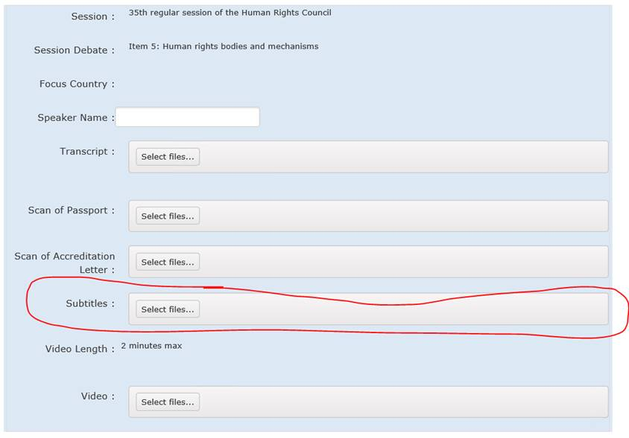

**Guidelines on how to produce subtitles** are available at the HRC NGO Participation page, under *“Point 8. Participating in the Human Rights Council by video message”*.

**Please note that all participants via video-message also need to be accredited through INDICO (see point 3) by checking the option:**

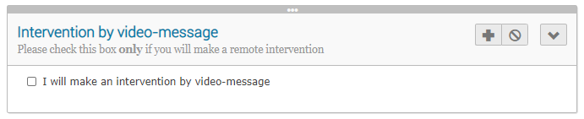

**The accreditation through INDICO is mandatory.**

*By submitting a video statement to the HRC Secretariat for the purpose of screening it during an official meeting of the HRC, the video statement will become an official record of the HRC session and considered as a UN audio-visual asset that can be re-disseminated to media organizations worldwide on a non-commercial basis, in accordance with guidelines of the Department of Global Communications, and will be included in the webcast archive of the meeting on webtv.un.org.*

### Recommended technical specifications for video messages

1. **MP4**The MP4 or MPEG-4 file format is a digital multimedia container format most commonly used to store video and audio, but it can also be used to store other data such as subtitles and still images.
   * video encoding: **H.264**
   * audio encoding: **Min 44100Hz**
   * video resolution: **Min 640x480**

**Max 1920x1080**

**Frame rate 24, 30 fps**

1. **MOV**MOV is the Apple Inc. Quicktime multimedia container file that contains one or more tracks, each of which stores a particular type of data: audio, video, effects, or text (e.g. for subtitles).
   * video encoding: **H.264**
   * audio encoding: **Min 44100Hz**
   * video resolution: **Min 640x480**

**Max 1920x1080**

**Frame rate 24, 30 fps**

1. **AVI/WMV**Audio Video Interleaved (AVI) is a multimedia container format introduced by Microsoft that can contain both audio and video data in a file container that allows audio-with-video playback.

Windows Media Video (WMV) is a video compression format for several proprietary codecs developed by Microsoft.

* + video encoding: **WMV3** (Windows Media Video 9)
  + audio encoding: **Min 44100Hz**
  + video resolution: **Min 640x480**

**Max 1920x1080**

**Frame rate 24, 30 fps**

When using a smartphone, shoot the video in landscape (horizontal) mode.

Please note that no professional equipment is required to record video messages. Most modern consumer electronics (smartphones, laptops, etc.) are capable of recording video that complies with the specifications.

**All files will be played using VLC Media Player.** **Please note that the Secretariat does not bear responsibility if files that do not comply with the recommended specifications cannot be displayed in our audio-visual system. Depending on the quality of the video-statement, interpreters may stop interpretation.**

# Side events

As a result of the current COVID-19-related restrictions, side-events cannot take place inside the Palais des Nations during the 46th regular session of the Human Rights. For the sole purpose of information-sharing, external events that would be organized by NGOs in consultative status with ECOSOC in parallel to the session could be listed on the OHCHR civil society webpage (<https://www.ohchr.org/EN/Issues/CivicSpace/Pages/ProtectingCivicSpace.aspx> ). In such cases, the NGOs should contact the Civil Society Team of OHCHR at [hrcngo@ohchr.org](mailto:hrcngo@ohchr.org) – providing the details of their event (title, date, time, on-line link, and contact person). Please note that such NGO events will not be considered as official Human Rights Council events, and are held on the sole responsibility of the organizing NGOs, with the Secretariat bearing no responsibility whatsoever.

# Reprisals

Any act of intimidation or reprisal for cooperation in the context of the HRC session should be promptly reported to the HRC Secretariat.

# Programme of work, additional information and useful contacts

All relevant information on the 46th session is made available on the HRC website and the [HRC Extranet](https://extranet.ohchr.org/_layouts/15/LoginPage/login.aspx?ReturnUrl=%2fsites%2fhrc%2f_layouts%2f15%2fAuthenticate.aspx%3fSource%3d%252Fsites%252Fhrc&Source=%2Fsites%2Fhrc). Credentials for the Extranet are as follows:

* Username: **hrc extranet**
* Password: **1session**

For any further questions or information, please contact us through the usual e-mail address at [hrcngo@ohchr.org](mailto:hrcngo@ohchr.org). Questions relating to accreditation should be sent to the following address: [hrcaccreditation@ohchr.org](mailto:hrcaccreditation@ohchr.org)

***

For updated information, consult the website: <https://www.ohchr.org/EN/HRBodies/HRC/Pages/NgoParticipation.aspx>