**47th session of the Human Rights Council**

**Information note for NGOs**

***(Latest update: 16 June 2021 – Subject to change)***

Contents

Introduction 1

NGO Liaison Office 1

1) Dates and important information 1

2) Accreditation to HRC47 2

3) Oral statements and lists of speakers 2

Recommended technical specifications for video messages 3

4) List of speakers on HRC Extranet 4

5) Confirmation of speaking slots 4

6) Side events 4

7) Reprisals 5

8) Programme of work, SCHED, additional information and useful contacts 5

**ANNEX I – CHECKLIST FOR NGOs** 6

# Introduction

The purpose of this document is to provide information to civil society representatives participating in the 47th session of the Human Rights Council. This is based on information available at this moment and will be revised and updated on a regular basis.

**IMPORTANT: This document is subject to change.**

# NGO Liaison Office

Due to the COVID-19 situation, the NGO Liaison Office of the Human Rights Council Secretariat will remain closed. The Office will be available for any queries through the usual e-mail address: [hrcngo@ohchr.org](mailto:hrcngo@ohchr.org)

Due to the COVID-19 context, there will be no distribution of documents in the meeting rooms. Likewise, distribution of any material or document in the meeting rooms, at the tables and boards outside meeting rooms or elsewhere in the Palais des Nations is not permitted.

# Dates and important information

**The 47th session of the Human Rights Council is scheduled to take place from 21 June to 15 July 2021.**

Taking into account the current health context and the host country’s rules governing in-person meetings and related guidance from the United Nations Office at Geneva, which limit the participation in public meetings, **no in-person participation by NGO representatives will be possible during this session.**

Consequently, NGOs in consultative status with the ECOSOC and active Designations with UNOG wishing to participate in the session are invited to submit **pre-recorded video statements for interactive dialogues as well as for panel discussions and UPR adoptions**, as set out in Council decision 19/119. **The full official name of the NGO should be displayed within the video**.

Please note that, pursuant to President’s statement OS/14/1 adopted on 7 December 2020**, no general debates will be held during the 47th session**. Therefore, the reports and oral updates of the High Commissioner, the Secretary-General and subsidiary bodies to be presented at the 47th session will be considered during the relevant general debates at the 48th session, unless they are mandated to be considered in the context of an interactive dialogue.

# Accreditation to HRC47

**All NGO representatives participating through video-statements will have to register through INDICO**, here: <https://indico.un.org/event/33587/>.

When submitting an accreditation request, NGO representatives are invited to indicate if they already possess an annual badge or a valid temporary ground pass at UNOG. If so, by uploading a picture of it in the relevant field in INDICO platform, this will be accepted *in lieu* of the accreditation letter, which remains mandatory for all temporary accreditations.

It is mandatory, for all participants, to provide a valid phone number, possibly mobile phone for contact tracing purposes.

# Oral statements and lists of speakers

The online registration system for the 47th session can be found on the usual website: <https://ngoreg.ohchr.org>. The system will open **on Thursday, 17 June at 2 PM.**

After registering for a debate, **NGOs can upload a video statement at a later stage**. It is not necessary to upload it at the moment of registration.

**The deadline to upload a video statement is at 6PM on the day prior to the debate.** Video-statements received past this deadline will not be displayed.

When selecting “By video-messages”, NGOs will have to enter the name of the speaker and upload the following files:

1. The transcript of the statement in accessible format (Word or Accessible PDF);
2. A scanned copy of the passport of the speaker;
3. The letter requesting the accreditation of the speaker;
4. The video file.

As recalled by the Bureau of the Human Rights Council, with the exception of an official representative of a UN Member State speaking in front of the national flag and/or the official picture of the Head of State/Government, **the background of video-statements should be neutral without any flag, banner, flyer, picture or symbol.**

**The full official name of the NGO should be displayed within the video**. Please note that the name displayed should be the one of the NGO delivering the statement only (no co-sponsors or non-ECOSOC NGOs), and it should in accordance with that registered in the database of NGOs in consultative status with ECOSOC.

As mentioned above, the video and the accompanying files can be uploaded at a later stage. Please note that the video file has to **adhere strictly** to the speaking time limits. Video that are longer than the allocated time will be rejected automatically by the platform.

The speaking time limits are as follows:

|  |  |  |
| --- | --- | --- |
| **SPEAKING TIME MODALITIES HRC47 NHRIs/NGOs** ​ | | |
| **Type of discussion** | **Time limit video-statements** | **Time allocated to NGOs per debate** |
| Interactive dialogues | 1 minute and 30 seconds | 15 minutes |
| Panel discussions | 2 minutes | 2 NHRIs and 4 NGOs in two speaking slots |
| UPR outcomes | 2 minutes | 20 minutes |

**Captioning of the video is strongly encouraged** in order to ensure accessibility of persons with disabilities. In order to facilitate this procedure, NGOs are able to upload a specific file for subtitles directly in the online registration system. This is not a mandatory field and it can be left blank:

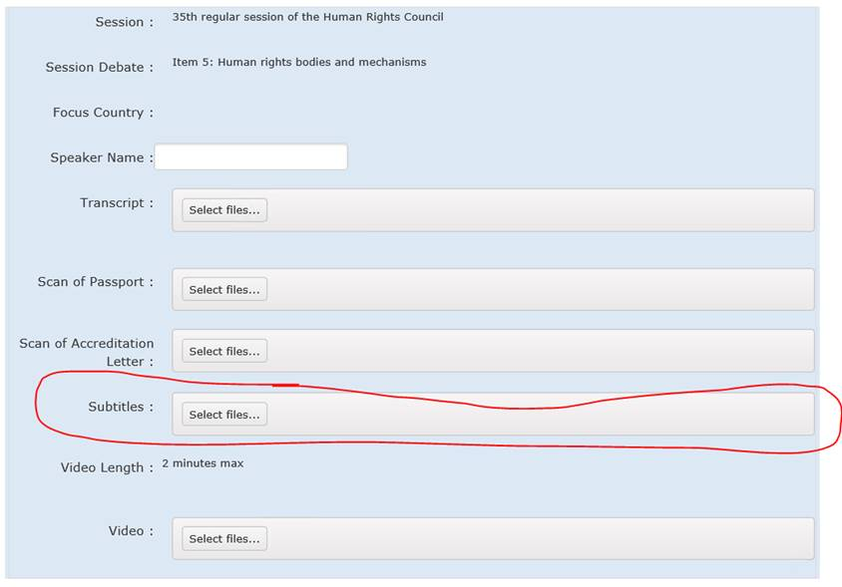

**The accreditation through INDICO is mandatory.**

***DISCLAIMER****: By submitting a video statement to the HRC Secretariat for the purpose of screening it during an official meeting of the HRC, the video statement will become an official record of the HRC session and considered as a UN audio-visual asset that can be re-disseminated to media organizations worldwide on a non-commercial basis, in accordance with guidelines of the Department of Global Communications, and will be included in the webcast archive of the meeting on webtv.un.org.*

### Recommended technical specifications for video messages

1. **MP4**The MP4 or MPEG-4 file format is a digital multimedia container format most commonly used to store video and audio, but it can also be used to store other data such as subtitles and still images.
   * video encoding: **H.264**
   * audio encoding: **Min 44100Hz**
   * video resolution: **Min 640x480**

**Max 1920x1080**

**Frame rate 24, 30 fps**

1. **MOV**MOV is the Apple Inc. Quicktime multimedia container file that contains one or more tracks, each of which stores a particular type of data: audio, video, effects, or text (e.g. for subtitles).
   * video encoding: **H.264**
   * audio encoding: **Min 44100Hz**
   * video resolution: **Min 640x480**

**Max 1920x1080**

**Frame rate 24, 30 fps**

1. **AVI/WMV**Audio Video Interleaved (AVI) is a multimedia container format introduced by Microsoft that can contain both audio and video data in a file container that allows audio-with-video playback.

Windows Media Video (WMV) is a video compression format for several proprietary codecs developed by Microsoft.

* + video encoding: **WMV3** (Windows Media Video 9)
  + audio encoding: **Min 44100Hz**
  + video resolution: **Min 640x480**

**Max 1920x1080**

**Frame rate 24, 30 fps**

When using a smartphone, record the video in landscape (horizontal) mode.

Please note that no professional equipment is required to record video messages. Most modern consumer electronics (smartphones, laptops, etc.) are capable of recording video that complies with the specifications.

**All files will be played using VLC Media Player.** **Please note that the Secretariat does not bear responsibility if files that do not comply with the recommended specifications cannot be displayed in our audio-visual system. Depending on the quality of the video-statement, interpreters may stop interpretation.**

# List of speakers on HRC Extranet

The lists of speakers for the 47th session will be made available on the [HRC Extranet](https://hrcmeetings.ohchr.org/HRCSessions/RegularSessions/47session/Pages/default.aspx) on a weekly basis. All the posted lists will be constantly updated**.**

# Confirmation of speaking slots

As per usual practice, all NGOs are requested to confirm their speaking slots. Their participation will be confirmed once the video statement is uploaded on the online registration system as per the deadline set. Please note that the speaking slots of those NGOs that have not uploaded a video statement before the deadline will be removed from the list of speakers.

# Side events

As a result of the current COVID-19-related restrictions, side events cannot take place inside the Palais des Nations during the 47th regular session of the Human Rights Council (21 June - 15 July 2021).

For the sole purpose of information-sharing, external events that would be organized by NGOs in consultative status with ECOSOC in parallel to the session could be listed on the OHCHR civil society webpage through the following link under “News”: (<https://www.ohchr.org/EN/Issues/CivicSpace/Pages/ProtectingCivicSpace.aspx>).

In such cases, the NGOs should contact the Civil Society Team of OHCHR at [hrcngo@ohchr.org](mailto:hrcngo@ohchr.org) – providing the details of their event (date, time, title, on-line link, and contact person email). Please note that such NGO events will not be considered as official Human Rights Council events, and are under the sole responsibility of the organizing NGOs, with the Secretariat bearing no responsibility whatsoever.

# Reprisals

Any act of intimidation or reprisal for cooperation in the context of the HRC session should be promptly reported to the HRC Secretariat.

# Programme of work, SCHED, additional information and useful contacts

All relevant information on the 47th session is made available on the HRC website and the [HRC Extranet](https://hrcmeetings.ohchr.org/HRCSessions/RegularSessions/47session/Pages/default.aspx). Credentials are no longer needed to access the Extranet.

**The programme of work is subject to change**. For updated information on the schedule, NGOs are invited to consult the SCHED meeting calendar of the session, which reflects all changes in the schedule of the debates, available through the following link: <https://www.ohchr.org/EN/HRBodies/HRC/RegularSessions/Session47/Pages/47RegularSession.aspx>

For any further questions or information, please contact us through the usual e-mail address at [hrcngo@ohchr.org](mailto:hrcngo@ohchr.org). Questions relating to accreditation should be sent to the following address: [hrcaccreditation@ohchr.org](mailto:hrcaccreditation@ohchr.org).

For updated information, consult the website: <https://www.ohchr.org/EN/HRBodies/HRC/Pages/NgoParticipation.aspx>

# **ANNEX I – CHECKLIST FOR NGOs**

This checklist is designed to facilitate NGOs’ participation in the 47th session by summarizing the mandatory steps that they are required to take.

Please note that if you have not taken any of these steps, your video-statement will not be processed.

**Checklist:**

* Your NGO is in consultative status with ECOSOC (<http://csonet.org/>)
* Your NGO has duly accredited Designated representatives with UNOG for 2021 (<https://www.ungeneva.org/en/practical-information/civil-society>)
* You have registered to deliver a video statement through the online registration system (<https://ngoreg.ohchr.org>)
* You and/or the person who will deliver the statement on behalf of your organisation is/are accredited and approved for the session in INDICO (<https://indico.un.org/event/33587/>)
* You have checked your position on the list of speakers uploaded on the HRC Extranet: <https://hrcmeetings.ohchr.org/HRCSessions/RegularSessions/47session/Pages/default.aspx>
* You have uploaded all relevant documents, including the video statement(s), to the online registration system (<https://ngoreg.ohchr.org>) before the deadline of 6 pm of the day prior to the beginning of each debate. For updated information on the schedule, you can check SCHED: <https://www.ohchr.org/EN/HRBodies/HRC/RegularSessions/Session47/Pages/47RegularSession.aspx>
* You have made sure that your video statement(s) abide by the rules applicable for video statements, *i.e.* the background should be neutral without any flag, banner, flyer, picture or symbol and the full official name of the NGO in consultative status with ECOSOC should be displayed in the video.