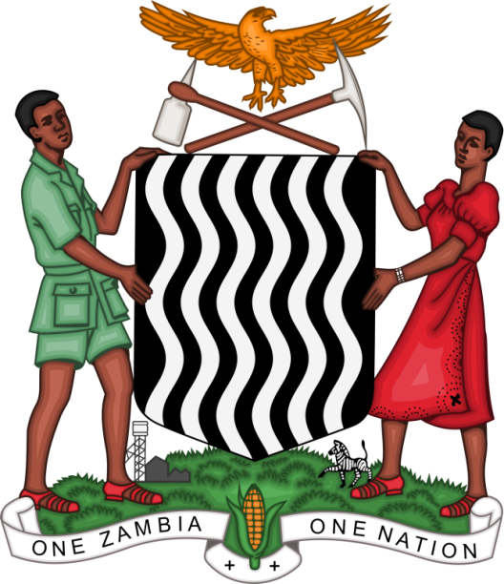

Joint Statement Delivered
By
NATASHA B. MUSEBA
PRINCIPAL COUNSEL – INTERNATIONAL LAW AND AGREEMENTS
REPUBLIC OF ZAMBIA

On behalf of the
SIDS/LDCs that benefitted from the Trust Fund at the HRC 38th Session namely Jamaica, Marshall Island, Mauritius, Samoa, Seychelles, Sudan, Tonga, and Zambia

Geneva, Switzerland
2nd July, 2018
MR. PRESIDENT

It is an honour to speak on behalf of the following Small Island Developing States (SIDS) and Least Developed Countries (LDCs) who have, during this Session, benefitted from the Voluntary Technical Assistance Trust Fund; namely Jamaica, Marshall Islands, Mauritius, Samoa, Seychelles, Sudan (the Republic of Sudan), Tonga (the Kingdom of Tonga), and Zambia (the Republic of Zambia).

At this very important time when we celebrate the 70th Anniversary of the Universal Declaration of Human Rights, we pay tribute to the visionary efforts of the Trust Fund, the generous contributions of its Donor friends, and to the sterling support of the OHCHR. In particular, our States have been able to participate in the Universal Periodic Review (UPR) process and to follow up the implementation of recommendations.

MR. PRESIDENT
The Universal Periodic Review is an opportunity to evaluate human rights situations and to improve frameworks for the promotion and protection of human rights globally. The UPR encourages States to learn from one another and promotes adherence to human rights obligations.

We appreciate the cooperation and skillful leadership of the President of the Council and encourage constructive recommendations from our sister States. We call upon Member States to continue to assist SIDS and LDCs with the full implementation of their UPR recommendations, where requested and as appropriate. We wish to congratulate all States whose UPR reports have been adopted and we urge all countries to honour the commitments made in their national reports.

MR. PRESIDENT
We reiterate our call for Member States to continue to actively support the work of the Trust Fund, per the mandate entrusted to the Council in Resolution 34/40 in order to promote universal participation at the Human Rights Council.

Thank you for your kind attention!

