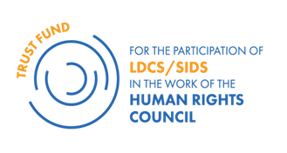

VISA INFORMATION FORM

NAME OF THE APPLICANT TO THE LDCs/SIDS :
COUNTRY:
Functional Title
Ministry /Government Office:

The APPLICANT will need a Swiss/Shengen visa to participate in the programme: Yes / No
If No: please explain and send a copy of the Visa

If Yes, please fill in the below :

Contact details of the applicant:
Email address (official)
Email address (private)
Mobile number: (+ country code,)

Passport number:
Diplomatic /Regular (please circle the appropriate response)
Passport issued on:
Date of expiration (passport MUST HAVE a 6-month validity AT THE TIME OF APPLICATION):

Contact details of the nearest Embassy that can deliver a Shengen Visa:
Country of the Embassy:
Location: city, country
Address Email:

It is the responsibility of the applicant to undertake all the necessary formalities to secure his/her visa. This form is mandatory and should be included in the application package.

