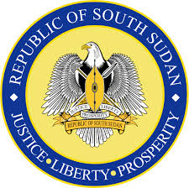

Joint Statement Delivered
By
Amb. Agnes A. Oswaha
Republic of South Sudan

On behalf of the Beneficiaries of the Voluntary Technical Assistance Trust Fund
On
Item 6 - 37th Session of the United Nations Human Rights Council

Geneva, Switzerland
19th March, 2018

Mr. Vice President, Excellencies and Distinguished Delegates;

I am humbled and honored to speak on behalf of the twelve (12) beneficiaries of the Voluntary Technical Assistance Trust Fund from Afghanistan, Antigua and Barbuda, The Bahamas, Bangladesh, Burundi, Democratic Republic of Congo, Haiti, Mozambique, Nepal, Saint Vincent and the Grenadines, Yemen and my own country South Sudan.

Our governments are pleased by the support rendered to us through the Trust Fund. It has enabled us to deepen our understanding of the Universal Periodic Review (UPR) mechanism.

Our countries support this mechanism, which we consider as an equal and fair process to evaluate human rights situations in member states. UPR assists countries in developing frameworks for the promotion and protection of human rights. It uses models that suit each state. Additionally, the mechanism encourages learning from one another and urges member states to adhere to their particular obligations.

We strongly encourage the Council and other member states to continue to assist LDCs and SIDS, which are particularly challenged with the full implementation of their UPR recommendations.

Mr. Vice President

Finally, we take this opportunity to congratulate all states whose UPR reports have been adopted by the Council in the third UPR cycle, and urge the countries to honor the commitments made in their reports.

Thank you for your kind attention!

