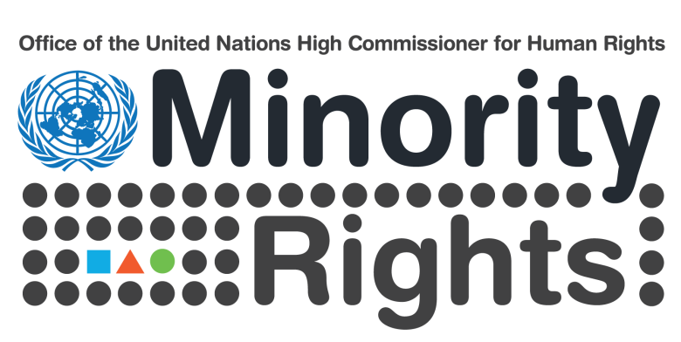

“Promoting and protecting minority rights

through visual arts”

A joint project between OHCHR, the Canton of Geneva and the City of Geneva
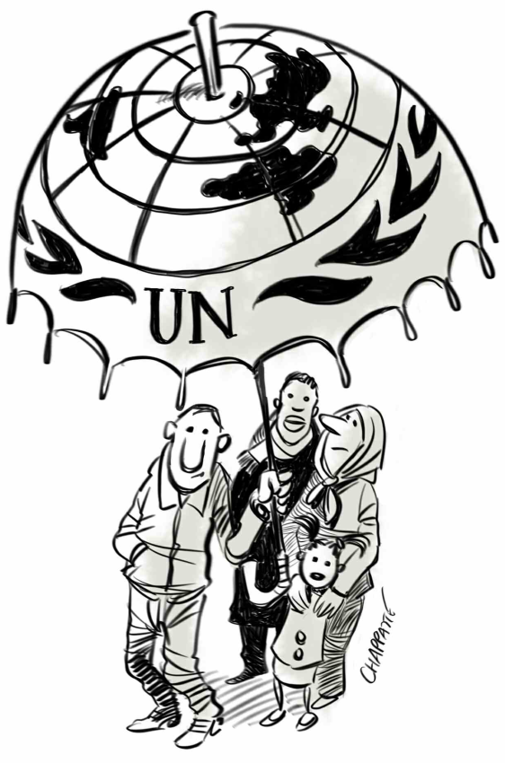

Thursday, 24 November 2016

13.00—15.00

Room XII, Palais des Nations

(Refreshments will be provided)

Opening

Ms Mona Rishmawi
Chief of the Rule of Law, Equality & Non Discrimination Branch (OHCHR)

Ms Rita Izsák-Ndiaye
Special Rapporteur on minority issues

Mr Yves de Matteis
Canton of Geneva: Deputy of the Parliament and Vice-President of the Human Rights Commission

Conversation with cartoonists

Moderator

Chappatte
Patrick Chappatte

Panellists

Gado (Godfrey Mwampembwa)
Hani Abbas
Boligan (Angel Boligan Corbo)

