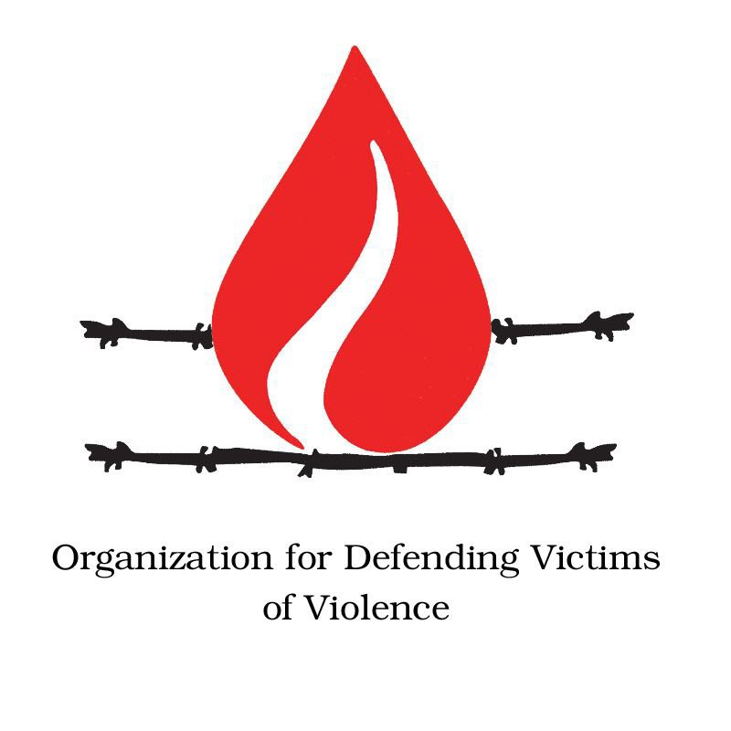
Ninth session of the Forum on Minority Issues

Addressing Violence and Discrimination Against Minorities

Mr. President,

There are many kinds of violations of minority rights in our world. Discrimination against ethnic, linguistic and religious minorities has been identified all over the world and remains a serious problem.

These facts and figures are empirical evidence of such crimes against the world’s minorities. The black population in Brazil comprises almost half the population; 48 per cent, or 80 million. Yet, their economic participation is only 20 per cent of the GDP. A sizeable majority of Afro-Brazilians, 78 percent, lives below the poverty line, compared to 40 percent of the white population. According to a report by Human Rights Watch, religious repression has intensified in China–mainly in regions where the majority of the population is Muslim. In such areas, minors under the age of 18 are forbidden to participate in Islamic practices, and thousands are detained every year for illegal religious activity.

Shiite-phobia is the other side of Islamophobia, which indicates irrational panic, dislike and hatred toward Shiites. This phenomenon has been showing its ugly face more frequently and openly in the last decade spreading quickly in Syria and Iraq, and subsequent to the establishment of ISIS. Furthermore, the Shiites are treated as second-class citizens in Saudi Arabia. Human Rights Watch has recorded the killing of 850 Shia Hazaras by Pakistani Sunni militants in 2012 and 2013 alone. The United Nations reports, ISIS still holds 1,935 Yezidi women as well as 1,864 Yezidi men as captives. In addition, eight Nigerian Shia Muslims have been killed by the governmental authorities at a religious procession in Kano city, and a suicide bomber has blown himself up in a mosque in Kabul, and killing 27 people and wounding dozens, only 3 days ago.

Organisation for Defending Victims of Violence welcomes the focus of this year’s Forum on protecting minority rights, and looks forward to reviewing the outcome of this session. However, our goals will remain impossible until all States contribute to ending this ongoing violent conflict, while working to protect minorities. In this way, we can all continue to live, work, and learn–in our languages, in our territories, in harmony, without feeling like second-class citizens.

I thank you for your attention.

https://unchronicle.un.org/article/race-and-poverty-latin-america-addressing-development-needs-african-descendants
https://www.hrw.org/news/2008/09/25/saudi-arabia-shia-minority-treated-second-class-citizens
https://www.hrw.org/news/2014/07/07/pakistans-shia-under-attack
http://www.bbc.com/news/world-africa-37975158

