Check against delivery

Ninth Session of the United Nations

Forum on Minority Issues

“Minorities in situations of humanitarian crises”
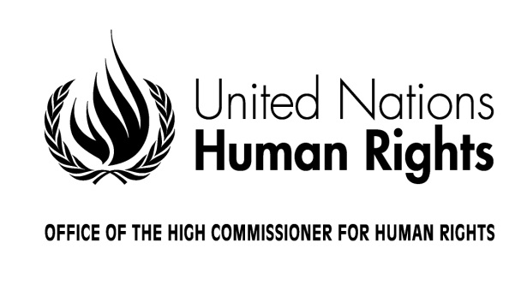

Statement by H.E. Negash Kebret Botora

Vice-President of the Human Rights Council

Geneva, 24 November 2016
10:00-13:00
Room XX, Palais des Nations

Mister Chairperson,
High Commissioner,
Distinguished delegates and participants,
Ladies and Gentlemen,

On behalf of the President of the Human Rights Council, it is a great pleasure for me to open this ninth session of the Forum on Minority Issues on “Minorities in situations of humanitarian crises”.

Firstly, I would like to warmly welcome and congratulate Mr Mario Yutzis, who has kindly accepted the important task of chairing this session of the Forum and who brings a wealth of experience in the field of minority issues, including as a member of the Committee for the Elimination of Racial Discrimination for over 20 years. I also welcome and thank Ms. Rita Izsák-Ndiaye, the Special Rapporteur on minority issues, who is mandated by the Human Rights Council to guide the work of this important Forum and prepare its annual sessions. I would also like to welcome representatives of Member States, United Nations specialized agencies, representatives of human rights mechanisms and bodies, international and regional organizations, national human rights institutions, as well as non-governmental organizations, academics and experts.

This Forum is a unique venue to reflect on issues pertaining to minorities through dialogue and cooperation between all stakeholders. I am particularly pleased to see that this Forum has been successful in bringing together hundreds of minorities from all over the world who have travelled to Geneva to share their personal experiences and discuss on challenges and good practices in the protection and promotion of minority rights. I would therefore like to extend a special welcome to all representatives from minority groups who are here today and who will contribute constructively and substantively to the Forum’s discussions, as well as to thank them for their efforts and also sacrifices to come here and be the voice of their communities.

The selection of the theme of this Forum’s session cannot be more timely: humanitarian crises across the globe, either resulting from conflict or global challenges such as natural disasters, climate change, epidemics and other major emergencies, have increased dramatically. Within affected communities, minority groups are often the most vulnerable, overlooked or neglected in times of crises, often bear the cost of conflicts, even when they are not directly part of it, and are often worst placed to respond to a disaster when it strikes.

The Human Rights Council is deeply concerned by current humanitarian crises in different regions across the globe that demonstrate the pressing need to take action in order to protect minorities and other groups in situation of vulnerability. The Council must and does play an important role in drawing international attention to such situations and seeking to prevent, address and mitigate them.

The work of the Special Procedures mandate-holders, including the Special Rapporteur on minority issues, is key to bringing to the attention of the Council specific minority concerns and reliable information through the substantive reports they are mandated to present. In many occasions, mandate holders are the first ones to ring the alarm, together with civil society, on a humanitarian crisis in the making or in rapid deterioration.

It is my desire that this important session of the Forum on Minority Issues will act as the catalyser to trigger action to better prevent and address the impact of humanitarian crises on minority communities.

Since its establishment, nine years ago, the Forum on Minority Issues has played an essential role in promoting minority rights as contained in the UN Declaration on the Rights of Persons Belonging to National or Ethnic, Religious and Linguistic Minorities. The Forum has produced valuable guidance to human rights actors at the international, regional and national levels through a set of action-oriented recommendations, which is presented to the Council during its March session, by the Special Rapporteur on minority issues. We have the opportunity, for the next two days, to actively contribute to this set of recommendations as well as use the recommendations produced by the Forum throughout its previous sessions as a fundamental advocacy tool.

Before concluding, I would like to reaffirm the commitment of the Human Rights Council to protect the rights and lives of all individuals who cooperate with the United Nations and its mechanisms in the field of human rights. The Council condemns any and all acts of intimidation or reprisal against such individuals and groups, I therefore count on your cooperation in this important collective endeavour, to make sure that all those who dare to speak, to raise alarm and to bravely defend the rights of their communities, are able to do so without any risk to themselves or to their communities.

Chairperson, Ladies and Gentlemen,

I wish you all a fruitful and constructive dialogue over the next two days and I also make a call to keep this discussion open all year long, in order to encourage that all the discussions and experience shared in the context of the Forum may lead to tangible actions.
Let’s have a successful Forum on Minority Issues.

Thank you.

