Check against delivery

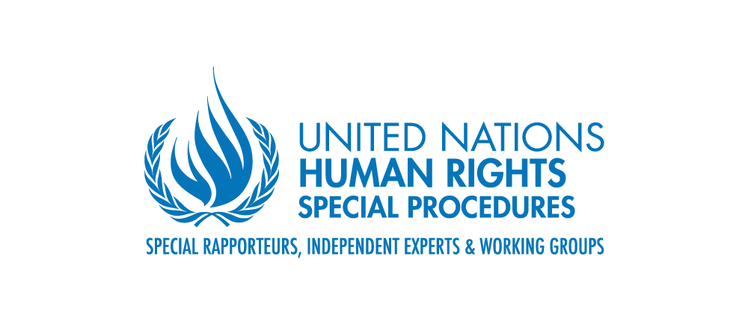

Statement by Mr. Surya Deva
Vice Chairperson, Working Group on the issue of human rights and transnational corporations and other business enterprises

at

the 2nd session of the open-ended intergovernmental working group to elaborate the content of an international regulatory framework, without prejudging the nature thereof, relating to the activities of private military and security companies

26 April 2021 (via Zoom)

Chairperson-Rapporteur, excellencies, distinguished delegates, ladies and gentlemen,

I would like to thank the Chairperson-Rapporteur for inviting the UN Working Group on Business and Human Rights to participate in the 2nd session of the open-ended intergovernmental working group to elaborate the content of an international regulatory framework, without prejudging the nature thereof, relating to the activities of private military and security companies (PMSCs).

During my statement at the December 2016 session of the previous process of the intergovernmental working group on PMSCs, I had highlighted the relevance of the UN Guiding Principles on Business and Human Rights (Guiding Principles) to the content of an international regulatory framework concerning PMSCs. In my remarks today, I will outline how the current process could benefit from insights gained from regulatory developments in the last once decade.

Let me start with a basic point. Companies can affect the enjoyment of all human rights in both positive and negative ways. This holds true for PMSCs as well. By protecting human lives and property, PMSCs could safeguard various human rights. At the same, if the activities of PMSCs are not regulated effectively, they could violate a full range of human rights.

Any future international regulatory framework concerning PMSCs should take into account several factors. First, there is a growing realisation that voluntary or self-regulatory initiatives alone will never be adequate to prevent business-related human rights abuses or hold the concerned companies accountable. A ‘smart mix’ of binding and voluntary measures are needed to create an effective regulatory eco-system.

Second, providing security or military services are unique functions which essentially belong to States. Therefore, even if States decide to outsource some of these functions to private companies, they should not adopt a ‘hands-off approach’. Rather, States should proactively regulate the full life cycle of services provided by PMSCs.

Third, many PMSCs operate at a transnational level or on the high seas. This means that regulatory measures which are entirely territorial will not suffice. Nor will it be sufficient if States acted individually without some form of mechanism to facilitate mutual legal assistance and international cooperation amongst them.

Fourth, PMSCs often operates in conflict zones and this creates additional regulatory challenges. In such situations, the host State may, for example, not be willing or able to regulate effectively the activities of PMSCs. Moreover, PMSCs operating in conflict zones may also need to follow international humanitarian law and international criminal law.

Fight, the key objectives of the proposed international regulatory framework should be to prevent human rights abuses by PMSCs as well as hold them accountability for abuses which could not be prevented. Moreover, because of certain special characteristics of PMSCs, some sector-specific regulations may be needed for PMSCs in addition to generic regulations for businesses.

Sixth, the framework for PMSCs should build on, and complement, existing general standards such as the Guiding Principles as well as specific standards such as the International Code of Conduct for Private Security Service Providers and the Montreux Document. The framework should also draw inspiration from mandatory human rights due diligence laws emerging in Europe as well as the second revised draft of an international legally binding instrument on business and human rights.

Seventh, States would need to consider an appropriate model for the international regulatory framework for PMSCs. However, irrespective of the model chosen, an inclusive consultative process involving all relevant stakeholders should be adopted to develop an effective regulatory framework for PMSCs.

Chairperson-Rapporteur

Based on these factors, I will suggest that that the proposed international regulatory framework for the PMSCs should provide for the following:

- It should mandate States to require all PMSCs within their territory or jurisdiction to conduct human rights due diligence in line with the Guiding Principles. The Working Group in its 2018 report to the UN General Assembly recommended States to use all available levers – including legislation – to make human rights due diligence part of standard business practice. The OECD Due Diligence Guidance for Responsible Business Conduct could also provide useful reference point in this regard.

- PMSCs operating in conflict zones should be required to conduct ‘heightened’ human rights due diligence. Here inspiration could be drawn from the Working Group’s 2020 report to the UN General Assembly, which recommended that both home and host States to use various policy tools and levers to ensure that business conduct conflict-sensitive heightened due diligence when operating in conflict-affected areas.

- As the activities of PMSCs are likely to have differentiated and often disproportionate impact on the rights of women and girls, a gender responsive approach should be adopted in conducting human rights due diligence as well as providing remediation. The Working Group’s 2019 report to the UN Human Rights Council provides useful practical guidance on how to integrate a gender perspective in practice.

- Access to effective remedy should be an integral component of the responsibility of PMSCs to respect human rights. As the Working Group clarified in its 2017 report to the UN General Assembly, affected rights holders should be able to secure an effective remedy, not merely access to a remedial mechanism. Therefore, the proposed regulatory framework should require States to take all appropriate legislative, judicial and administrative steps to provide victims effective, adequate and prompt remedy against PMSCs as well as their personnel. The OHCHR’s Accountability and Remedy Project provides important recommendations on overcoming barriers to access to remedy.

- The proposed international regulatory framework for PMSCs should also include provisions to facilitate mutual legal assistance and international cooperation among States.

I look forward to the dialogue today. The Working Group on Business and Human Rights also welcomes the opportunity to engaging constructively with this process during this session and in future.

Thank you very much for your kind attention.

The report of the Working Group on the issue of human rights and transnational corporations and other business enterprises, ‘Corporate human rights due diligence – emerging practices, challenges and ways forward’, A/73/163 (16 July 2018).
Report of the Working Group on the issue of human rights and transnational corporations and other business enterprises, ‘Business, human rights and conflict-affected regions: towards heightened action’, A/75/212 (21 July 2020).
Report of the Working Group on the issue of human rights and transnational corporations and other business enterprises, ‘Gender dimensions of the Guiding Principles on Business and Human Rights’, A/HRC/41/43 (23 May 2019).
Report of the Working Group on the issue of human rights and transnational corporations and other business enterprises, ‘Access to effective remedies under the Guiding Principles on Business and Human Rights’, A/72/162 (18 July 2017), para 15.
‘OHCHR Accountability and Remedy Project: Improving accountability and access to remedy in cases of business involvement in human rights abuses’, https://www.ohchr.org/EN/Issues/Business/Pages/OHCHRaccountabilityandremedyproject.aspx

