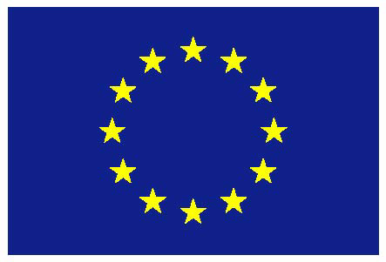
European Union

UNITED NATIONS

2nd session of the Open-ended intergovernmental working group to elaborate the content of an international regulatory framework on the regulation, monitoring and oversight of the activities of private military and security companies

Intervention by the European Union

Geneva, 26 April 2021
- CHECK AGAINST DELIVERY -

2nd session of the Open-ended intergovernmental working group to elaborate the content of an international regulatory framework on the regulation, monitoring and oversight of the activities of private military and security companies
EU intervention

The European Union would like to congratulate the new Chair-Rapporteur on his election. We would also like to thank the Chair-Rapporteur and the Secretariat for their efforts in holding this session in a hybrid format under such difficult circumstances.

As you know, the EU had expressed strong concerns during the informal negotiations in 2020 on the renewal of the mandate, particularly on its duration. Indeed, the EU regretted that the last three-year mandate has delivered little, with only one session held out of the three expected, and with no new discussion documents or reference documents being produced or updated.

It is worth noting that we made requests during the recent meeting with regional coordinators held on 30 March, and reiterated at the informal consultation on 13 April, for an updated discussion document on elements. This is the document which should have factored in work already done in 2019 to allow stakeholders to engage constructively in the discussions. We regret that these requests have remained unfulfilled.

Chair-Rapporteur
This working group was mandated to elaborate the content of an international regulatory framework on the regulation, monitoring and oversights of the activities of private military and security companies. It is worthy of note that the current mandate does not make any presumptions about the ultimate legal nature of the potential future framework and, in line with resolution 15/26, to date there is still a difference of views on the nature of a potential new international regulatory framework. The EU will carefully assess the content and added value of any possible proposal of a non-binding international regulatory framework to regulate PMSCs’ activities. Its content would need to be in line with international human rights law and international humanitarian law.

The debate on PMSCs is complex and fast evolving and demands a multifaceted response to the challenges faced. PMSCs have to operate under precise contractual obligations, monitoring and controls. Safeguards and checks must be in place to prevent excessive use of force. Regulations for PMSCs must be in line with existing international humanitarian law and international human rights law.

While we all naturally agree on the need to protect human rights and ensure accountability for violations and abuses, we would like to recall that PMSCs do not operate in a vacuum and that an international legal framework exists. States have the primary responsibility to regulate PMSCs, including to, inter alia, protect and respect human rights. In this regard, the Montreux Document plays an important role in reaffirming the existing obligations of States under international law, in particular under international human rights law and international humanitarian law, relating to the activities of PMSCs during armed conflict. Therefore, the EU supports the Montreux Document and its universalisation. We encourage States that have not yet endorsed the Montreux Document to do so in the near future.

We are pleased to note that the Co-Chairs of the Montreux Document Forum (MDF), the International Code of Conduct Association (ICoCA), academics, and relevant experts have been invited to participate in this session. We also believe that the participation of the Co-Chairs of the MDF, the ICoCA, relevant experts as well as ensuring that the process remains inclusive, including participation from civil society organisations and business communities throughout the session’s activities, would enrich the discussion and could contribute to the elaboration of the content of the international regulatory framework in a meaningful way.

We hope that the discussions in this second session of the working group [mandated to elaborate the content of an international regulatory framework] will continue to complement and strengthen existing initiatives such as the MDF and the ICoCA.

In conclusion, while we request the IGWG to deliver shortly on its mandate, we continue to engage constructively in the proceedings of this IGWG and we will re-assess our position according to substance and progress achieved by the IGWG.

We look forward to following the discussion during this session.

Thank you

