Anne van Schaik

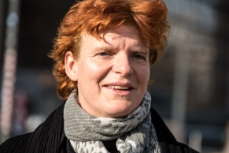

Anne van Schaik is the corporate accountability and accountable finance campaigner at Friends of the Earth Europe, which is a member of Friends of the Earth International. She divides her time between two campaigns. First, she campaigns for support for the UN Treaty on businesses and human rights within Europe and beyond. Her second campaign is on regulating European financiers to stop them from providing financial services to land-grabbing companies.

Prior to joining Friends of the Earth Europe she lived and worked in Mexico, building a coalition of local and national groups in Latin America against climate change.

Until 2009 she was the Head of Campaign International at Friends of the Earth Netherlands, where together with ERA-Friends of the Earth Nigeria, she researched and brought the case of four Nigerian fishermen against Shell in the Netherlands. This was the first time a Dutch multinational had to answer for its actions in a Dutch court. Ms van Schaik has been studying law since 2012.

