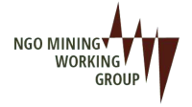
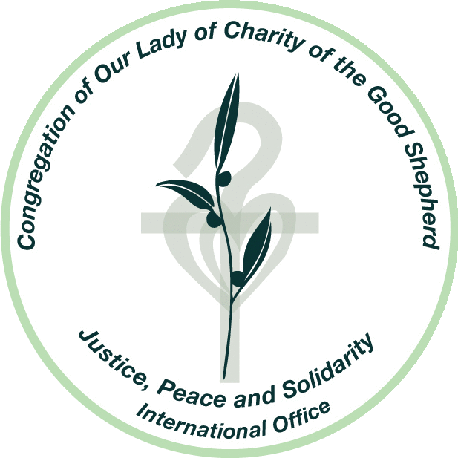
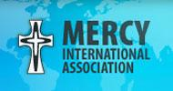

Thank you, Mr./Madame Chair,
I am making this statement on behalf of the Sisters of Mercy, Mercy International Association, the Congregation of Our Lady of Charity of the Good Shepherd, and 13 undersigned members of the NGO Mining Working Group. We welcome the opportunity to speak.
Experiences of our members and partners on the ground in over 75 countries indicate that human rights continue to be violated on the account of corporate activities. This is particularly apparent where extractive industries have exploited local communities through land grabbing, intimidation, gendered violence and inequalities, demonstrating how corporate self-regulation has failed to look beyond profit. This systematic oppression affects in particular the lives of women and rural and indigenous communities. According to recent statistics, 25 corporations of the world, have a greater revenue than 170 states combined. This obliges transnational corporations in legal and ethical aspects to be transparent and act with integrity.
Solutions must include a whole of society approach; thinking in silos will not help to ensure no one is left behind. The implementation of the frameworks and principles within the 2030 Agenda into domestic law and corporate regulations are necessary to prevent abuses.
States need to act according their responsibility to implement effective judicial remedy and grant access to grievance mechanisms.
Mr/Madame Chair,
This Draft Treaty has the potential to achieve a breakthrough in relation to human rights violations committed by corporations.
We recommend:
- Implement effective and transparent review mechanisms that hold corporations accountable.
- Undertake inclusive community consultations prior to corporate activity in order to listen and address the concerns and rights of the community.
- Establish regulations with corporations that mandate, not only “pre and post environmental and human rights impact assessments” (Article 9.2e), but assessments that are ongoing and regular.
- Integrate preventative mechanisms, as outlined in the UN Guiding Principles on Business and Human Rights, within the legally binding treaty.
- Establish forums where people, in particular women, can testify, safely and privately, in regards to injustices (Article 8.11 and 8.12); and at all costs, reject forums in which foreign investors have access to private dispute tribunals.
- Ensure the ratification of a strong legally binding treaty that places the rights of people and the earth before profit of corporations.
I thank you.

Sisters of Mercy, Mercy International Association, Congregation of Our Lady of Charity of the Good Shepherd, Society of Catholic Medical Missionaries, Fondazione Proclade Internazionale, Maryknoll Sisters of St. Dominic, Inc.(ECOSOC/DPI)/ Maryknoll Office for Global Concerns, Sisters of Charity Federation, Congregation of the Mission, Missionary Oblates of Mary Immaculate, Edmund Rice International, Dominican Leadership Conference, Partnership for Global Justice, Religious of the Sacred Heart of Mary, International Presentation Association, VIVAT International, Loretto Community
This intervention focuses on Article 8 "Rights of Victims”, Article 9 “Prevention”, and Article 12 “International Cooperation" within the Draft Treaty.
Sandoval, Greg; “25 Companies that are bigger than entire countries” Business Insider. July 25, 2018 https://www.businessinsider.com/25-giant-companies-that-earn-more-than-entire-countries-2018-7. Another related article from 2016 was published on the World Economic Forum website:https://www.weforum.org/agenda/2016/10/corporations-not-countries-dominate-the-list-of-the-world-s-biggest-economic-entities/

