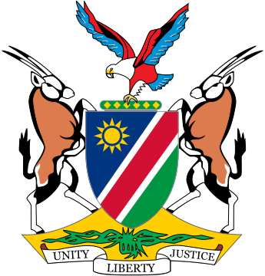

Statement by ***Gladice Pickering – Ministry of Justice and Office of the Attorney-General,*** 4th session of the WG on Transnational Corporations and Human Rights, Geneva, 18 October 2018

Item 4 –Article 5 - Jurisdictions

Mr Chair,

Thank you Mr. Chair and thanks to the panelists for their views and opinions.

Mr. Chair,

For many States, it is problematic to take on passive jurisdiction, as it conflicts with their legal systems. Also, in many States it is a requirement that a ground for active jurisdiction exists before it is exercised. However, we have seen developments in the international law sphere, including IHRL where the concept of passive jurisdiction has developed and has been embraced by States, as indicated by Mr. De Schutter. It is known that jurisdiction is traditionally based on territorial considerations aimed at establishing the existence of some link between the preferred or chosen forum and the dispute. There should thus be a real and substantial link between the two. This link usually relate to the subject matter of the litigation or to the parties.

Other jurisdictional requirements might also be established in addition to the above and this differs according to the jurisdictions. In common law jurisdictions for example, the presence of the defendant within the forum can serve as additional basis of jurisdiction whereas in some civil law jurisdictions, it is linked to the nationality of the parties or even the existence of the defendant’s property within the forum. There are thus clearly very substantial differences. Given the mixture of different legal norms within which TNCs operate, the aim of this treaty should be to provide a uniform application that will ensure access to remedies for all victims of corporate human rights abuses, especially in developing countries which lacks effective accountability mechanisms.

Despite development, as pointed out before, there are still a series of regulatory gaps, some due to the fact that corporations operate internationally, while the laws regulating them have a national character. In this context of impunity, business corporations more easily capture international as well as national institutions.

Mr. Chair,

It is a reality that the principle of “separation of corporation identity” and *“froum non conveniens*”, which, when applied together, very often serve multinational corporations well to avoid being held liable in the parent company’s domicile for the damages caused in other countries, thereby enabling them to apply “double standards” in developing countries. Mr. Meeran also highlighted this in the WG session of 2017.

Mr. Chair,

Conflict of jurisdictions is a risk as the violations and abuses can occur in more than one State or territory, under the hand of one business. In that regard, we will have to consider the consequences on the ground. We also welcome the inclusion of Article 5 (3), but we are weary of a façade of consent in the absence of real consultations, especially in the case of illiterate victims and also in the case of indigenous or marginalized people.

The inadequacy of jurisdictional doctrines in light of the complexities of operations of TNCs should not shield them.

We take note of the warning sent out by Mr. Wijekoon on the consequences of withdrawal of investors as a result of possible accession to this treaty, investors we value and cannot do without, but we are also aware of the manipulating nature of these threats by investors and we remain acutely aware that in many countries, we have not seen the livelihood of the people improved as a result of investment, but to the contrary, it has deteriorated.

I thank you.