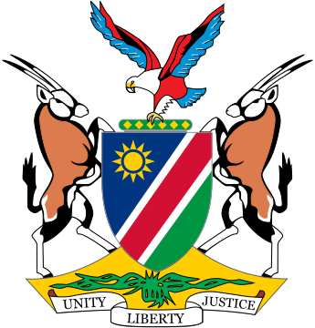

Statement by ***Gladice Pickering – Ministry of Justice and Office of the Attorney-General,*** 4th session of the WG on Transnational Corporations and Human Rights, Geneva, 16 October 2018

Item 4 – Articles 6, 7 & 13

Mr Chair,

Article 6: Statute of limitations:

States have the duty to ensure that victims have access to justice and to remedies and to participate in the process, which will ensure an appropriate remedy is availed to them, therefore this article is very crucial.

In Namibia we have a statute of limitation, which prescribes time limits for civil action, in which category most of the cases would fall and some criminal cases and we will have to consult in great detail on the way forward. However, one thing we are clear on is that victims should be granted a fair and reasonable opportunity to bring a matter before a court that has jurisdiction for adjudication. The way for an indigent victim to the doors of the courts is never an easy one and can take many years because of obvious reasons.

We should not lose sight of the fact that piercing of the corporate veil and other mechanisms used to establish culpability are often time consuming and complicated procedures. Provision should be made for prescription to be interrupted and/or being extended in cases based on violation of human rights by TNC’s especially because of the complexities of their transnational character. We should be weary of making a fallacy of the remedies to be offered in terms of this treaty as the focus is on these remedies.

Article 7:

The purpose of MLA is to provide States the opportunity and ability to solve many complex legal issues even where a conflict of laws exists. Thus, it can be employed also with regards to this treaty.

Article 13: Consistency with International Law

Various existing international instruments, as referred to by the Chair, have already paved the way for us in this regard and we should follow suit on those instruments. For States such as Namibia, which follows a monist system on incorporation of international law, it means that we have to pay extra attention to the provisions of an international instrument before we become a State party thereto. We welcome the way in which Article 13 is crafted, although it can be streamlined to draw a clearer connection with Trade and Investment Treaties with the aim to highlight the primacy of human rights obligations, as indicated by some of the panellists. Sovereignty is a principle, which cannot be compromised, but which should also not be used a veil to refuse cooperation.

I thank you.