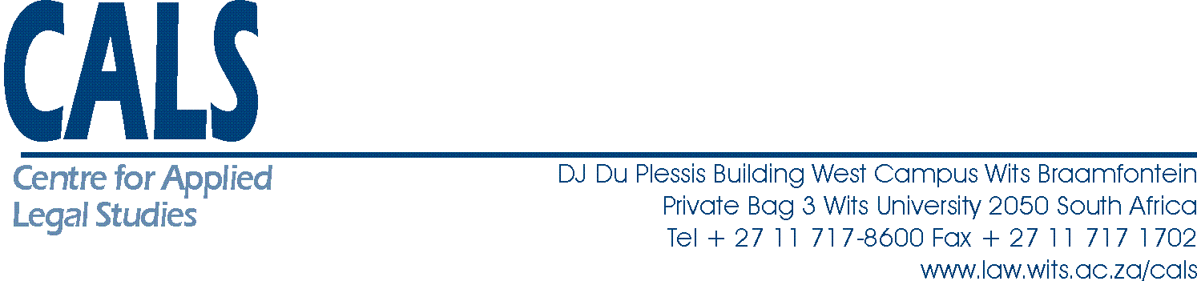

- Thank you chairperson

- I am honoured to join you up here this morning to weigh in on this important subject.
- In the last four days we have seen considered input from both state delegation and civil society organisations represented here.
- I eco a lot of what has been said by civil society organisation in particular how a treaty of this nature needs to take into account the particular positions of women who experience human rights abuses in the hands of corporations in the Zero draft and all negotiations to follow from here on wards.
- This morning I have been asked to comment on some of the work we have done with communities affected by the conducts of TNS and OBS in litigations and advocacy spaces.
- It has been alluded to a number of times that the nature of abuses that victims of TNC face takes various forms. Including displacement from land, gender based violence on woman, pollutions of water and can suffer various respiratory illness because of the work of TNC.

- The first point to make then on what communities we have been working with in South Africa and those communities affected by mining is that this treaty process must be able to ensure effective remedies for human rights abuses caused by TNCs.
- This is to go over and above what is already available in voluntary mechanism. Communities we have worked with have used such mechanisms and have found them ineffective.
- For example, when the Marikana massacre happened in August of 2012 in South Africa. With a huge corporation at the heart of that massacre it was obvious what had happened in that instance to the workers. The violence that was untold was that of the community where these workers had come from and the poverty they lived in despite the wealth or resources that was on their land and being taken as soon as it was mined by Lonmin.
- Naturally hidden in that story were the struggles and the faces of the woman of Marikana whom after the massacre had to grapple not only with grief but also the absence of justice for what had happened to them.
- The woman did not rest and went to lodge a complaint with the IFC to investigate how the massacre could have been avoided if Lonmin had met some of the conditions of the money invested in it by the IFC to improve the living conditions of the women. Due to the voluntary nature of the IFC process Lonmin did not engage with the women and eventually they had to withdraw from the complaint with no remedy for what they required from the process

- Secondly I cannot emphasis enough the need for the treaty to take into account the particular position of woman in abuses by the TNCs a number of civil society organisations have made this point a number of time
This is an important point to raise at this draft stage instead of waiting for the finalised product to consider GBV as an afterthought as that may have been the case in some instruments
Woman suffer various abuses including GBV
- Months before the Marikina massacre in February 2016 at about 4 am in the morning a woman from an informal settlement who was employed by Anglo American in South Africa
- Although we were able to get a settlement in Binkey’s case this is not available to all abuses suffered by woman
- Last story, the treaty must capture the experiences of HRD. In most communities that is tied with the issue of consent when mining takes place. In the south African context we have been grappling with the need in negotiations with TNCs to give community the space to say no to some kinds of development
- Bazoka
Although there is protection in terms of SA against the conducts of TNCs that protections is not always available across the continent and it is no doubt that the global south suffers most of these abuses.
Taking into account our history of apartheid with a number of real examples about how TNCs across sectors benefited from Apartheid, as civil society organisations based in SA we find this process and the work that has been done by SA in it as very important to ensure the avoidance of experiences like ours.

