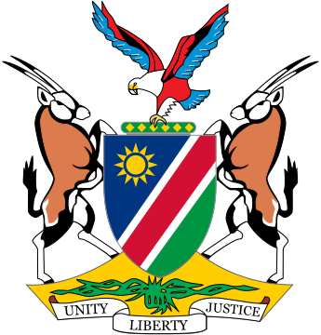

Statement by ***Gladice Pickering – Ministry of Justice and Office of the Attorney-General,*** 5th session of the WG on Transnational Corporations and Human Rights, Geneva, 17 October 2018

Thank you Mr. Chair and thanks to the panelists for their respected views and opinions. Our comments on Articles 10 & 11 are as follows:

The purpose of MLA and International Cooperation is to provide States the opportunity and ability to solve many complex legal issues and no State will be able to operate in isolation in the context of adjudicating claims against TNCs and OBEs. In International Criminal Law, we see the value and importance of MLA and how effective cooperation has contributed to a strengthened network amongst States to combat organized crime and corruption. Cross-border cooperation is essential in bringing the needed evidence before the courts with the least possible impediments.

Mr. Chair,

Since this instrument relates to criminal activities involving individuals as well, we would like to know what the position would be in the event of the need to have that individual extradited for an offense committed? Would this be covered under Article 10 or not?

We also believe that Articles 10 & 11 should be applicable to all cases and not only criminal matters. We are still consulting on the inclusion of Trade and Investment agreements and will revert with our position in due course, but agree with those who submitted that it is necessary to consider this inclusion and we would certainly be in favour of impact assessments. The comments made by Mr. Joe Zhang on the UNCITRAL discussions in Vienna is very relevant and we welcome his reference thereto.

Article 12:

We seek the opinions of the chair and panelists on how we will ensure that regional and sub-regional agreements shall be compatible and shall be interpreted in accordance with their obligations under this (Legally Binding Instrument) and its protocols if not all States involved are parties to this instrument?

I thank you.