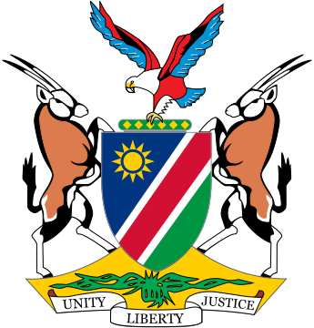

Republic of Namibia

Statement by ***Ms. Gladice Pickering, Ministry of Justice,*** 6th session of the Open-Ended IGWG on Transnational Corporations and Other Business Enterprises with respect to Human Rights, Geneva, 27 October 2020

Mr. Chair,

Namibia would like to make the following intervention on Articles 3 & 4:

Article 3 – Scope:

We appreciate the incorporation of the term ‘**transnational corporations and other business enterprises**’ in the second revised draft as it takes us closer to the objective anticipated in HRC Resolution 26/9. We further welcome the link between **‘other business enterprises’** with the definition of **‘business activities of transnational character’** as incorporated in Art. 1.4. as our focus should remain on the transnational character of the businesses. We might however want to consider that some articles of the instrument will be more or even exclusively applicable to those businesses that conduct business of a transnational character and not to all businesses in general. The reason for this endeavor is that we are seeking to close a gap in the international legal framework in respect of human rights due diligence of transnational corporations and remedies for victims in that regard.

In terms of Article 3.2, State Parties may establish in their law, a non-discriminatory basis to differentiate how business enterprises discharge their obligations commensurate with their size, sector, operational context and the severity of impacts on human rights. We do understand the explanatory notes which refer us to the United Nations Guiding Principles and which gives States Parties flexibility in the implementation of their obligations under Article 6 on the basis as set out. Our understanding is further that this approach can enable States to place more emphasis on businesses with a higher risk of severity of impact. Caution should however be applied to avoid losing sight of smaller entities that can also cause harm, even if at a lesser degree.

Namibia welcomes the inclusion of customary international law in Article 3.3 as this has the potential of expanding the spectrum of rights and remedies for victims. Article 38 of the Statute of the International Court of Justice recognises **international custom as a source of international law**; therefore, we regard this inclusion as a step forward.

We are satisfied that the reference to “all internationally recognized human rights and fundamental freedoms emanating from the Universal Declaration of Human Rights” sufficiently covers the scope of rights to be protected and fear that setting a criteria of being a state party to core human rights instruments might cause a variance in the consistency of application of the instrument, which can adversely impact on the access of justice for victims.

Article 4 – Rights of Victims:

The array of rights that victims have in terms of Article 4 is welcomed, especially the provision that victims are also guaranteed their right to life, personal integrity, freedom of opinion and expression, peaceful assembly and association, and free movement, which are fundamental human rights enshrined in the Namibian Constitution.

These are our submissions on the Articles under discussion, Mr. Chair.

I thank you.