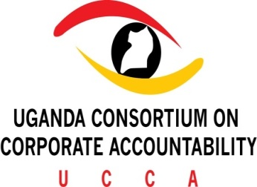

ESCR-NET ORAL INTERVENTION: OCTOBER 27, 2020 ON THE SECOND REVISED DRAFT OF THE INTERNATIONAL LEGALLY BINDING INSTRUMENT TO REGULATE CORPORATE ACTIVITY

Thank You Mr. Chair-Rapporteur

My Name is Arnold Kwesiga from the Uganda Consortium on Corporate Accountability and Initiative for Social and Economic Rights (ISER) both members of ESCR-Net.

- FIRSTLY, we welcome some improvements under Article 7(5) related to the doctrine of forum non conveniens. However, text can further be strengthened by removing the word legitimate as it is not clear what legitimate refers to exactly.

- Article 7(2), which requires States party to the LBI to ensure that their domestic laws facilitate access to information, should require states to assist with the provision of all relevant information, and by recognising the validity of different forms of data and information gathered by communities.

- In Article 7(3)(e), it must be clear that economic barriers should be considered a valid reason to waive legal fees and costs. Legal costs should not place an unfair and unreasonable burden on victims.

- Article 7(3) should also incorporate an obligation on the State to ensure robust legal representation throughout all proceedings related to abuses or violations, by providing legal aid from public defenders/ombudspersons’ offices.

- Article 7(4), should be strengthened so that not being able to afford legal fees and costs to start a court case, will not hinder the possibility to bring cases forward.

- Regarding Article 7(6) on burden of proof, should be strengthened to the benefit of victims. Accordingly, this provision should require corporate and State entities involved in a case of business-related harm to provide sufficient evidence for acquittal.

FINALLY, In Article 7(7), States must enforce remedies when State-entities are also involved in human rights infringements related to business activity. As such we recommend the following amendment; “State parties shall provide effective mechanisms for the enforcement of remedies for human rights abuses and violations including through prompt execution of national or foreign judgments or awards, in accordance with the present LBI and other legal obligations.

