Protecting human rights during and after the COVID-19
Joint questionnaire by Special Procedure mandate holders
Date:10/6/2020
The report is submitted by the Sudanese Physical Disability Federation to the Human Rights Commission and the International Disabled Persons Association IDA
The report is prepared by Professor Nabil Shams Al-Din Abu Al-Qasim Ahmed Al-Sudan Khutum

The Sudanese government has taken a number of precautionary measures to counter the Corona virus and limit its spread, including:
- Sudan stopped issuing visas and trips to eight countries, including Italy and Egypt, due to fears of the Coruna outbreak.
- The closure of kindergartens, Sudanese and foreign schools, cellular and religious institutes at all stages for a month. And stop festivals, camps and remedial classes.
- . Close all universities, colleges, higher institutes and government, private and foreign higher education institutions for a month.
- Banning public gatherings in weddings, weddings, and public events.
- . The curfew was imposed from 6 pm until 6 am.
- . Closing all commercial stores, markets, restaurants, cafeterias, and all commercial activities in the state at 4:00 pm.
- . Postponing the Sudanese certification exams until a later date The Sudanese certification exams are postponed until a later date.
8. Stopping the movement of buses and travel buses between the states.
9. The Minister of Information announced the start of the imposition of the complete curfew (24 hours) in Khartoum State, starting on April 18, 2020 for a period of 3 weeks.
10.The Health Emergency Committee extended the total ban in Khartoum State, starting on May 9, 2020, for a period of 10 days.
11.Giving public sector workers a ten-day leave.
12- Extending the complete ban in Khartoum State, starting from 19 May 2020, for a period of 14 days, after studying recent reports on the epidemiological situation in the country.

With the emergence of the emerging coronavirus around the world, the Federal Ministry of Health, the United Nations in Sudan and their other partners are calling on the Sudanese people to exchange confirmed facts, health advice and information from official antivirus corona new agencies to help combat the emerging corona virus.

Wrong information, rumors, and myths can have a lethal effect like the emerging corona virus. Lives can be saved during the emerging epidemic of Corona virus by sharing accurate information and stopping the spread of wrong information
. We call on all Sudanese to spread the facts, not fear, in their war against the emerging Corona virus. Combating false or misleading information about the virus is an individual and collective responsibility.
Despite the great sharing of facts, validated health advice and measures Effective protection from trusted sources, misinformation is widely shared by the people, especially on social media and message platforms. In addition, incorrect health information claimed to be from United Nations agencies appeared on the Internet.

False information about the virus, misguided myths about treatment, and incorrect health advice can have serious consequences.

To help stop the spread of misleading information, we recommend taking the following four steps:
• Use only official authoritative sources such as the Ministry of Health, WHO and UNICEF.
• Check the facts on official websites or social media platforms before acting, endorsing advice or sharing information online.
Do not post misinformation, even if it appears accurate.
• Help the authorities get real advice and exchange official materials. To support national efforts to control the spread of the virus, the United Nations in Sudan will continue to disseminate important information to the Sudanese people while adhering to the principles of physical separation and avoiding large gatherings. In addition, the United Nations will regularly share guidelines and recommendations with health authorities at the federal and state levels.

Sudan is going through a transition from dictatorial regimes to democracy thanks to the change that occurred last year, the December revolution, and that is why the krona pandemic has spread in Sudan and the health and social system suffers from weakness. Despite this, we find that there are efforts by all citizens to prevent them from contracting the disease. The work was for all residents in all regions of Sudan and there is a great weakness to reach people with disabilities, especially in awareness programs such as visual impairment, they were not able to obtain the publications and publications in Braille and did not find Likewise, people with auditory language did not have the sign language, and so the protection of intellectual disabilities, people with mental disabilities, the elderly, street children and children of unknown parents. There were no clear measures from the state to support the poor from the forged segments. Most health institutions are not friendly to people with disabilities and medical personnel are not trained to deal with People with disabilities The social isolation did not threaten the residents before, as many of the clergy did not accept the issue of closing mosques and churches, but they were satisfied with the matter and called on the residents to pray in homes. However, people with disabilities were most required to accompany you to help you, for example, to reach the toilets, which are always ready, as well as deaf people, in need of interpreters, continuously and blind. They need facilities for mobility, reading and other important necessities, and we find that these groups have no income because they lost work opportunities and now they live in extreme poverty.

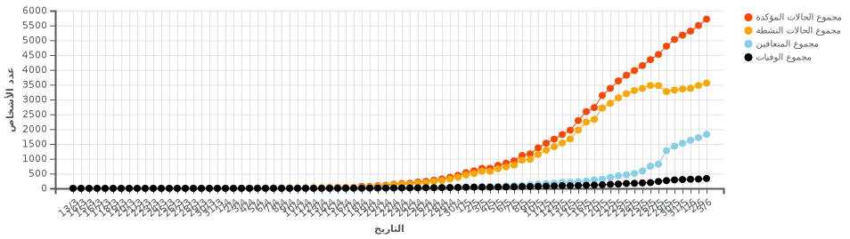
-Total confirmed cases
Total active cases
Total recovered
Total deaths
Recovering for every day
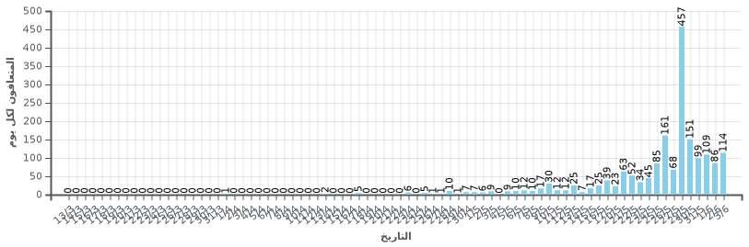

Deaths per day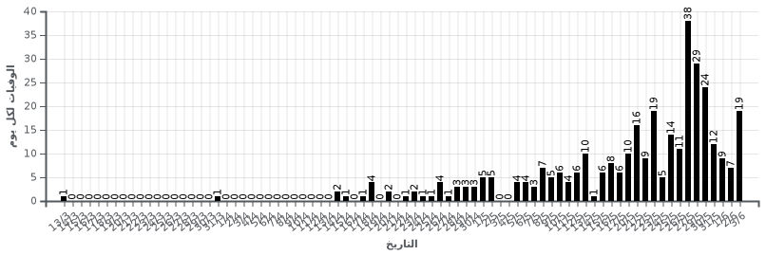
The number of persons with disabilities in Sudan

The United Nations has set the percentage of disability at 15 per cent of the population worldwide and this percentage is increasing in developing countries, due to diseases, accidents, wars and the lack of primary health care. In Sudan, the census of persons with disabilities was conducted within the census of 1993, and the percentage was 1.5% according to the 1993 statistics for the northern states only, which equals 323,595. According to the aforementioned census, it has been shown that the rural disability rate exceeds the urban disability rate by 1.3%, and that the male disability ratio is 53% of the total number of persons with disabilities, while the female proportion is 47%. The number of persons with disabilities according to the fifth census of the year 2008 reached (1,854,985) or (4.8%) of the total population.
Important stats

Table 1 shows the disability ratio among males over females
Type | the number | percentage
Male | 086968 | 52.2
female | 899886 | 47.7
Total sentence | 9858541 | 100

Persons with disabilities in urban, rural and nomads that the percentage of disability in the countryside is high compared to urban areas, due to the degree of awareness among the rural population

Table 2 shows the causes of disability between urban and rural
Accommodation type | the number | percentage
Urban | 695488 | 26.3
the countryside | 5502361 | 66.7
Nomads | 740129 | 7.0
Total sentence | 9858541 | 100

Table A shows the number of persons with disabilities in the different states of Sudan

State name | the number | percentage
North | 88046 | 2.5
The Nile River | 32759 | 2.9
The Red Sea | 99850 | 3.3
kasla | 47980 | 4.3
Gedaref | 77165 | 3.5
alkhartum | 77165 | 3.5
aljazira | 258159 | 8.5
White Nile | 79580 | 4.3
Blue Nile | 29363 | 2.0
North Kordofan | 462169 | 9.1
South Kordofan | 52281 | 4.4
West Kordofan
North Darfur | 254104 | 5.6
Central Darfur | 76780 | 4.4
West Darfur
South Darfur | 844176 | 9.5
Sennar | 462169 | 3.4
East Darfur
Note that there are states that are not covered by the inventory, which are West Darfur - East Darfur - West KordofanThere are many problems due to the lack of information on persons with disabilities in Sudan. We need a project to restrict persons with disabilities in Sudan.

Restrictions must be carefully designed and the least intrusive methods used to protect public health. Restricting persons with disabilities' contact with their loved ones without any form of protection exposes them to abuse and neglect in institutions. States take an increasing responsibility towards these people because of the structural discrimination they already have. ”States must also adopt clear protocols for public health emergencies and ensure that no discrimination against persons with disabilities is exercised in accessing health care if medical resources are scarce, including Life-saving measures. Also, "To cope with the epidemic, it is essential that information on how to prevent and contain the Coronavirus is accessible to all. Public campaigns and information published by the national health authorities should be available in sign language and other copies available, including digital technology available to all, text annotations, data migration services, text messages, and plain and simplified language.

The Sudanese Federation for Physical Disability in Sudan launched a campaign to distribute sterilizers and gags with wheelchairs in addition to a package of invasive materials to confront the harsh days that people with disabilities go through living in poverty, especially in areas that find conflict and there are groups of people with disabilities who suffer from marginalization and discrimination due to disability such as people with disabilities Leprosy, gonorrhea, or short stature and highly paralyzed, as motor aids such as the industrial limb, sticks, gaiters, and hearing aids are not available, all assistive devices, lack of appropriate health services, and chronic diseases suffer from people with disabilities due to lack of medicines such as insulin and crisis sprays, respiratory devices, as mentioned above in this report, the percentage of disability In Sudan, 5% according to the population of Sudan 2008
The category of pharmacists is making unremitting efforts to reduce the scale of the disaster of scarcity of sterilization fluids and tools, and it reveals the efforts of its colleagues to install solutions locally, and distribute them to hospitals and gathering places.
The Sudanese Engineers' Association launched the initiative to manufacture and equip a number of washing and sterilization units in transportation stops and crowded areas in Khartoum, and they are spread in 200 locations. A simplified sink was distributed in each location: The epidemic
The Federation of Chambers of Commerce is far away, and has adopted an awareness campaign for the most vulnerable groups in society, such as the elderly in the nursing homes, children without support in orphanages, cancer patients, deaf and dumb and blind, and residents of peripheral neighborhoodsYoung men and women were active in a number of Sudanese cities and villages, in sterilizing mosques, and providing sterilizers and disinfectants for pedestrians at transportation and road stations. These are initiatives launched by civil society organizations, and in Khartoum there are a number of shelters for the elderly and children in the streets and the role of persons with disabilities, but there was not enough care to confront them like 19 of what is required to intervene to save these groups

As for the International Labor Organization’s recommendation on social protection floors, we find that the social protection package is still weak and the current government is a transitional government that has many economic problems. The economic deterioration of most of the Sudanese population is suffering from extreme poverty, but the government is doing its part towards the elderly - and the children of the unknown parents are in a few borders. It also gives people with a disability a medical insurance card and provides artificial limbs and compensation devices at very expensive prices. People with disabilities can save the money and the Ministry of Labor and Social Development tries to limit the disabled to work a treatment to alleviate poverty towards the marginalized groups, especially that social divergence has a great impact on people with disabilities, especially in food insurance and treatment
Sudan, as I mentioned at the beginning, is in the process of changing the transition from military rule to democracy, freedom, and justice. Therefore, there was no clear discrimination on the basis of gender or color, and there are appreciated efforts to change the abolition of laws and policies restricting freedoms. In Sudan, for example, its inability to provide treatment, people died due to the lack of treatment (especially those with safe diseases), but the community suffered from Covid 19 as a stigma, and the community refuses to deal with the patient and his family once and for all.
The state methodology for communicating information is characterized by honesty and transparency and is available on social networking sites and the Internet in the pages of the competent ministries and allocates hotlines for reporting cases and complaints, but unfortunately not available for people with disabilities there is no translation of a sign for the deaf and Braille for the blind Protest against the state's marginalization of them
The government did not take any measures or declarations regarding persons with disabilities to stay in their homes especially that there are pressing economic conditions, but we find organizations of persons with disabilities distributed a food basket for a month, but for a small number of people with disabilities and the dispatch of some medicines necessary for chronic diseases such as insulin for diabetics, stress and the crisis of People with disabilities and the elderlyWhen the government does not announce the ban, which is a long period of three months, disabled persons who rent out their homes cannot pay the rent. Note that the landlords took out the landlords with disabilities. In Sudan, the building code did not work, so the buildings were not prepared for the disabled.
On the cultural side, persons with disabilities participated in awareness campaigns with Covid 19 and made a lyrical connection between a blind person and another of the movement disability. They presented a beautiful melody, but the deaf, the blind, and intellectual impairment were unable to follow the events regarding the Krona pandemic, which eliminates everyone without discrimination.

The new krona virus spread all over the world. No one could threaten everyone, threatening death, leaving social and economic effects, and leaving an imbalance in the movement of Sudanese human lives. The virus arrived and killed them. They faced very difficult conditions. Poverty deepens its roots in Sudanese societies, with the lack of bread and medicine, and the weak health system in Sudan. Conditions included all groups of society, and there are groups completely crushed due to lack of sufficient income for them due to the high cost of living and krona. The matter has become more complicated, so everyone is now in a critical situation.
Sudan is an African-Arab country, and it is the components of its islands, a population that coexists with the hatred of all. It has the right to full citizenship, but long civil wars have affected some regions, especially the place of conflict and wars such as eastern Sudan, the Blue Nile region, the Nuba Mountains, and Darfur, which are areas where health services are weak, especially for the two genders. Sudan is a country Most of its population is Muslim and they have customs and beliefs that reject this social deviation. They consider it a social deviation for the practice of sexual titration, but for sure now there is a government that works hard to provide for the mistake of all citizens with equality for all groups. Sudan all its residents live in rural areas working in agriculture and grazing. There are few job opportunities in cities and the constitution of Sudan. The constitutional document granted all Sudanese the right to decent living without discrimination on the grounds of racism, disability or any other difference. There are no slavery practices until we thank them in this report. He relied on that by peaceful coexistence and stability that Sudan is living after the December revolution, which came with a government that was mostly civilians, entrenching justice, equality and freedom, and there was a great improvement that resulted in Sudanese society and increased awareness among people, especially young people.

With regard to the protection of children in Sudan, there is a mechanism to implement and implement the Child Agreement 2011. The mechanism is called the National Council for Child Welfare. There are a large number of civil society organizations working in the field of childhood. Kids for example The Secretary General of the National Council for Child Welfare A. Osman Sheba met with representatives of the Ministry of Endowments and Religious Affairs Mr. Ahmed Ramadan and the Committee for the Development of Al-Khalawi, which consists of sufi road elders and sheikhs of Al-Khalawi in his office at noon on March 29th... The meeting discussed the situation of children in Khalawi and the need to be deported to their families in the different states of Sudan in accordance with the decisions of the Council of Ministers and the High Emergency Committee, as part of the precautionary measures to protect these children from the danger of the coronavirus ... The security of the meeting is that they should be deported in an orderly and secure manner so that they do not take any risks while being delivered to their homes... The meeting agreed to start the deportation of about 2,000 children with five khalawi, where they are assigned a team of social researchers to study their conditions and the locations of their areas to make the necessary arrangements as soon as possible and deport them to ... In addition to reconciling their situation in the states in cooperation with the state children's councils and UNICEF, the world child welfare organization and civil society organizations in the states to receive them and to ensure communication with their families to receive them.
It should be noted that the implementation of the action plan, which was developed by the Council to include al-Khalawi in all different states of Sudan, was approved at the meeting. In addition to presenting and discussing the action plan presented by the Minister of Labor and Social Development Professor Lina Al-Sheikh to the High Emergency Committee on the integration of al-Khalawi children with their families in the context of precautionary steps to confront e
UNICEF indicated that Sudan is one of the countries with the highest rate of female genital mutilation mutilation. According to a survey conducted in 2014, the rate of female circumcision reaches 86.6%.
This practice is not only a violation of the rights of every child, it is a harmful practice and has serious consequences for the physical and mental health of the girl. Therefore, governments and societies alike should take immediate action to end this practice. "
Sudan is going through a very bad economic situation and does not have the equipment, mechanisms and mechanisms for medical personnel and the lack of important treatment for chronic diseases, which called on the government of Sudan to support from China to confront European krona. The European Union has announced support for Sudan of 80 million euros to confront Krona, and there are some countries that have sent aid such as the UAE, Saudi Arabia and Egypt, and the Supreme Committee is still working on the emergency committee to provide support to protect all Sudanese citizens.

One of the very important recommendations is the exemption of the Diwan of Sudan, because there are vulnerable groups in society, such as persons with disabilities, children, the elderly, and women, for example, who are definitely affected by the economic situation to confront the new krona. And for the future, the government will work for all the Sudanese and residents of Sudan to establish a social health system that preserves the health of all citizens and citizens through good planning and accurate information, and that health officials work responsibly and impartially and not leave anyone behind.
Finally, I hope that I will answer all questions and contribute to the great effort made by the Committee for the Protection of the Rights of Persons with Disabilities.
Thank you
Nabil Shams Al-Din Abu Al-Qasim - Sudan - Khartoum - Physical Disability Federation

