**Annex-1**

**Table on limiting effects on Human Rights due to measures imposed amid COVID-19 pandemic**

| **No:** | **Measure imposed:** | **Effect on human rights:** | **Why it was adopted:** | **When it will be / was lifted:** | **Relevant legislation:** | **Was it necessary?** | **Were they proportional?** | **Discriminatory effects on various groups of population:** |
| --- | --- | --- | --- | --- | --- | --- | --- | --- |
|  | Restricted travel from tourist resorts to all inhabited islands of Maldives and vice versa  Restricted anyone from entering/ leaving a number of islands where suspected cases of COVID-19 were seen | Restricted the right to freedom of movement | To prevent the transmission of the virus and to prevent health-care services becoming overwhelmed | Till further notice | Section 34 of the Public Health Protection Act | Yes | Yes | - |
|  | Restricted entry of all passengers regardless of nationality, (except for Maldivian citizens), who have China as their port of embarkation or transited through China  Travel restrictions for passengers originating from, transiting to or with a travel history in Iran, South Korea, Italy, Bangladesh, Spain, Germany and France  Travel restrictions for passengers from Malaysia and the UK  Suspension of entry of all tourists via safaris, yachts and other passenger vessels  Suspension of on-arrival visa for all passengers arriving to Maldives by air and sea | Restricted the right to freedom of movement | To take precautionary steps to prevent the spread of virus in Maldives | 1 July 2020 | Section 34 of the Public Health Protection Act | Yes | Yes | - |
|  | A three-hour (5pm to 8pm) curfew in the Greater Male’ Region  Restricted the gathering of more than three persons  A 24-hour lockdown in the Greater Male’ Region | Restricted the right to freedom of movement and freedom of assembly | As a measure to prevent the spread of virus in Maldives  To control and reduce the number of positive cases | 15 April 2020  Till further notice  15 June 2020 | Section 34 of the Public Health Protection Act | Yes | Yes | - |
|  | Suspended all check-ins at all guesthouses and city hotels in the Greater Male’ region | Restricted the right to employment | As a measure to prevent the spread of virus in Maldives | Till further notice | Section 34 of the Public Health Protection Act | Yes | Yes | - |
|  | Closure of all spas | Restricted the right of enjoyment of the highest attainable standard of physical and mental health | As a measure to prevent the spread of virus in Maldives | Till further notice | Section 34 of the Public Health Protection Act | Yes | Yes | - |
|  | Closure of gyms | Restricted the right of enjoyment of the highest attainable standard of physical and mental health | As a measure to prevent the spread of virus in Maldives | Till further notice | Section 34 of the Public Health Protection Act | Yes | Yes | - |
|  | Closure of cinemas and theatres | Restricted the right to cultural life | As a measure to prevent the spread of virus in Maldives | Till further notice | Section 34 of the Public Health Protection Act | Yes | Yes | - |
|  | Closing Schools and Education Providing facilities | Restricted the full right to education (online classes and classes via television are ongoing) | As a measure to prevent the spread of virus in Maldives | Till further notice | Section 34 of the Public Health Protection Act | Yes | Yes | - |
|  | Closure of Government offices | Provision of certain services to the public were interrupted | As a measure to prevent the spread of virus in Maldives | Partially lifted on 31 May 2020 | Section 34 of the Public Health Protection Act | Yes | Yes | - |
|  | All passengers entering the country subject to mandatory quarantine for 14 days  All employees at resorts and safari boats instructed to remain on board for 14 days after the last guest departs | Restricted the right to freedom of movement | As a measure to prevent the spread of virus in Maldives | Till further notice | Section 34 of the Public Health Protection Act | Yes | Yes | - |
|  | All dine-in services offered by local restaurants and hotels in the Greater Male’ region closed with only food deliveries and take-away services allowed | Restricted the right to employment | As a measure to prevent the spread of virus in Maldives | Till further notice | Law Number 7/2012 (Public Health Protection Act), section 34 | Yes | Yes | - |
|  | Banned all tourist excursions across the country | Restricted the right to employment | As a measure to prevent the spread of virus in Maldives | Till further notice | Law Number 7/2012 (Public Health Protection Act), section 34 | Yes | Yes | - |

**Note:** Additional measures taken by the Government of Maldives in response to the COVID-19 pandemic, can be viewed from https://covid19.health.gov.mv/en/

**Annex-2**

**Table on COVID-19 Infections, Recovery and Mortality Rates**

**16.%20(Due%2026.06.2020)%20-%20Joint%20Questionnaire%20from%20several%20mandate%20holders%20(Sama%20:%20Jana)/Information/Health/statinfo%20co**

**16.%20(Due%2026.06.2020)%20-%20Joint%20Questionnaire%20from%20several%20mandate%20holders%20(Sama%20:%20Jana)/Information/Health/statinfo%20copy**

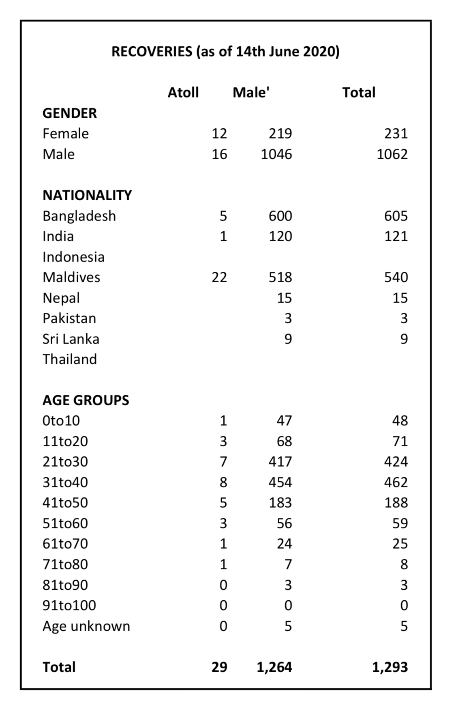

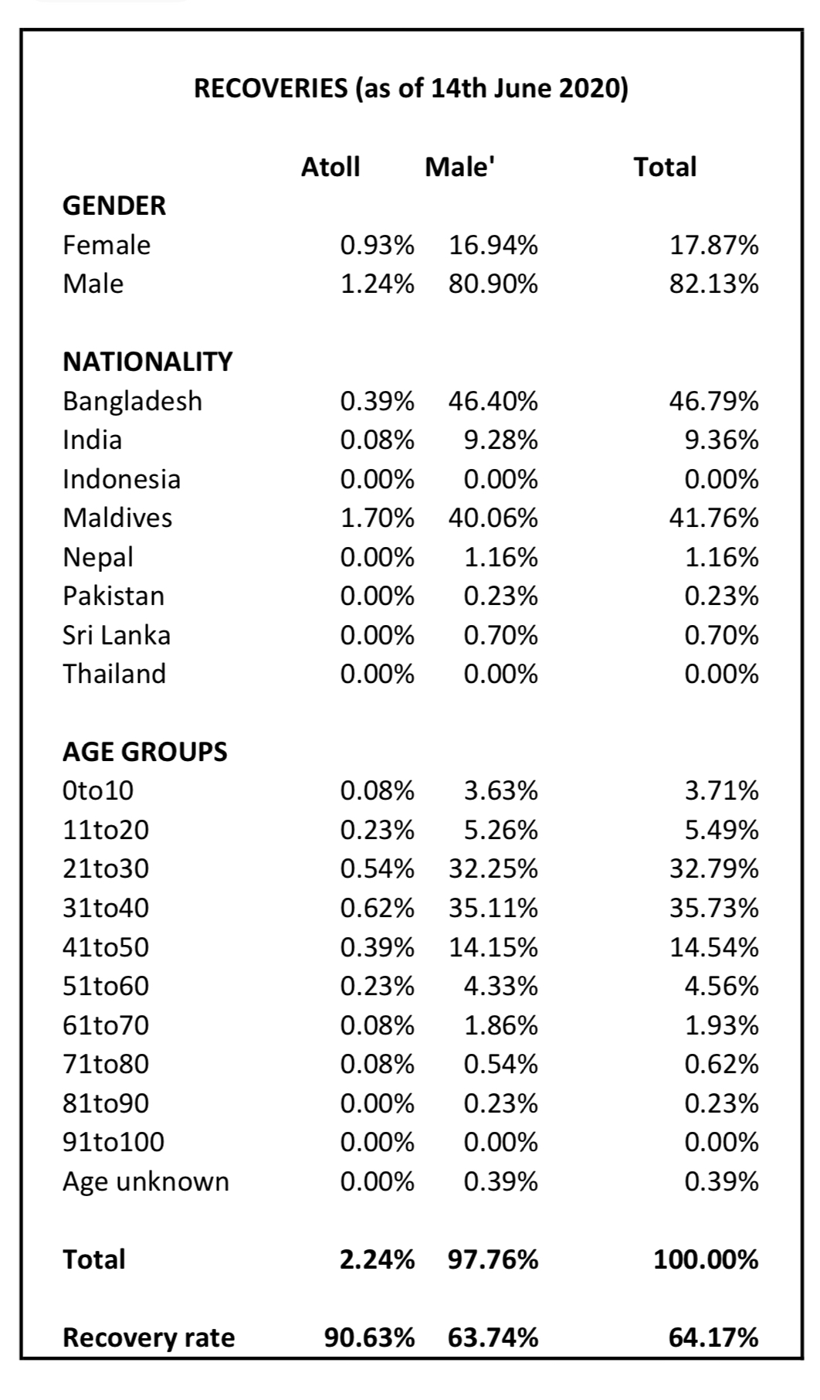

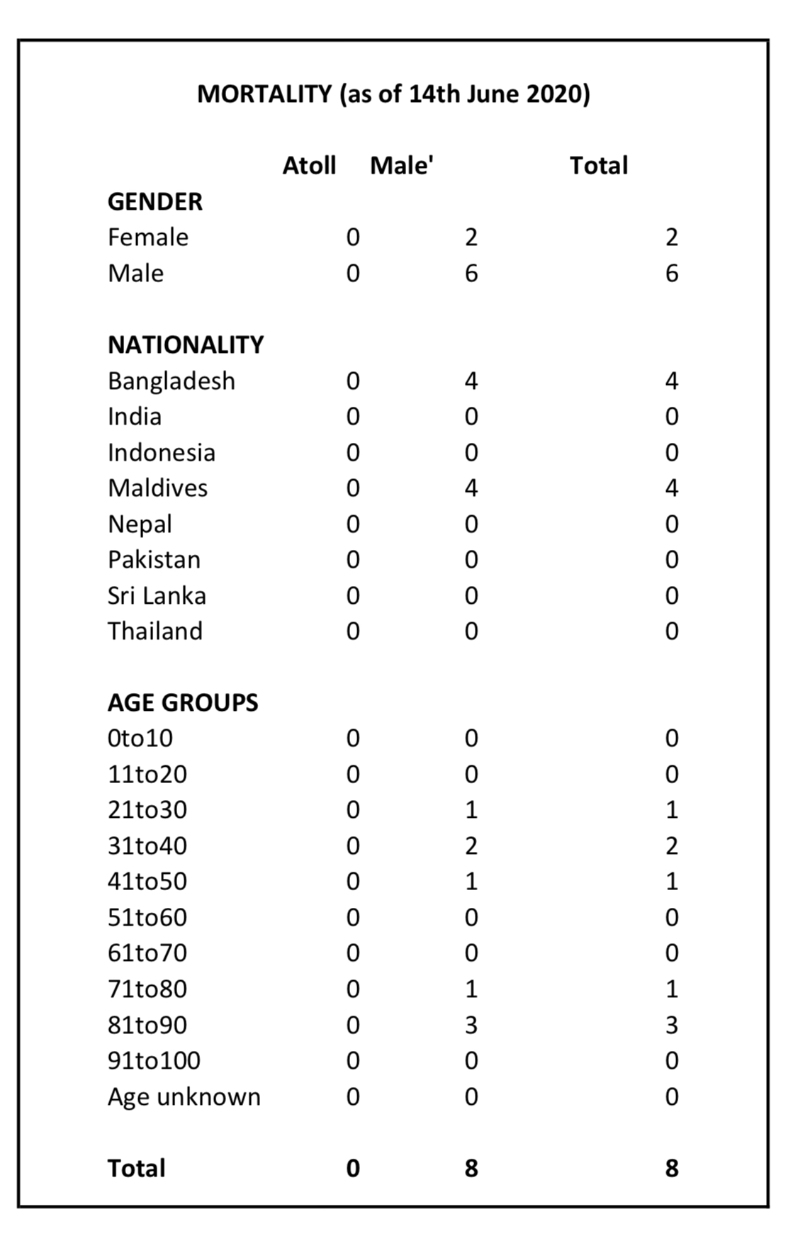

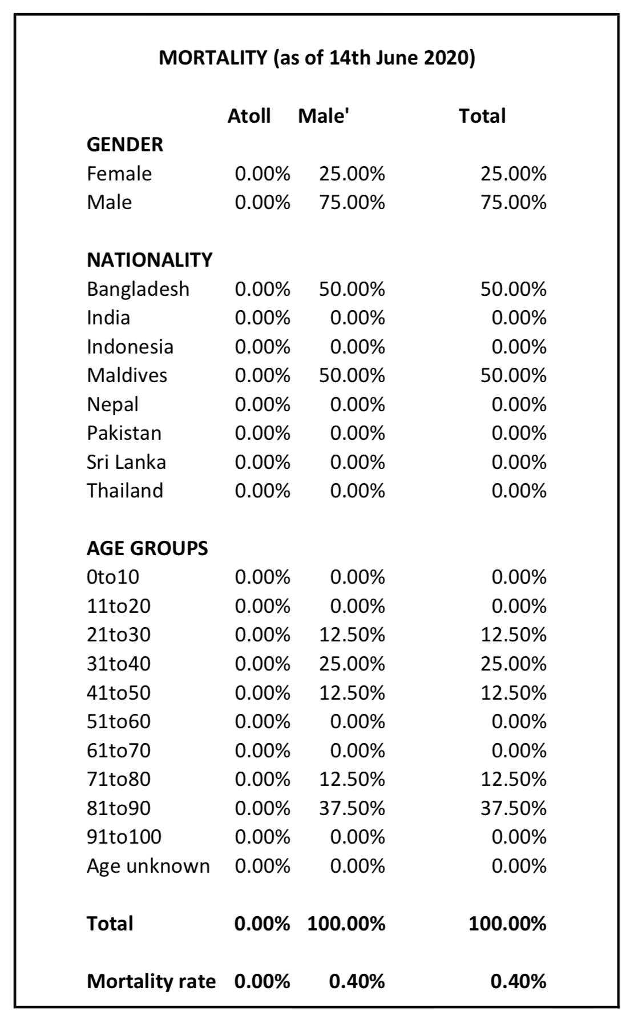

**Annex-3**

**Domestic Violence Cases Reported to FPA from 18 March 2020 to 22 June 2020**

* Total number of cases reported to FPA: **110**

|  |  |  |  |  |  |  |  |  |
| --- | --- | --- | --- | --- | --- | --- | --- | --- |
| **ACTS OF ABUSE** | | **Above 18** | | | **Below 18** | | | **Total** |
| **F** | **M** | **n/a** | **F** | **M** | **n/a** |  |
| 1 | Physical Abuse | 51 | 9 | - | 8 | 7 | 0 | 75 |
| 2 | Sexual Abuse | 17 | 0 | - | 6 | 3 | 0 | 26 |
| 3 | Verbal and psychological Abuse | 54 | 10 | - | 10 | 10 | 0 | 84 |
| 4 | Financial Abuse | 9 | 0 | - | 0 | 0 | 0 | 9 |
| 5 | Impregnating spouse – against doctor’s advice | 0 | 0 | - | 0 | 0 | 0 | 0 |
| 6 | Impregnating women - against will | 0 | 0 | - | 0 | 0 | 0 | 0 |
| 7 | Withholding property | 2 | 1 | - | 0 | 0 | 0 | 3 |
| 8 | Intimidation | 32 | 7 | - | 8 | 6 | 1 | 54 |
| 9 | Harassment | 17 | 2 | - | 6 | 4 | 0 | 29 |
| 10 | Stalking | 6 | 1 | - | 0 | 0 | 0 | 7 |
| 11 | Damage to property | 9 | 2 | - | 1 | 0 | 0 | 12 |
| 12 | Entry to residence without consent | 1 | 0 | - | 0 | 0 | 0 | 1 |
| 13 | Any other - controlling behaviour | 8 | 1 | - | 1 | 3 | 0 | 13 |
| 14 | Coercion | 5 | 0 | - | 0 | 0 | 0 | 5 |
| 15 | Restricting movement | 1 | 0 | - | 0 | 0 | 0 | 1 |
| 16 | Attempting to commit and act, apprehension | 11 | 3 | - | 7 | 4 | 0 | 25 |
| 17 | DV in front of children | 0 | 0 | - | 17 | 19 | 7 | 43 |
| TOTAL | | 223 | 36 | 0 | 43 | 56 | 8 | 387 |
|  |  |  |  |  |  |  |

|  |  |  |
| --- | --- | --- |
| # | DV RELATIONSHIP | TOTAL |
| 1 | Brother | 7 |
| 2 | Ex-Husband | 14 |
| 3 | Ex-Wife | 3 |
| 4 | Father | 25 |
| 5 | Daughter-in-law | 2 |
| 6 | Ex-Boyfriend | 8 |
| 7 | Ex-Girlfriend | 2 |
| 8 | Grand Father | 3 |
| 9 | In-Law | 1 |
| 10 | Relative | 3 |
| 11 | Step Mother | 1 |
| 12 | Step Son | 1 |
| 13 | Husband | 43 |
| 14 | Mother | 13 |
| 15 | Son | 5 |
| 16 | Step-Father | 7 |
| 17 | Wife | 3 |
| 18 | Shared Residence | 2 |
| 19 | Uncle (Maternal) | 2 |
| 20 | n/a | 2 |
|  |  |  |
| **TOTAL** | | **147** |

**Annex-4**

**Breakdown of cases lodged at the Human Rights Commission of the Maldives during the COVID-19 pandemic**

|  |  |
| --- | --- |
| **Detail** | **Number of cases** |
| Issues of quarantine / isolation facilities | 5 |
| Effect on jail services due to COVID-19 | 1 |
| Effect on employment rights | 24 |
| Difficulty in getting essential goods to islands due to lockdown | 1 |
| Housing rights | 2 |
| Effect on migrant worker rights | 13 |
| Safety of frontline workers | 3 |
| Issues in contract tracing | 1 |
| Backlash faced by COVID-19 suspected individuals from public | 1 |
| Right to travel | 7 |
| Alleged unlawful arrest due to lockdown regulation violations | 2 |
| Inefficient arrangements in government run homes in COVID-19 period | 2 |
| Domestic violence | 1 |
| Alleged issues in testing individual reported prior to death | 2 |
| Medical negligence caused by delay in COVID-19 testing | 1 |
| Effect on maternal health services | 6 |
| Death of COVID-19 positive individuals | 2 |
| Issue in service provided to suspected/ positive COVID-19 patients | 4 |
| Livelihood effected by COVID-19 | 2 |
| Electricity issue in an island put in monitoring status due to positive case(s) | 1 |
| Unrest in quarantine facility | 1 |
| **Total** | **82** |