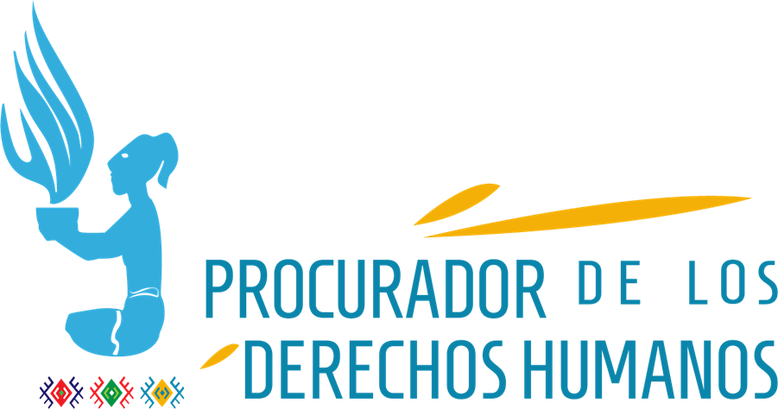

Process of the consideration of the state of the UN human rights treaty body system

July 7th, 2020

Preliminary considerations

Guatemala´s Ombudsman Jordan Rodas Andrade, is aware that the States, when ratifying different human rights treaties and conventions, in use of their sovereign faculties, contract international obligations that imply the development of internal regulations, institutionality, public policies and the availability of financial and human resources for their effective implementation and compliance. The presentation of reports to the different mechanisms of the United Nations system, allows the Ombudsman to account for the fulfillment of Guatemalan State to these obligations.

Navi Pillay´s initiative in her period as High Commissioner, and the adoption of Resolution 68/268 on strengthening of the treaty bodies, recognizes the need for continuous improvement to transform such strengthening into better outcomes. The guidelines contained in Resolution 68/268 have complement the provisions established in the treaties related to their monitoring bodies. The simplified reporting procedure has been a positive mechanism for the States to report on their progress in complying with the Conventions.

Some major progress are the technical assistance program to aid countries in need to meet the treaty provisions; the reaffirmation of the necessary independence and impartiality of the treaty bodies and their members; the guarantee that the committees are more accessible to people with disabilities; as well as the strong condemnation of retaliation against individuals and organizations that cooperate with the treaty bodies. These measures are particularly important for those countries that, as Guatemala, have alarming levels of violence and systematic attacks on the independency of the justice system, which is reflected in the institutional crisis that the State of Guatemala is currently experiencing.

It is important to emphasize the statements made by the High Commissioner in her most recent speech, she pointed out that “Creative thinking and innovation are needed to address the immediate risk of protection gaps and to strengthen longer-term working methods”. This is especially important in those States whose institutions related to human rights work, lack of sufficient budget and deal with deficient technological systems.

In COVID-19 pandemic context, it is necessary that the Committees develop dialogues through virtual platforms with the States (specifically with the State of Guatemala) to assure basic services for the populations living in critical situations of vulnerability, comparing with information provided by civil society actors and the Ombudsman.

To answer the survey, it is pertinent to start from the institutional mandate and the work expertise, which is why general observations are presented and in consideration to the transversality and interrelation of human rights.

Survey Answers

Election of experts
In order to improve the functioning of the monitoring bodies, it is important to insist that in the process of experts election, who integrate the Committees, the candidacies presented by the States should be validated with the national human rights institutions (NHRIs), to assure that the elected persons have the technical competences, thematic experience and the ethical qualities required to join the Committees.

Advisory and communication
It is essential the orientation given by the Committees to the States on the implementation of treaties, in their specific fields and contexts. Likewise, the promotion of regional dialogues on topics of common interest among the States, could be a useful tool for operational and coordination process; for example, on issues related to migration and human trafficking in the Northern Triangle and México, as well as those related to the challenges presented by the COVID-19 pandemic, especially in groups and people living in vulnerable situations. Another aspect that is considered of utmost importance is that the monitoring bodies share the good practices developed by the States.

The utilization and democratization of digital tools will allow closer and regular communication between the Committees and NHRIs. In the same way, opportunities for NHRIs participation at a regional level could be promoted to share information on the compliance of treaties. The implementation of tables with summaries of progress and setbacks can be useful to succinctly present the results of evaluations to the States and improve their comprehension.

It is important to implement communication mechanisms with the counterpart of state institutions. The people, represented by both NHRIs and civil society through their organizations, the participation of women, indigenous peoples, people with disabilities, among others, play a leading role in monitoring compliance of recommendations issued by the Committees.

Furthermore, it is proposed an improvement on the accessibility to official United Nations platforms for the entire population, with especial attention to persons with disabilities; also the communications of its mechanisms should be carried out in accessible formats to that population.

Periodicity of reports
About the periodic evaluations of the State of Guatemala, it is important to consider shorter periods between the presentation of reports by the State and the delivery of recommendations by the Committees.

The Committees should consider evaluating the State in a period of less than four years, therefore being able to examine, by segments, the compliance with the provisions of the international treaties; in order to have the possibility to promptly address priority, urgent or emergent situations regarding serious human rights violations in the country.

Inter-institutional coordination
It is important a closer work between the United Nations Human Rights Office of the High Commissioner in Guatemala and the Ombudsman Institution, on a regular and planned form.

On the other hand, it is important to improve communication between the expert Committees, the United Nations Human Rights Office of the High Commissioner in Guatemala, and the Ombudsman Institution, in order to continuously track the implementation of the recommendations issued by these bodies, as well as be able to report promptly their compliance and serious human rights situations that arise.

Observations and recommendations
The concluding observations and recommendations of the treaty bodies have been useful to Guatemala´s Ombudsman Institution to supervise the human rights situation in the country. Nevertheless, on several occasions the recommendations are very general, they are not measurable, they are not achievable and there is no indication of temporality, which diminishes the effectiveness of the recommendations.

It is necessary that the presidents of the different Mechanisms develop standardized techniques and methods to issue more quality and usefulness recommendations. They can be guided by the double SMART model, a methodology that establishes ten interrelated criteria to guarantee adequate recommendations, these being: specific, measurable, achievable, based on results, limited by time, focused on solutions, awareness of priorities, grounded, sensitive to causes, and aimed.

For example, the observations and recommendations to the State of Guatemala, particularly issued by the Committee on the Protection of the Rights of All Migrant Workers, have contributed to a clearer scenario about the necessary actions to harmonize legal, institutional and public policy instruments with human rights standards. Overall, it is necessary to strengthen the approach of observations, these should be concrete, pertinent, and measurable.

The evaluation of the recommendations can be objective and measurable if they are written in a simple way, with goals and indicators for short and medium-term periods, aimed at tangible results, especially for emergent and unforeseen situations such as the COVID-19 pandemic; also, establish the periods for upcoming evaluations by the treaty bodies to demonstrate the progressivity or setbacks of the implemented actions by the States based on human rights standards.

Reports to the Mechanisms
The Ombudsman Institution considers that the reports presented by the States in the different Committees, compared with the reports sent by civil society (including NHRIs) provide valuable information that helps to determine the human rights situation.

Concerning the observations and recommendations issued by the Experts Committees on different years, it is necessary to notice that they are repeated because the States parties have not made any substantial changes. It is suggested to establish parameters that allow to measure the progressivity of the recommendations and the implementation of the general observations.

To establish a limit of words in the reports could be a solution to synthesize the different reports that are required by the United Nations. The obstacles may be in the transcription of reports to a language requested. Therefore, the reports should be submitted in the official language recognized by the State, and the Committees or the different organs of the United Nations, should have a specific staff to translate them into the language that is needed.

Another limitation are the national statistical systems, which are not reliable and lack of systematized data, making it difficult for deeper analysis.

Treaties related to specific populations such as women, childhood, and adolescence, allow reporting with defined parameters for these population groups. The reports submitted by the State of Guatemala, related to specific populations or specific issues such as racial discrimination, torture, or enforced disappearance, include focused information on these topics and populations. The specificity of the population of the treaty, simplifies monitoring the recommendations and observations. However, the reports and recommendations regarding to Economic, Social and Cultural Rights, and Civil and Political Rights treaties, are not widely known.

As a reference, the efforts of the Committee for the Protection of the Rights of All Migrant Workers, have contributed to establishing the opportunities and limits that the State of Guatemala has had in complying with its commitments (among others, the commitments of the International Convention on the Protection of the Rights of All Migrant Workers and Members of their Families). Likewise, as valuable strengths are considered the statements made on specific issues in the matter (migration for example); establishing principles for addressing specific issues (such as those related to migrant children); and joint observations made with other Committees in interrelation of the rights of populations (such as those developed between the Committee on the Rights of the Child and the Committee for the Protection of the Rights of All Migrant Workers).

Considering Guatemala´s situation already described, and the constantly rights violation of different populations, especially children and adolescents, women, people with disabilities, and indigenous peoples, it would be essential for the Committees and other organs of the United Nations to work more closely, in order to transversely address situations related to the rights of these populations. For example, the recommendations of the World Health Organization should associate to those issued by the Committee on the rights of Persons with Disabilities.

Regarding the simplified reporting procedure, in 2019 the State of Guatemala chose this modality to submit to the II Evaluation on the application of the International Convention on the Protection of the Rights of All Migrant Workers and Members of their Families. For that reason, it is necessary to continue with this modality, due to the practical benefits of its simplicity, which could still have improvements.

The State of Guatemala, through the periodic reports and the evaluations carried out by the treaty bodies, has been able to identify its progress and challenges in various topics on human rights, like the analyzed issue related to the Committee for the Protection of the Rights of All Migrant Workers.

The Committee on the Rights of Persons with Disabilities should consider specific investigations into serious and systematic violations of the rights of persons with disabilities in Guatemala, there are several investigations urgently considered. The continuous violation of the rights of people with disabilities represents a breach of the Convention on the matter; as consequence, the Committee has the immediate possibility of pronouncing on these particular situations, for example: the situation related to the National Hospital for Mental Health, the lack of disaggregated data about disability in public programs and policies, as well as frequent abuses against this population, mainly in labor, community and social context.

It is important to strengthen some processes such as thematic reports, which are considered a successful practice because involves effective participation of civil society and state entities. For instance, the methodology to approach advanced HIV / AIDS in Guatemala, has allowed articulated efforts between government institutions, non-government organizations, community and multisectoral networks.

Concerning to the LGBTIQ+ population, it is important to emphasize the need for State parties to comply with the recommendations of the Mechanisms for the protection of Human Rights. Repots of the situations of this population should be required periodically; as well, the Committees should make regular observations to promote good practices.

Good practices and advances in addressing issues related to women and HIV, should be taken as an model and set a guidance to a better approach on issues related to youth and sexual diversity, as these currently lack of an effective method. For instance, the international discrepancy in the criteria about the age parameter of youth, hinders an effective approach to promote the human rights of this population.

Bachelet, Michelle. Preliminary address by the High Commissioner, informal meeting of the treaty bodies’ Chairpersons. June 2020. At: https://www.ohchr.org/SP/NewsEvents/Pages/DisplayNews.aspx?NewsID=25918&LangID=S
As reference: https://www.apt.ch/sites/default/files/publications/Briefing1_esp.pdf, July 6th, 2020.

