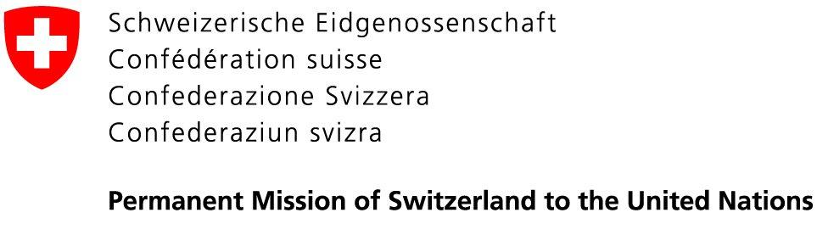 | 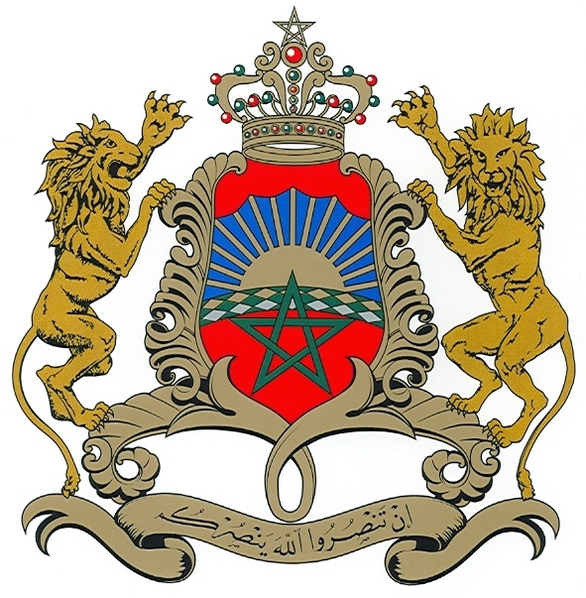  Permanent Mission of the  Kingdom of Morocco to the UN

18 August 2020

Excellency,

In our capacity as co-facilitators of the process of the consideration of the state of the UN human rights treaty body system, we are pleased to share with you further details on the modalities of the informal consultation with Member States in Geneva, scheduled on Friday, 28 August 2020, from 10:00 a.m. to 01:00 p.m. in Room XX in the Palais des Nations.

All delegates wishing to participate in the informal consultation either in person in room XX, Palais des Nations, or on-line on webex, are requested to register their participation with the Secretariat through INDICO. Please note that due to COVID-19 physical distancing restrictions in place at UNOG, the capacity of room XX is limited to 101 participants at desks with microphones. Therefore, participation will be limited to one person per delegation. If you wish to observe the consultation, i.e. not to take the floor, the meeting will be on webcast and accessible to the public on UN Web TV.

The meeting will be structured into discussions on the following issues:
- Simplified reporting procedures;
- Harmonization and working methods;
- Aligned methodology for constructive dialogue;
- Fixed calendar;
- Periodicity of the human rights treaty bodies sessions;
- Concluding observations and recommendations, including their follow-up.

For each of the above-mentioned items, the co-facilitators will make a brief presentation based on the written contributions received. After each agenda item the floor will be opened for delegations. Statements should not exceed 2 minutes for individual delegations and
3 minutes for groups. Please note that interpretation in all six UN languages will be provided in room XX, however due to technical reasons interpretation is not possible on webex. Therefore, delegates wishing to speak in another UN language than English are kindly requested to participate in person in room XX. Otherwise, please indicate in advance in which UN language you wish to deliver the statements.

All Permanent Representatives and
Permanent Observers to the United Nations
New York

The Office of the High Commissioner for Human Rights will soon circulate a detailed information note in this regard to Permanent Missions in Geneva.

Please accept, Excellency, the assurances of our highest consideration.
Pascale Baeriswyl  Ambassador, Permanent Representative of  Switzerland to the UN | Omar Hilale  Ambassador, Permanent Representative of  The Kingdom of Morocco to the UN

