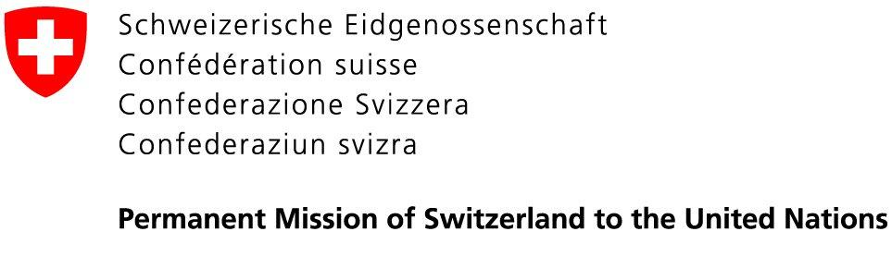 | 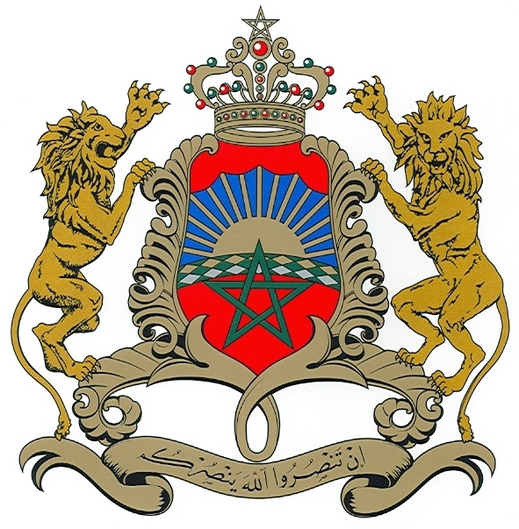  Permanent Mission of the  Kingdom of Morocco to the UN

22 May 2020

Excellency,

We have the honour to write to you in our capacity as co-facilitators of the process of the consideration of the state of the UN human rights treaty body system.

At the outset, we would like to thank the President of the General Assembly for conveying us with this highly important responsibility. We are committed to fulfill this duty through an open, inclusive and transparent process.

In order to launch this process, we have the pleasure to invite you to a first (virtual) meeting on Tuesday, 2 June 2020, from 10:00 a.m. to 01:00 p.m., during which we will present our vision of the process and its timeline. In this regard, we are delighted that the President of the General Assembly. H.E. Mr. Tijjani Muhammad-Bande, and the High Commissioner for Human Rights, H.E. Ms. Michelle Bachelet, have agreed to participate in this meeting to share with us their views on this process.

Member States will have the possibility to make a statement. Due to time constraints, the interventions are limited to 3 minutes for individual delegations and 5 minutes for groups. Delegations are kindly invited to focus their statements on the process in general.

Following this launch meeting, we will convene, together with the OHCHR, a (virtual) technical briefing at expert level on the UN human rights body system. This briefing will provide useful information on the Treaty Bodies, as well as on the background of this process. Further details (date and time) regarding this briefing will follow in due time.

Experts from the Permanent Missions in Geneva are invited to follow both, the launch meeting and the technical briefing.

The Secretariat will circulate an information note providing guidance on how to join the virtual launch meeting on Tuesday, 2 June 2020.

Please accept, Excellency, the assurances of our highest consideration.
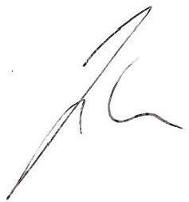  Jürg Lauber  Ambassador, Permanent Representative of  Switzerland to the UN | Omar Hilale  Ambassador, Permanent Representative of  The Kingdom of Morocco to the UN
All Permanent Representatives and
Permanent Observers to the United Nations
New York

