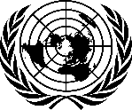
THE PRESIDENT
OF THE
GENERAL ASSEMBLY

4 September 2020

Excellency,

I have the pleasure to transmit herewith, a letter dated 4 September 2020 from
H.E. Ms. Pascale Baeriswyl, Permanent Representative of Switzerland to the United Nations and H. E. Mr. Omar Hilale, Permanent Representative of Morocco to the United Nations, the co-facilitators for the review of the UN human rights treaty body system.

The letter invites Member States and Observers to a virtual wrap-up meeting of the review process, scheduled to take place on Friday, 11 September 2020 from 10 a.m. to 12 p.m..

I avail of this opportunity to express my solidarity with Member States who are fighting COVID-19 and extend my sincere condolences for their loss.

Please accept, Excellency, the assurances of my highest consideration.

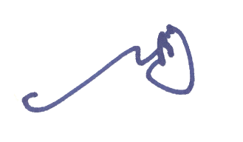
Tijjani Muhammad-Bande

All Permanent Representatives and
Permanent Observers to the United Nations
New York

