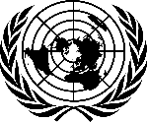
THE PRESIDENT
OF THE
GENERAL ASSEMBLY

12 June 2020

Excellency,

I have the pleasure to transmit herewith, a letter dated 11 June 2020, from
H.E. Mr. Jürg Lauber, Permanent Representative of Switzerland to the United Nations
and H. E Mr. Omar Hilale, Permanent Representative of Morocco to the United Nations, the co-facilitators for the review of the UN human rights treaty body system.

The letter outlines the timeline for the modalities of the review of the UN human rights treaty body system.

I avail of this opportunity to express my solidarity with Member States who are fighting COVID-19 and extend my sincere condolences for their loss.

Please accept, Excellency, accept, the assurances of my highest consideration.

(signed)

Tijjani Muhammad-Bande

All Permanent Representatives and
Permanent Observers to the United Nations
New York

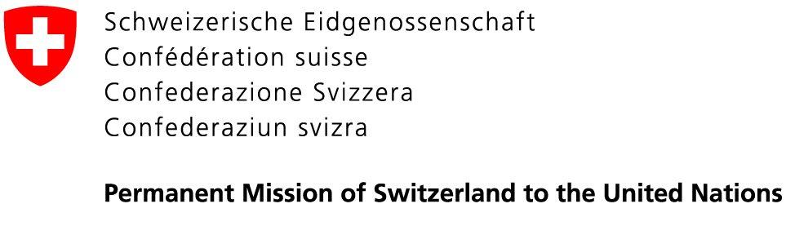 | 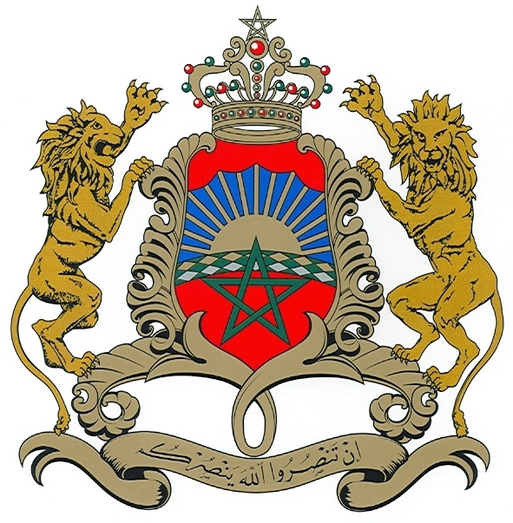  Permanent Mission of the  Kingdom of Morocco to the UN

11 June 2020

Excellency,
In our capacity as co-facilitators of the process of the consideration of the state of the UN human rights treaty body system, we would like to thank you again for your constructive participation in the first virtual meeting to launch this process, held on 2 June 2020.
As announced during the abovementioned meeting, we would like to outline the timeline for the process ahead:
- Given the current circumstances linked to Covid-19, we will adopt a flexible hybrid system, where we will first seek written contributions, before holding informal consultation meetings.
- Therefore, we will soon send out a letter to Member States and all the relevant stakeholders with specific guiding questions, seeking their views to be submitted as written contributions. The deadline for these contributions will be by the end of June. In order to guarantee full transparency, contributions will be published on the dedicated OHCHR website.
- Based on these contributions and as mandated by the President of the General Assembly in his letter dated 8 April 2020, we will hold informal consultation meetings with Member States, in New York, in the beginning of July, and in Geneva during the second half of July.
- We will also hold dialogues with all relevant stakeholders to seek their contributions, including with OHCHR, treaty bodies, civil society members, National Human Rights Institutions and others.
- If needed, we might organize additional consultations towards the end of the month of July.

All Permanent Representatives and
Permanent Observers to the United Nations
New York
- At the end of the consultation process, we plan to hold a wrap-up session in order to present the results, conclusions and possible recommendations we will reflect in our final report.
- During the month of August, we will draft the report that we will submit to the President of the General Assembly by the end of the current 74th General Assembly. The report will describe the consultation process, present the results of the informal consultations and, based on the latter, outline the recommendations of the
co-facilitators so as to assess and decide, if appropriate, on further action to strengthen and enhance the effective functioning of the human rights treaty body system.

The specific modalities of all these meetings will depend on the situation and developments related to Covid-19 in New York and Geneva, whether physical meetings will be possible or if the meetings need to be conducted virtually.
Throughout the process, we will work in complete transparency and inclusivity. We will ensure that information is shared with and accessible to all, and at all stages of the process.
In this spirit, we are looking forward to working with you on this process. We count on your openness, flexibility and spirit of compromise in order to achieve our collective ultimate objective to strengthen the treaty body system, to ensure that they can fully implement their mandates for the protection of human rights worldwide.

Please accept, Excellency, the assurances of our highest consideration.

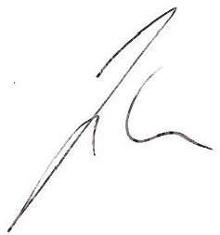  Jürg Lauber  Ambassador, Permanent Representative of  Switzerland to the UN | Omar Hilale  Ambassador, Permanent Representative of  The Kingdom of Morocco to the UN

