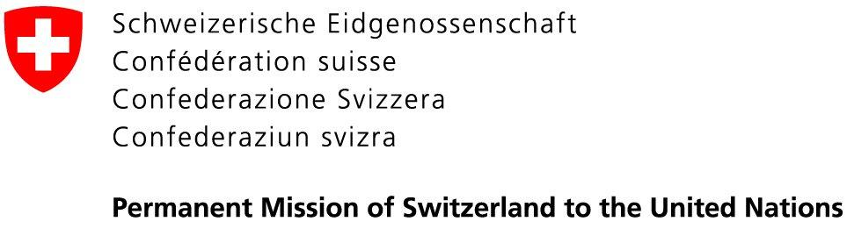 | 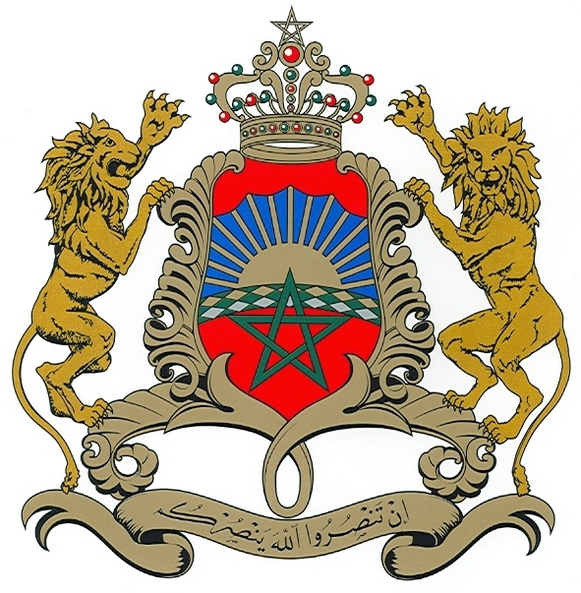  Permanent Mission of the  Kingdom of Morocco to the UN

12 June 2020

Timeline for the process of the consideration of the state of the UN human rights treaty body system

Given the current circumstances linked to Covid-19, the co-facilitators will adopt a flexible hybrid system, where they will first seek written contributions, before holding informal consultation meetings:
- First the co-facilitators will send out a letter to Member States and all the relevant stakeholders with specific guiding questions, seeking their views to be submitted as written contributions. The deadline for these contributions will be by the end of June. In order to guarantee full transparency, contributions will be published on the dedicated OHCHR website.
- Based on these contributions and as mandated by the President of the General Assembly in his letter dated 8 April 2020, the co-facilitators will hold informal consultation meetings with Member States, in New York, in the beginning of July, and in Geneva during the second half of July.
- The co-facilitators will also hold dialogues with all relevant stakeholders to seek their contributions, including with OHCHR, treaty bodies, civil society members, National Human Rights Institutions and others.
- If needed, the co-facilitators might organize additional consultations towards the end of the month of July.
- At the end of the consultation process, the co-facilitators plan to hold a wrap-up session in order to present the results, conclusions and possible recommendations they will reflect in their final report.
- During the month of August, the co-facilitator will draft the report that they will submit to the President of the General Assembly by the end of the current 74th General Assembly. The report will describe the consultation process, present the results of the informal consultations and, based on the latter, outline the recommendations of the
co-facilitators so as to assess and decide, if appropriate, on further action to strengthen and enhance the effective functioning of the human rights treaty body system.

The specific modalities of all these meetings will depend on the situation and developments related to Covid-19 in New York and Geneva, whether physical meetings will be possible or if the meetings need to be conducted virtually. Throughout the process, the co-facilitators will work in complete transparency and inclusivity. Information is shared with and accessible to all, and at all stages of the process.

