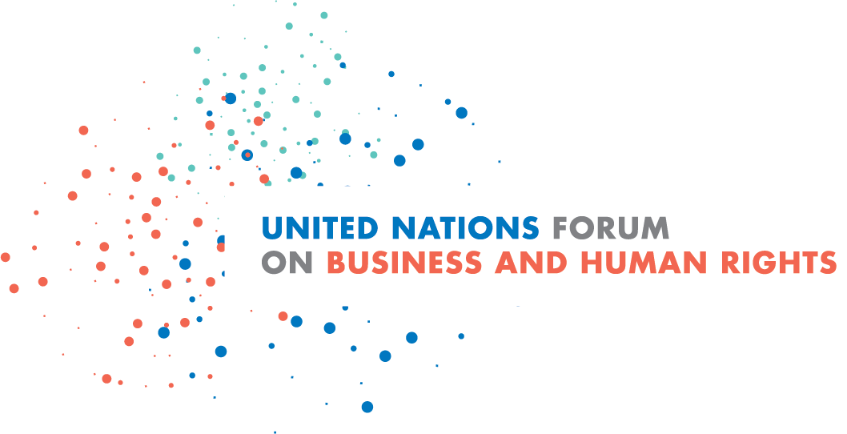
Concept note
2020 Virtual UN Forum on Business and Human Rights
16-18 November 2020

Preventing business-related human rights abuses:
The key to a sustainable future for people and planet

Overview
The ninth annual UN Forum on Business and Human Rights will be held virtually, from 16 to 18 November 2020, taking into account the extraordinary circumstances relating to the COVID-19 pandemic and its impact on global travel.
Over three days, participants in the virtual Forum will discuss trends, challenges and progress in advancing implementation of the UN Guiding Principles on Business and Human Rights in all regions of the world and examine a selected number of key current business and human rights issues.
The Forum is guided and chaired by the UN Working Group on Business and Human Rights and organized by the Office of the UN High Commissioner for Human Rights (OHCHR). As the world’s foremost gathering in this field, it provides a unique space for dialogue between governments, international organizations, businesses, industry associations, trade unions, civil society organizations, human rights defenders, affected individuals and academics on current trends, challenges and good practices in preventing and addressing business-related human rights abuses. Each year, the Forum brings together a range of stakeholders in Geneva for three days of constructive, action- and solution-oriented dialogue. Despite travel restrictions this year which prevent a physical Forum from taking place, the virtual Forum will strive to continue to be an important meeting place for different stakeholders and even benefit from the opportunity provided by virtual platforms to reach new and diverse participants in all regions.
The 2020 focus: Preventing adverse impacts to build a sustainable future
As the world has entered a new decade, threats to human rights and a sustainable future for all loom large. The human rights and economic consequences of the COVID-19 pandemic have clearly demonstrated the urgency for Governments and businesses alike to take a sustainable, people-centred path while fighting Covid-19 and in “building back better”. This crisis, coming on top of other severe global challenges, such as the climate crisis and growing economic inequality, highlighted that implementing the UN Guiding Principles on Business and Human Rights with its three pillars – “Protect, Respect and Remedy” framework – has become more urgent than ever.
The UN Guiding Principles were designed precisely as a response to such global challenges. By reinforcing business respect for human rights and access to remedy for business-related human rights abuses, they offer a pathway to a sustainable future for all – their implementation by States and businesses will contribute to the Decade of Action for the Sustainable Development Goals and the UN Secretary-General’s 2020 Call to Action for Human Rights.
The role of business is at the centre of debates on the way forward, recognizing that responsible business is a key part of the solution, and conversely that the harm inflicted by irresponsible business practices on individuals, communities and the environment is often irreversible, but is generally preventable. A renewed emphasis on the need to prevent adverse impacts on people and the planet resulting from harmful business activities is urgently required. The important preventative role of human rights due diligence and improved access to effective remedy for business-related human rights abuses, are among the key elements of the business and human rights agenda that should be recognized more widely and reinforced by States and other stakeholders.
Many current challenges are the cause of widespread concern, including climate change and environmental disasters, growing inequalities, rising levels of violence and populism, persistent discrimination, pervasive corruption, shrinking civic space, the rapid deployment of new technologies without appropriate human rights oversight, and impunity for human rights abuses. These challenges underscore the urgent need for multilateral and multi-stakeholder collaboration and action for the next decade and beyond.
States and business actors must use this moment as they strive to emerge from the current crisis, not to revert to business as usual, but to “build back better”. They must deliver on the commitments “to leave no one behind”, including by scaling-up implementation of the UN Guiding Principles and hence contributing to the Decade of Action for the Sustainable Development Goals and the UN Secretary-General’s 2020 Call to Action for Human Rights.
As the world’s largest multi-stakeholder event on business and human rights, the 2020 UN Forum is well placed to support dialogue on confronting these global challenges. A central premise for the Forum dialogue is that responsible business practices, as well as political leadership in taking concrete and cohesive actions, are central to what is needed.
Building on this recognition, the 2020 UN Forum seeks to reinforce the message that strengthening prevention of business-related human rights abuses – by learning from both good practices and from things that have gone wrong, as well as by addressing systemic gaps – can help to build a sustainable future for people and planet.
Background
The Guiding Principles on Business and Human Rights – the key reference of the Forum based upon international human rights standards – were unanimously endorsed by UN Human Rights Council in 2011 and provide a globally recognized and authoritative framework for the respective duties and responsibilities of Governments and business enterprises to prevent, mitigate and remediate adverse human rights impacts arising in relation to business activity. They comprise three independent, but closely inter-related pillars:
- The State duty to protect against human rights abuses by third parties, including business, through appropriate policies, regulation and adjudication;
- The business responsibility to respect human rights, which means to avoid infringing on the rights of others and to address adverse impacts with which a business is involved (by adopting appropriate policies, conducting human rights due diligence, and remediating abuses when they occur); and
- The need for access to effective remedy for rights-holders when abuse has occurred, through both judicial and non-judicial grievance mechanisms.
With an emphasis on strengthening prevention, the 2020 Forum will address challenges and solutions along these three dimensions of the Guiding Principles.
This year’s theme builds on previous Forums as well as regional events organized, and reports prepared, by the Working Group. For example, the Working Group has highlighted that preventing adverse impacts is at the core of corporate human rights due diligence, that preventing and addressing business-related human rights abuses provide the most significant contribution that most businesses can make to realize the Sustainable Development Goals, that access to remedy is critical for those negatively affected, that fighting corruption by all actors may prevent and mitigate business-related human rights abuses and that both States and businesses should adopt gender-responsive measures.
The 2020 Forum’s theme aligns with calls from the UN Secretary-General and the High Commissioner for Human Rights for the need to reinforce prevention of adverse human rights impacts as the foundation for sustainable development. The choice of theme also underscores that prevention is a current priority concern of the Human Rights Council and takes into account the recent intersessional seminars that have been held on the contribution that the Human Rights Council can make to the prevention of human rights violations.
With a major focus on prevention of business-related human rights abuses, the 2020 Forum will examine several of the urgent global challenges where the issues of human rights and the role of business come together, including in the context of current and emerging crises, such as COVID-19. The following provides a non-exhaustive list of thematic issues that will be discussed in the Forum:
- The connection between the climate crisis and the business and human rights agenda. Building on discussions at the 2019 UN Forum, the 2020 Forum will examine how the UN Guiding Principles can guide and assist States, businesses and investors in their efforts to achieve a “just transition” to a greener economy. The Working Group will be developing an Information Note on this issue to provide further guidance to all stakeholders.

- The key role of human rights defenders who speak up against business-related risks and harms on people and the environment, in contributing to a sustainable future for all. Prevention of threats, harassment and reprisals against human rights defenders working to address harmful business-related practices will again be at centre of discussions concerning a range of sectors and contexts.

- The alignment between the business and human rights and anti-corruption agendas. Discussions will build on the Working Group’s 2020 report to the Human Rights Council, A/HRC/44/43, examining how corruption involving the private sector causes, contributes or is linked to human rights abuses, how it may undermine business respect for human rights, and what measures and good practices can be taken by States, business and civil society to prevent and address adverse human rights impacts linked to corporate-related corruption.
- How to better prevent and address business-related human rights abuses in conflict-affected settings and create conditions for responsible investment and business that help build sustainable peace. These discussions will build on the Working Group’s 2020 report to the General Assembly, which aims to identify and clarify practical steps that States, businesses and investors should take to prevent and address business-related human rights abuses in conflict and post-conflict contexts.

- The latest developments around efforts to improve access to effective and gender-responsive remedy for victims of business-related human rights harms, recognizing that corporate accountability is critical to preventing future human rights abuses.

- Initiatives to promote common understanding of the policy developments and measures to be taken by States and business today to prevent future human rights abuses arising in the context of rapid technological transformation, including in relation to the “future of work”, artificial intelligence and surveillance.
In line with the Forum’s mandate, it will continue to address broad trends and challenges in implementing the Guiding Principles, taking stock of and promoting dialogue on:
- wider legal and policy developments, including with a focus on developments in different regions to implement the UN Guiding Principles; and
- trends in company and investor performance and uptake of the responsibility to respect human rights and human rights due diligence.
Multi-stakeholder dialogue on trends and challenges at the 2020 Forum will be a key input to the Working Group’s process of assessing achievements of the UN Guiding Principles at their 10th anniversary in 2021 and developing a joint vision for the next 10 years of implementation of the Guiding Principles.
Contributing to the 2020 Forum
Due to the virtual format of the Forum, the Working Group has not issued a general call for session proposals this year and there will be fewer sessions than in previous years. Information about the agenda, registration process and virtual participation will be posted on the Forum web page. As in previous years, the Working Group and the Forum Secretariat will involve a range of different stakeholders in the preparation of the Forum programme.

https://www.ohchr.org/EN/HRBodies/HRC/Pages/PreventionOfViolations.aspx

