Inputs for United Nations Human Rights Special Procedures: Multi-stakeholder consultation
Connecting the business and human rights and anti-corruption agendas
5 March 2020

Question 1: What are the key areas where corruption causes, contributes or is linked to human rights abuses and negative impacts for right holders? Are there key sectors or key areas where corruption leads to human rights abuses with a business nexus (For example in particular actors or in specific areas such as large-scale land acquisitions or government procurement)?
Answer: The WJP Rule of Law Index 2017-18 (appendix 1) portrays a relatively weak performance of East Asia and Pacific region. The 8 factors that lead to this inference include constraints on government powers, absence of corruption, open government, fundamental rights, order and security, regulatory enforcement, civil justice, and criminal justice. The interlinked nature of these factors make it important to study the overlaps between corruption and human rights violations in the region.
Indeed, this is exemplified in key industries in the ASEAN region. In the Palm oil industry in Malaysia and Indonesia, weak governance fails to control trafficking and forced labour. In Thailand, the illegal and un-regulated migration of workers of the fishing industry from neighbouring Cambodia and Myanmar is facilitated by police, military officers and brokers. And in the construction sector, corruption in form of public officials granting easy permits result in weak infrastructure, endangering people’s lives, for instance in the Rana Plaza building collapse in Bangladesh, that caused death of more than a thousand workers.
Some of these examples are explained below:
1. Trafficking and forced labour in the palm oil industry in Malaysia:
Palm oil production is a key pillar of the Malaysian economy, which is also one of the largest palm oil producing and exporting countries in the world. Human rights violations, forced and trafficked labour along with corruption in the sector came to light with civil society complaints against FGV Holdings Berhad (Felda), the largest producer in Malaysia.
Lack of effective governance, large informal sector with powerful and corrupt local authorities, lack of monitoring and due diligence allow prevalence of the unregulated nexus of labour supply.
2. Livelihoods of indigenous people lost to palm oil industry in Indonesia
Livelihoods of Indonesia’s 50-70 million indigenous people are suffering and devastated due to palm oil plantations. Weak laws, corruption, poor government oversight, and the failure of plantation companies to fulfil their human rights due diligence responsibilities, have resulted in loss of land and livelihood opportunities for these Indigenous people, especially in West Kalimantan and Jambi regions.
3. Human Rights violations in sugar plantations in Cambodia
In Cambodia, Equitable Cambodia (EC) (NGO) and Inclusive Development International (IDI) (Human Rights Organization), on behalf of nearly 681 families in Cambodia reported the breaches of the OECD Guidelines for Multinational Enterprises by Australia and New Zealand Banking Group Ltd. (ANZ) and its controlled entity ANZ Royal Bank. These were in relation to human rights violations in the sugar plantation industry.
Forced evictions, military-backed land seizures and destruction of crops and property have been carried out to make way for sugar plantations. In January 2014, two confidential social and environmental “site assessment” reports were leaked to EC and IDI, revealing that ANZ Royal had provided significant financing to Phnom Penh Sugar Co. Ltd. (PPS) to develop its sugar plantation and refinery in the Cambodian province of Kampong Speu. PPS is owned by LYP Group, a conglomerate wholly owned by Cambodian tycoon and senator Ly Yong Phat, who is notorious for engaging in unethical, corrupt and illegal business practices.
This is an instance where corruption at the political level, to serve business/industrial interests perpetrates human rights violations on locals.
4. Forced labour in Thai fishing industry
Thailand is the world’s third largest seafood exporter. In the past 5 years, it has been heavily criticized following reports of human and labor rights abuses and illegal, un-reported and unregulated (IUU) fishing practices. Human Rights Watch has reported the plight of migrant workers, specially those from Cambodia and Myanmar. Mostly undocumented migration of these workers subjects them to danger and coercion at the hands of the employers. Victims record that police officers and soldiers at check-points turn a blind eye and allow their passage into Thailand. This reveals how corrupt public officials catalyse and allow this abusive nexus of worker’s migration to sustain.

5. More than 1000 lives lost in garment factory collapse in Dhaka, Bangladesh
The 2013 collapse of the eighty-story commercial building (Rana Plaza) was a structural failure that killed more than 1000 workers. Investigations showed that the upper four floors were built without a permit. Hence, the collapse raised the issue of corruption and inadequate monitoring of permits in the construction sector, that put the lives of workers at stake. A case with the police accusing 17 people of breaching regulation was filed by the Anti-corruption commission (ACC) in 2014. In 2016, all the accused were indicted.

Question 4: How can anti-corruption compliance and human rights due diligence be better coordinated within companies as part of an overall approach to responsible business conduct? What are examples of good practice?
Answer: Informed by research conducted by Liberty Shared and the UN Global Compact, the following are some recommendations on how anti-corruption compliance and human rights due diligence can be coordinated in companies.
- Compliance with increased reporting, prioritizing transparency and human rights due diligence standards should become a key concern at the board level

- Companies must ensure ethical recruitment of migrant workers with adequate background checks

- Worker voices must be heard, for example, those of migrant labour in remote locations, to complement other supply chain transparency measures. Hence open channels of communication across all levels in a company must be ensured

- Aligning policy commitments to respect human rights with a company’s anti-corruption commitments demonstrates that the company adheres to pro-social values and takes human rights responsibilities as seriously as it does the combatting of corruption. These can be included in a company’s external documents, internal business codes of conduct, governance reports and operating policies on issues like security.

- Multinational businesses face risks of both corruption and adverse human rights impacts, not only from their own business activities but also from actions of third parties with whom they do business (including in their supply chains). Companies can combine corruption and human rights risk assessment as part of their due diligence for their business partners. For example, a company can review a prospective local security firm’s record for both violence and corruption.

Question 5: How does corruption and corrupt activities impact the ability of victims to seek access to an effective remedy (both judicial and non-judicial)? What measures can States and companies take to address these challenges?
Answer: Evasion of rule of law is a common practice by perpetrators of violations in a corrupt environment which deprives victims from access to justice. In turn, the poor and the workers face the most damaging brunt of this.
For example, a Liberty Shared report on the human rights violations in the palm oil industry in Malaysia shows that often, the victims are not aware of their rights, or that they are entitled to compensation following a successful conviction. Further, the resource inadequacy of victims in seeking due process in the courts often contributes to the limited victim compensation.
This situation is exacerbated in the instance of migrant workers, who also have language and geographic barriers to seeking compensation in courts outside their country of origin. Hence, they lack adequate access to justice.
On this subject, scholars like Dr Junaita Olaya Garcia argue that “right to reparation is a basic legal principle.” Further, Article 35 of the UN Convention Against Corruption (UNCAC) also mandates that those who have suffered damage due to corruption have the right to initiate legal proceedings to obtain compensation.
Hence to make compensation and justice accessible to workers, the State and companies must raise awareness on workers’ rights throughout the industrial sector (for example, the palm oil industry). In addition, operational level grievance mechanisms should be set up, wherein, victims of corruption and human rights violations could seek remedy and guidance on filing petitions and approaching legal aid.
This would also better equip the migrant workers who are most at risk of exploitative labour practices to access their labour rights and rights as victims of forced labour and human trafficking.
On the other hand, corruption at the judicial level, among judges and court-staff also impacts the victim’s access to justice. According to the 2017 the Global Corruption Barometer, 25% of total respondents said that ‘Most’ or ‘all’ judges and magistrates are involved in corruption. For Asia Pacific, 23% of responding service-users said they have paid a bribe in courts. Hence corruption in judicial systems comes forth as a major obstacle to access to justice.
Often, this jeopardizes the rights of the poor to seek judicial remedy, as they do not have the resources pay bribes to the judges and advocates. Prevalence of corruption at this level in the region makes it imperative for the state to uphold the independence as well as transparency and accountability of courts, to ensure free and fair access to justice for all.

Question 9: What role should international financial institutions, and investors play in exerting leverage to ensure both prevention of corruption but also business respect for human rights?
Answer: The following are some instruments and measures that financial institution and investors could incorporate and engage with, to safeguard against corruption while respecting human rights.
- Most importantly, human rights and anti-corruption due diligence must be conducted for all investments and customers. It must be ensured that companies receiving investment maintain proper internal controls and share evidence of their own risk assessments and due diligence.

- Institutions and investors should voluntarily abide by, and encourage adherence to the UNPRI (UN Principles of Responsible Investment), that supports integration of Environmental, Social and Governance (ESG) issues in investment and decision making.

- Investors should engage in associations to gain knowledge of global best practices. For example, the PRI Investor Working Group(s) provides opportunities for signatories to convene, share knowledge and collaborate for change and impact.

- Investors can benefit from engaging with portals and organizations like KnowTheChain, which is a resource for companies to understand and address forced labor risks within their global supply chains in order to be alert about corruption and human rights violation.

Question 10: How can United Nations bodies such as OHCHR and the UN Office on Drugs and Crime, work more closely together to address the human rights impacts of corruption?

UNDP’s two projects titled Business and Human Rights in Asia and Promoting a Fair Business Environment in ASEAN focus on engaging certain government bodies and ministries like the National Anti-Corruption agencies, private sector as well as the civil society to strengthen the business landscape in alignment with the Sustainable Development Goals (SDGs) in the region.

- In doing so, the Business and Human Rights (B+HR) in Asia programme seeks to ensure effective implementation of the UN Guiding Principles on Business and Human Rights, with a particular focus on National Action Plans and remedy provisions. B+ HR works to provide technical and advisory supports to governments, regional peer leaning and capacity building on the UN Guiding Principles (UNGPs), support to the business sector in the development of company human rights policies, and support the role of civil society and national human rights institutions.

By leveraging B+HR's role as a thought leader and partner with governments to create an enabling environment for Business and Human Rights, B+HR also engages private sector to respect human rights in their business operations and remediate human rights abuses. In recognizing the strong links between corruption and human rights, presently, the Fair Business and B+HR teams are working to link their private sector engagement to promote anti-corruption efforts and respect for human rights.

- Further, the Promoting a Fair Business Environment in ASEAN (FAIR BIZ) project aims to promote a fair, transparent and predictable business environment in the dynamic ASEAN countries. With the aforementioned multi-stakeholder approach, the project strives to foster a level playing field for business competition wherein:
  - A culture of transparency and integrity in the public and private sectors is nurtured
  - Responsible and sustainable business practices are encouraged
  - Corruption risks are minimized, and the application of justice is fair

Appendix
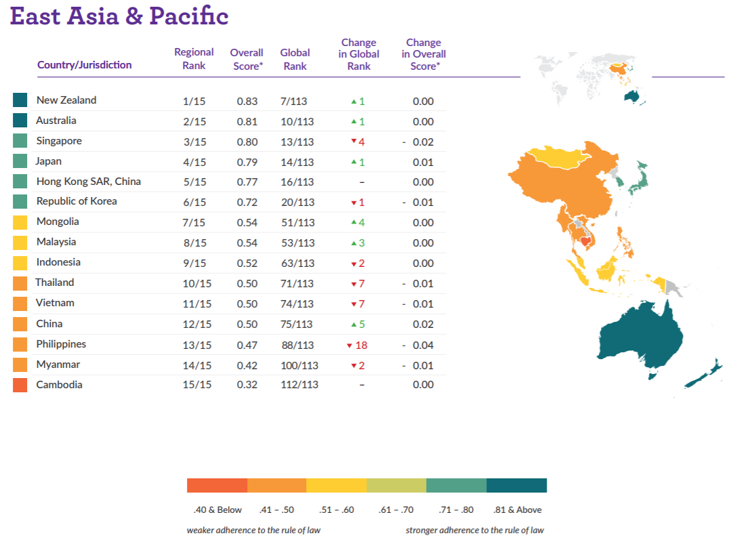

Source: World Justice Project, Rule of Law index, 2017-18

“Rule of Law Index”, World Justice Project, 2017-18; https://worldjusticeproject.org/sites/default/files/documents/WJP-ROLI-2018-June-Online-Edition_0.pdf
“Liberty Shared: Corporate accountability and liability in the Malaysian Palm oil industry”, Liberty Shared,2019;https://s3.ap-southeast-1.amazonaws.com/freedom.collaborative.prod/uploads/palmoil_malaysia_2019.pdf Pablo Pacheco et al, “Governing sustainable palm oil supply: Disconnects, complementarities, and antagonisms between state regulations and private standards”, Wiley Online Library, 2018; https://onlinelibrary.wiley.com/doi/full/10.1111/rego.12220
“When We Lost the Forest, We Lost Everything”, Human Rights Watch, 2018; https://www.hrw.org/report/2019/09/22/when-we-lost-forest-we-lost-everything/oil-palm-plantations-and-rights-violations Adisti Sukma Sawatri, “Indonesia still behind in indigenous peoples land recognition”, The Jakarta Post; https://www.thejakartapost.com/news/2018/09/11/indonesia-still-behind-in-indigenous-peoples-land-recognition.html
According to a 2010 report by international NGO, Global Witness, “the portfolio of Senator Ly Yong Phat and his company extends to casinos, hotels and economic land concessions.”
Equitable Cambodia and Inclusive Development International Report; https://www.inclusivedevelopment.net/wp-content/uploads/2014/10/Specific-Instance-against-ANZ-FINAL.pdf
Emmy Sasipornkarn, “Thai fishing industry makes headway, but challenges remain”, DW, November 2019; https://www.dw.com/en/thai-fishing-industry-makes-headway-but-challenges-remain/a-51223387
“Hidden Chains: Rights Abuses and Forced Labor in Thailand’s Fishing Industry”, Human Rights Watch, 2016; https://www.hrw.org/report/2018/01/23/hidden-chains/rights-abuses-and-forced-labor-thailands-fishing-industry “Thailand’s Seafood Slaves: Human Trafficking, Slavery and Murder in Kantang’s Fishing Industry”, Environmental Justice Foundation (EJF), 2015; https://ejfoundation.org/resources/downloads/EJF-Thailand-Seafood-Slaves-low-res.pdf
“One Year after Rana Plaza tragedy: Progress in governance must be sustained”, Transparency International Bangladesh, n. d; https://www.ti-bangladesh.org/beta3/index.php/en/activities/4209-one-year-after-rana-plaza-tragedy-progress-in-governance-must-be-sustained-2 Amy Westervelt, “Two years after Rana Plaza, have conditions improved in Bangladesh’s factories?”, The Guardian, 2015; https://www.theguardian.com/sustainable-business/2015/apr/24/bangladesh-factories-building-collapse-garment-dhaka-rana-plaza-brands-hm-gap-workers-construction
“Liberty Shared: Corporate accountability and liability in the Malaysian Palm oil industry”, Liberty Shared,2019;https://s3.ap-southeast 1.amazonaws.com/freedom.collaborative.prod/uploads/palmoil_malaysia_2019.pdf
Joanna Drewert, Kaustav Banerjee, “Linking Human Rights and Anti-Corruption Compliance”, United Nations Global Compact, https://www.globalcompact.de/wAssets/docs/Korruptionspraevention/Publikationen/Human_Rights_and_Anti_Corruption_Compliance.pdf
“Liberty Shared: Corporate accountability and liability in the Malaysian Palm oil industry”, Liberty Shared,2019;https://s3.ap-southeast 1.amazonaws.com/freedom.collaborative.prod/uploads/palmoil_malaysia_2019.pdf
Junaita Olaya Garcia, “Reparations for Corruption: How Corruption Enforcement Ignores Victim’s Rights”, The Fletcher School, 27 February 2020; https://sites.tufts.edu/ihs/reparations-for-corruption-how-corruption-enforcement-ignores-victims-rights/
“People and Corruption: Asia Pacific, Global Corruption Barometer”, Transparency International, 2017; https://www.transparency.org/whatwedo/publication/people_and_corruption_asia_pacific_global_corruption_barometer
For example, since 2011, the PRI coordinates an Investor Working Group on Sustainable Palm Oil, with the aim to raise awareness amongst investors of the ESG issues that arise in the palm oil value chain, to provide a unified investor voice in support of sustainable palm oil, and to engage with companies in support of more sustainable practices.

