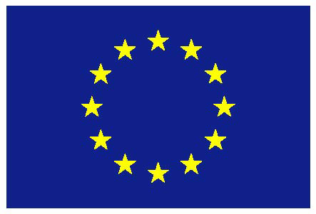

European Union

UNITED NATIONS HUMAN RIGHTS COUNCIL
Forum on Business and Human Rights
(3-4 December 2013)

Geneva, 3 December 2013

- CHECK AGAINST DELIVERY –

UNITED NATIONS
HUMAN RIGHTS COUNCIL
Forum on Business and Human Rights
(3-4 December 2013)

Mr Chair,
On behalf of the European Union, I wish to thank the Working Group for the organization of this second Forum on Business and Human Rights, and the Office of the High Commissioner for Human Rights for its support. We would also like to thank the core group, Argentina, Ghana, India, Norway and the Russian Federation, for their continuing efforts to drive the process on business and human rights in the Human Rights Council.

Since the adoption of the UN Guiding Principles on Business and Human Rights two and a half years ago, a lot of progress has been achieved: more and more states are taking action to promote the Guiding Principles and we have also seen important leadership by some companies. Still, the global implementation remains a challenge. It requires the commitment of all actors, in particular regional bodies, such as the European Union.

The EU remains fully committed to the Guiding Principles, as emphasised in the European Commission’s current strategy on Corporate Social Responsibility. The EU believes that governments have an important role to play as they are first and foremost responsible for the protection of human rights by law and in practice. Businesses, on the other hand, should carefully consider their impacts on society and a) plan and carry out operations in compliance with legal frameworks and b) integrate environmental, social, ethical, human rights and consumer concerns into their business strategies and operations.

The EU is dedicated to a two-pronged approach: first, to ensure that the Guiding Principles are fully understood and adhered to at European Union level; and second, to promote their implementation through its external actions.

At EU level, the EU and its Member States have taken tangible steps towards the adoption of national plans on the Guiding Principles. The United Kingdom was first to launch an action plan on business and human rights and a large number of EU member states intend to have an action plan in due course.

As part of the duty to protect, the European Commission has further developed guidance material to enterprises on meeting the corporate responsibility to protect. This includes our guidance material for three industry sectors, namely ICT, oil and gas and employment and recruitment agencies, as well as our guide for small and medium-sized enterprises.

For the EU’s external activities, our objective is to promote a global level playing field on business and human rights. This is why our guiding material is of global applicability and of relevance to companies operating inside and outside the EU. Further, the EU has included in recent Free Trade Agreements references to the promotion of Corporate Social Responsibility and intends to pursue a similar approach in ongoing and planned trade negotiations, including those for stand-alone investment agreements. The Guiding Principles further feature regularly on the diplomatic agenda as part of our political dialogues with third countries.

A further important element is that the European institutions ensure policy coherence of EU policies, which are of relevance to business and human rights. This includes in particular specific human rights and labour issues, such as child labour, forced labour, human trafficking, gender equality, non-discrimination, freedom of association and the right of collective bargaining etc. We are confident that the enhanced implementation of the UN Guiding Principles will also contribute to achieving these EU objectives.

We would also like to stress the importance of a multi-stakeholder approach in the implementation of the UN Guiding Principles, which should involve the private sector, social partners and civil society representatives. EU Delegations in third countries can play an important role in this process.
A lot has been done, but still we are only at the beginning of the implementation of the Guiding Principles. In the end, our success will be measured against the capacity to prevent human rights violations and to ensure effective access to remedy when such violations occur. The European Union remains strongly committed to these goals.
I thank you Mr. Chair.

