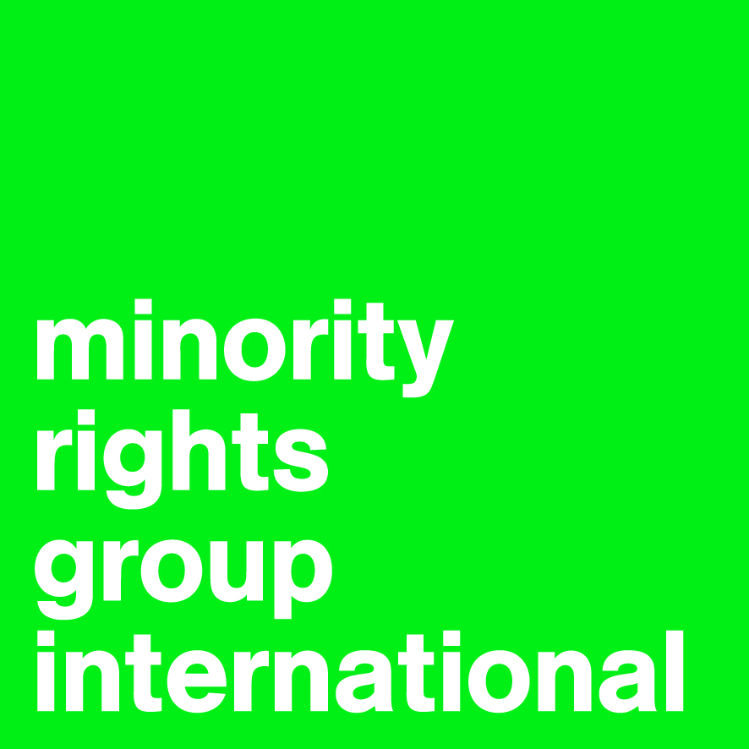
OHCHR report on best practices on birth registration,
particularly for those children most at risk
Contribution of Minority Rights Group International (MRG)
October 2017
- Introduction.
Minority Rights Group International (MRG) has been working for many years with ethnic minorities and indigenous communities, as well as with migrants, asylum seekers, and refugees across the world to secure their rights. Having consultative status with the United Nations Economic and Social Council (ECOSOC), MRG has worked with communities to document abuses, train lawyers and human rights defenders, undertake advocacy work and strategic litigation at the national, regional and international levels.
Through this contribution, MRG would like to share with the High Commissioner for Human Rights its experience and analysis on the importance of birth registration for minorities and indigenous peoples as well as the adverse consequences of failure to register births, particularly in the context of minority and indigenous statelessness.
Rising population mobility increases the importance of adequate and efficient civil registration systems. MRG has evidence to suggest that minorities and indigenous peoples are particularly vulnerable to non-registration and face specific barriers to registration. This is particularly true where ethnic minorities and indigenous communities live in remote/border areas, are nomadic, migrate internally or internationally, seek asylum or are refugees, or live in an area marked by a situation of armed conflict or by a natural disaster. For example, almost 80% of children under five of the majority population in the Central African Republic are registered, but less than 50% Sara minority children hold birth certificates. Registration systems may directly or indirectly discriminate against minorities and indigenous peoples e.g. by setting onerous requirements for documents for registration that they are less likely to be able to satisfy.
MRG has identified various general strategies on combatting this precarious situation. They include the clear acknowledgement of discriminatory practices and policies, at the state level as well as amongst civil society and the international community; the use of disaggregated data to map out and capture information on unregistered groups of people, and to integrate the results in process design and improvements; and the application of tailored programmes of engagement, mobilizing affected people and making their situation visible to fellow citizens and policy makers.
In the following, MRG identifies a series of problems that prevent many minority or indigenous communities from registering their children, and outlines possible strategies to counteract these by giving examples of good practices. Some of the examples of good practices relate to good practices established to ensure a good inclusion of minorities and indigenous peoples in the domains of naturalization, civil registration and efforts to address statelessness and lack of documentation. They are mentioned here as they can be applied in a birth registration context.
- Obstacles to birth registration and solutions, as well as good practices as identified by MRG.
Obstacles to  Birth Registration |  | Solutions | Examples (e.g.) and  Good Practices (GP) | Sources
- In some states, onerous requirements for documents to register a child’s birth often provide an insurmountable hurdle to parents. This impacts on minorities and indigenous peoples as earlier generations are less likely to have been registered and they are less likely to have detailed paper records of employment, residence, land etc. |  | - Simplify administrative processes and eliminate onerous requirements like provision of the parents’ birth certificates.  - Determine a fixed procedure needed to register a birth which is applied to all with no “ethnic profiling” or similar practice.  - Shift responsibility of provision of documentary evidence to administrative staff.  - Enable easier access to foreign data bases.  - Provide appropriately trained officials, legal representatives, interviewers, and interpreters that are aware of non-discrimination laws as well as cultural and religious sensitivities or factors like age, gender, and education.  - Accept the use of witnesses and testimonies instead of documentary evidence.  - States should consult with minority communities and indigenous peoples about the best ways to conduct birth registration. For example, mutually coordinated registration processes could enhance gender sensitive behaviour in the context of religious minorities or create time and location overlaps with the routes of nomadic peoples. | E.g. 1.1. Despite the legal entitlement of every child to be registered at birth, refugee parents in Germany continue to encounter difficulties in doing so. Failure to provide valid identification documents of the parents may lead to refusal of the official in charge to register a child.  GP 1.2.+1.3.+1.4. Moldova: Chapter X of the ‘Law on the Regime of Foreigners’ establishes a ‘statelessness determination procedure’ under which it is the examiner’s responsibility to acquire missing information and liaise with foreign authorities.  GP 1.5. Kyrgyzstan: mobile units have been established to offer free legal assistance to some members of the Mugat (Lyuli) community in Kyrgyzstan living in remote areas.  GP 1.6. Vietnam: The naturalization process allows Cambodian refugees to replace birth certificates by sworn testimonies about their date and place of birth. This approach could also be used in birth registration.  GP. 1.7. Syria: UNHCR has worked with internally displaced persons (IDPs) and has provided legal support to 27,414 IDPs across 10 governorates, mainly for receipt and replacement of birth certificates and marriage certificates. | Ad. 1.1. Hans, Barbara (2005), Country of nameless children. Der Spiegel Online. Source in German language.  Ad. 1.2.+1.3.+1.4.+1.5. Cantin, Heather (ed.) (2017), Handbook on Statelessness in the OSCE Area. International Standards and Good Practices. OSCE/ UNHCR, Feb. 2017.  Ad. 1.6. UNHCR (2015). Good Practices Paper - Action 1: Resolving Existing Major Situations of Statelessness.  Ad. 1.7. UNHCR (2016), In Search of Solutions: Addressing Statelessness in the Middle East and North Africa.
- Geographical distance from registration centres may keep remote communities from obtaining official birth certificates. This also affects nomadic or semi-nomadic populations. Minorities and indigenous peoples may have lower access to technology in some cases. Resorting to information and communication technologies can provide technical solutions but it does not automatically address the issue of disparities and discrimination in access to services and it may even exacerbate these problems. |  | - Allow extended registration deadlines.  - Permit and facilitate late registration processes.  - Establish mobile registration units equipped with appropriately trained staff.  - Increased use of technology. For example, use of mobile phones when transmitting information on events like birth. | E.g.. 2.1. Registration deadlines to register for free or for lower fares vary greatly: while a lower fee applies for Kenya for three months, in Rwanda, parents face a penalty fee of Rwf 2,000 (US$ 2,40) if they fail to register their child within 15 to max. 30 days. Extensions would be advantageous to everyone.  GP. 2.2.+2.3. Brazil: Mobile civil registrars travel to remote communities in the North East on large buses equipped with the informatics services necessary to provide people with documents.  GP. 2.4. Tanzania: The country’s second largest mobile services provider cooperated with government, enabling mobile registrar units to collect and store information of birth registration online via an app. | Ad. 2.1. Civil Registration Department of Kenya (2014). Information.  Rwirahira Rodrigues (2013), Rwandan Bill seeks to improve registration of births. Fri 12.2013.  Ad. 2.2.+2.3. Wendy Hunter & Natasha Borges Sugiyama (2017): Making the Newest Citizens: Achieving Universal Birth Registration in Contemporary Brazil, The Journal of Development Studies.  Ad. 2.4. GSMA (2016), Birth Registration in Tanzania: Tigo’s support of the new mobile birth registration system. July 22.
 | In some states, there can be dispute or confusion about the nationality of unregistered persons living in border areas. This can impede registrations where registration is linked to citizenship. This can especially affect nomadic or semi-nomadic populations. | - Simplify administrative processes.  - Accept the use of witnesses and testimonies instead of documentary evidence.  - Determine a fixed procedure for documentation needed to register a birth which is applied to all with no “ethnic profiling” or similar. | GP. 3.1+3.2. The Tuareg who live in the Libyan-Algerian-Malian-Nigerien borderland can obtain citizenship of these countries by providing witnesses who testify about their origin and family ties. | Ad. 3.1+3.2. Delphine Perrin (2014), Tuaregs and Citizenship: ‘The Last Camp of Nomadism’. Middle East Law and Governance , Brill, Migration, Mobility and Citizenship, 6 (3), pp.296-326.
- In some states, registration requires parents to possess valid IDs: Children of stateless or unregistered parents will not be registered. This impacts on minorities and indigenous peoples as minorities are disproportionately affected by statelessness and lack of registration, from generations to generations. |  | - Allow special procedures for registration of births for those whose parents do not have full ID documents  - Train midwives, community health workers and traditional birth attendants as ‘notifiers’ who can issue ‘birth notifications’ as a first step towards an official birth certificate.  - Accept the use of witnesses and testimonies instead of documentary evidence for those who may not have ID, and in late registration processes. | E.g. 4. Indigenous Australians struggle to give sufficient evidence in documents to register their children. Often, parents fail to provide the required documents as they cannot obtain them without having a birth certificate themselves (which many of them do not possess).  GP. 4.1 and 4.2. In the Dadaab camps in Kenya, midwives and medical officers submit birth notifications to UNHCR within 72 hours of a child’s birth. Moreover, midwives monitor the current data on the number of newborns in the area. | Ad. 4. Calabrò, Alainnah (2015), Proof of Birth.  Ad. 4.1. Plan International (2014): Birth registration in emergencies: a review of best practices in humanitarian action.
- In some states, children born out of wedlock will not be registered. This has an impact on certain religious minorities as children of parents whose “traditional wedding” is not officially accepted face difficulties in the registration processes. Further, collective family child-raising or individuals being called by different names in different contexts amongst indigenous peoples causes problems in identification procedures. |  | - Accept the use of witnesses and testimonies instead of documentary evidence.  - Legalise “traditional marriages” through ‘mobile legal identity service’.  - Coordinate with local initiatives/ NGOs who have expertise on the local circumstances.  - Make late registration of births and marriages possible without penalty. | E.g. 5. Despite the elimination of the requirement of the marriage certificates of the parents to register a birth, in practice, children in Indonesia will often not be registered if born out of wedlock.  GP. 5.2.+5.3. Indonesia: The Religious Courts, Office of Religious Affairs and Civil Registry Office together with other key stakeholders, came up with a mobile legal identity service offered at the community level which declared marriages official. However, there were reports that roll out/acceptance of this by officials remains problematic in some places. | Ad. 5.1. Jessica Ball, Leslie Butt & Harriot Beazley (2017) Birth Registration and Protection for Children of Transnational Labor Migrants in Indonesia, Journal of Immigrant & Refugee Studies, 15:3, 305-325.  Ad. 5.2. Plan International (2017) Innovations in Birth Registration.
- Parents may distrust state agents, fear ethnic, cultural or religious discrimination or persecution during civil conflicts. Hence, they sometimes wilfully refrain from registering their child. Furthermore, staff at registration offices may indeed discriminate against minority communities |  | - Where a civil conflict exists, consider utilising IGOs or NGOs as part of the registration process as an interim measure/neutral third party.  - Establish clear protocols for the type of information that can be stored, how it can be used and by whom, ensure these standards are adhered to and implemented, and effectively hold accountable agents for violations of these standards. | GP. 6.1. – see 4.1. Dadaab camps in Kenya.
- The necessity and long-term benefits of birth registration often remain unknown to minority and indigenous parents and caregivers. This lack of awareness leads to low registration rates. |  | - Ensure that information about benefits of registration is disseminated in all local languages and via relevant media e.g. on local language radio stations, especially where significant illiteracy exists.  - Train midwives, community health workers and traditional birth attendants to explain the benefits of birth registration and to expand the reach of registration in remote or conflict areas.  - Provide appropriately trained officials, legal representatives, interviewers, and interpreters that are aware of non-discrimination laws as well as cultural and religious sensitivities or factors like age, gender, and education.  - Establish mobile registration units equipped with appropriately trained staff.  - Combine birth registration with other social services like education and health services. This helps to identify unregistered children and demonstrates the benefits of being registered (e.g. school enrolment while being registered). | GP. 7.2. – see 4.1. Kenya: Midwives in Dadaab camps.  GP. 7.3. – see 1.5. Kyrgyzstan: mobile units reaching out to Mugat (Lyuli) community.  GPs. 7.4. (1) Tamil people in Sri Lanka: 2007 initiative from the Government of Sri Lanka and UNDP’s Access to Justice Project that aims at providing nationality and other civil-registration documents through mobile clinics.  OR – (2) IDPs in Colombia: Plan Colombia and UNHCR’s mobile civil registration units serving remote communities targeting ethnic minority groups and unregistered people, displaced by armed conflict.  OR – (3) see Ad.2.2.+2.3. Brazil: Mobile civil registrars.  GP. 7.6. Sudan: WHO, UNICEF and Plan Sudan integrated birth registration with vaccination campaigns currently implemented by the Ministry of Health’s Expanded Programme on Immunisation in Sudan. This enabled civil registrars to access high-risk conflict-affected areas, remote rural communities, IDPs and nomadic groups in order to increase the level of birth registration among children in these communities. | Ad. 7.4. (1) UNHCR (2015). Good Practices Paper - Action 1: Resolving Existing Major Situations of Statelessness.  Ad. 7.4. (2) + 7.6. Plan International (2014): Birth registration in emergencies: a review of best practices in humanitarian action.
- Crucial documents held by individuals required for proof of birth and/ or nationality might have been destroyed by natural disaster, or were lost or left behind in hazardous situations. Minorities are disproportionately affected by such situations. |  | - Mobile units to assess situation and re-issue certificates after natural disasters, internal displacement or cross-border migration.  - Encourage individuals to keep soft/ virtual copies of registration records in high risk areas.  - Usage of enhanced biometric technology, following best practice regarding data usage and accompanied by efforts to build trust with communities, providing the technology reaches to the whole population, in its diversity, including people in remote areas. | GP. 8.1. Burkina Faso: after floods in Ouagadougou, mobile units (consisting of a ministry senior official trained in and familiar with official registration procedures, a legal representative, and three to four local officials) stayed in affected district for two to three days processing and verifying given data. | Ad. 8.1. Plan International (2014): Birth registration in emergencies: a review of best practices in humanitarian action.
- Registration offices’ records are vulnerable to destruction in conflicts. |  | - Digitise all records and use highly secure online databases or servers in a cloud to keep copies of information  - Establish clear protocols for type and use of information stored and ensure adhered to and prosecute violations effectively. – see 7.2. | E.g. 9. It is not uncommon that in the framework of armed conflicts, documents and storages are being targeted by parties to the conflict (e.g. Guatemala, Uganda…) | Ad. 9. UNHCR (2007) Innocenti Insight: Birth Registration And Armed Conflict.
- When things go wrong, people belonging to minorities and/or indigenous peoples are less likely to challenge this effectively. This may be due to a lack of sense of entitlement, to a lack of awareness of their rights and legal processes, to a lack of access to information and quality advice, language problems and/or illiteracy in some cases. |  | - Work with communities on sense of entitlement and empowerment.  - Provide appropriately trained officials, legal representatives, interviewers, and interpreters that are aware of non-discrimination standards as well as cultural and religious sensitivities or factors like age, gender, and education. | GP. 10.1.+10.2. Bangladesh: Paralegals support Urdu-speaker communities in Bangladesh in acquiring vital documents, including birth certificates.  GP. 10.2. – see 1.5. Kyrgyzstan: mobile units reaching out to Mugat (Lyuli) community. | Ad. 10.1.+10.2. NAMATI, (2017), Birth Certificates in Bangladesh: Ruma’s Story, February 28, 2017.
- As minority groups are disproportionately affected by situations of poverty, the costs of registering their children may keep them from doing so. |  | - Eliminate the costs for birth registration if not for all, at least for individuals/families in situation of poverty | GP. 11.1. (1) – see 2.4. Tanzania: a mobile unit project was put in place to reach out to rural areas. One of its first measures was to abolish the registration fee of TSH 3,500 (US$ 1.60).  (2) Australia, Victoria: The Koori Access Fund has been established by the government to waive standard fees (AUS$ 32) for birth certificates for the indigenous Koori people if they show official proof of their Aboriginal descent and low income. | Ad. 11.1. (2) State of Victoria (2017), Koori Services: Culturally-sensitive services.

UNICEF (2013) Every Child’s Birth Right: Inequities and trends in birth registration
Some of the examples of good practices relate to good practices established to ensure a good inclusion of minorities and indigenous peoples in the domains of naturalization, civil registration and efforts to address statelessness and lack of documentation. They are mentioned here as they can be applied in a birth registration context.

