Input to the OHCHR’s report for the Human Rights Council on the theme "Empowering children with disabilities for the enjoyment of their human rights, including through inclusive education", Human Rights Council resolution 37/20
10 October 2018
The European Union Agency for Fundamental Rights (FRA) is an advisory body of the European Union. The FRA helps to ensure that fundamental rights of people living in the EU are protected. It does this by collecting evidence about the situation of fundamental rights across the EU and providing advice, based on evidence, about how to improve the situation.
The information compiled in this document is based on FRA’s report “Violence against children with disabilities: legislation, policies and programmes in the EU”, published in 2015. The study is based on desk research in 28 EU Member States and interviews with stakeholders in 13 Member States.
FRA’s desk research identified examples of measures adopted by Member States to prevent violence against children with disabilities. These address four different groups: stakeholders in general, children, families and communities, and professionals and institutions. Respondents stressed the need for a holistic approach entailing cross-cutting measures and services that include and cater to the needs of all children, including those with disabilities. This input present only a selection of the informacion contained in the report. For further information please visit: http://fra.europa.eu/en/publication/2015/children-disabilities-violence

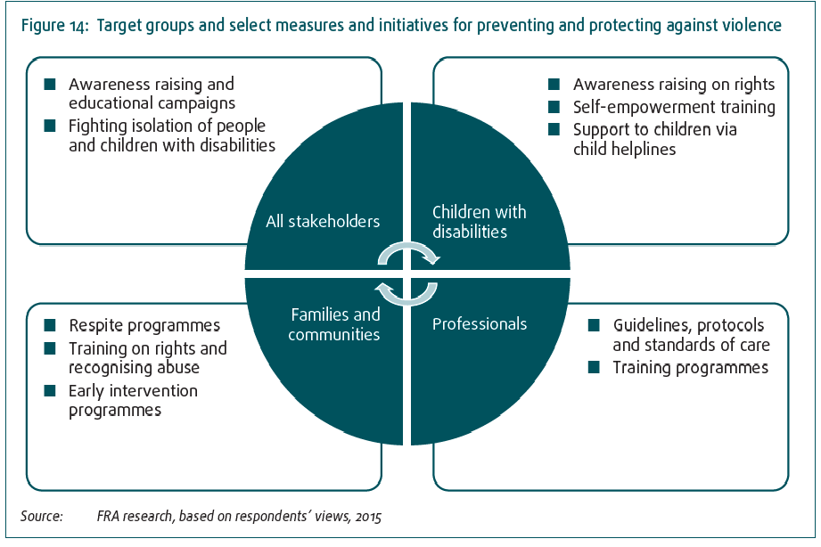

1/b. Please identify specific measures or actions being taken to empower children with disabilities in education settings, particularly children with disabilities with psychosocial and intellectual impairments.
Name | Description | Reference and link
Emma Untouchable! | In the context of the government‑funded programme ‘Abuse, neglect and violence in childhood and adolescence’ (Forschungsförderung: Missbrauch, Vernachlässigung und Gewalt in Kindheit und Jugend), the University of Rostock, in cooperation with the NGO Wildwasser München e.V., developed a training programme aimed at enabling  girls with intellectual disabilities to recognise sexual abuse, avoid or leave potentially dangerous situations, and get help. | Germany, Clinic for Psychiatry,  Neurology, Psychosomatics and  Psychotherapy in Children and  Adolescents, University of  Rostock (Klinik für Psychiatrie,  Neurologie, Psychosomatik und  Psychotherapie im Kindes- und  Jugendalter der  Universitätsmedizin Rostock),  https://emma-unantastbar.med.uni-rostock.de/
My body is my own (Enyém a testem) | The project, developed by the Hand in Hand Foundation, a Hungarian NGO, consists of a sex education and self-defence training programme for adults and children with intellectual disabilities, aimed at developing their capacity to recognise risky situations. It is accredited as a professional development programme and has already trained over 100 adults and children with disabilities. | Hungary, Hand in Hand Foundation (Kézenfogva Alapítvány), see: http://www.kezenfogva.hu/
Stay Safe’ –  personal  safety skills  programme | The Stay Safe Programme is a personal safety skills programme for  primary schools – both mainstream and specialised. Its overall objective  is to prevent child abuse, bullying and other forms of victimisation.  The programme teaches children how to recognise an unsafe situation  and inform adults when one arises. There is a specific programme  targeted at children with a disability (six‑to-13 year old age group),  divided in five categories aimed at children with: visual impairments,  physical disabilities, hearing impairments, intellectual disabilities,  and psychosocial disabilities (emotional and behavioural difficulties). | Ireland, ‘Stay Safe’ programme, http://www.staysafe.ie/ .
Friendly School (Draudzīga skola) and Friendly House (Draudzīga māja). | In 2010, the State Inspectorate for Protection of Children’s Rights started two initiatives with the involvement of NGOs  (Friendly School and Friendly House). Both initiatives aimed to improve relations between pupils and teachers and children placed in institutional care and their educators, and to reduce physical and emotional violence and promote tolerance. Both initiatives were a follow‑up to the project “Family Friendly School”, launched by the Ministry for Children and Family Affairs of the Republic of Latvia in 2005. | Latvia, The State  Inspectorate for Protection  of Children’s Rights (Valsts  bērnu tiesību aizsradzības  inspekcija), http://www.bti.gov.lv/lat/draudziga_skola/

2) Please identify laws, policies and good practices aimed at the inclusion and empowerment of children with disabilities, including through:
a. Awareness-raising and capacity building on the human rights of children with disabilities, both broadly to the general population and their families, and to children with disabilities themselves.
Name | Description | Reference and link
#be the change!  –campaign to  end abusive language | ‘Enable Scotlandʼ runs a campaign challenging negative attitudes and tackling offensive language about people with intellectual disabilities (learning disabilities). The campaign has two main elements – a school resource for teachers of 11–14 year old pupils across Scotland, which will raise awareness of intellectual disability, taking an early intervention approach to promoting positive attitudes; and a public awareness campaign that will tackle the use of abusive language. As part of the public campaign, adverts have been placed on various websites and in public spaces (metro, trains and buses). | Scotland, ENABLE, Campaign #be the change, see:  https://www.enable.org.uk/
Tackling stereotypes and prejudice against people with disabilities in schools | The Slovenian DPO ‘Association for the Theory and Culture of Handicap’ carried out an awareness-raising campaign in schools and kindergartens, promoting diversity and mutual respect from early age and countering stereotypes and prejudice against people with disabilities.  Trainers with disabilities carried out workshops, drawing on their personal experiences with discrimination, stereotypes and prejudice. In their evaluations, teachers indicated that, for many of the children, this was their first contact with a person with disability and noted that such activities foster understanding of disability. | Slovenia, Association for the Theory and Culture of Handicap (Društvo za teroijo in kulturo hendikepa), campaign ‘Botonček’ (Bontonček), see:  http://www.yhd-drustvo.si/bontoncek-166.html
Disability matters. E-learning to inform and inspire | A free e-learning resource for UK professionals. The programme is designed to support organisations, their workers and volunteers across all sectors in developing the communication and problem-solving skills required to engage confidently with disabled children and young people. | United Kingdom, Disability Matters, see  https://www.disabilitymatters.org.uk/
Training opportunities for peer supporters with intellectual disabilities (TOPSIDE) | The training, developed for and by people with intellectual disabilities, aims to teach people with intellectual disabilities how to be peer supporters.  The training materials are targeted at NGOs, associations, training centres and educational providers that want to support active citizens with intellectual disabilities. | Inclusion Europe, see: http://www.inclusion-europe.com/topside/index.php
Rock and Water and children with autism (Rots&Water en kinderen met autismespectrumstoornissen) | ‘Rock and Water and children with autismʼ provides psycho-physical social competency training for children with autism. Its objective is to increase their social competence and ability to deal with bullying and violence. The programme was developed in the Netherlands but is now widely used. 35,000 teachers in 14 countries worldwide have trained approximately two million children and students in different countries. The initial ‘Rock and Waterʼ training has been subject of an evaluation study, which concluded that the programme has positive effects. | Netherlands, Gadaku Institute / Rots & Water Instituut, Rock and Water and children with autism, see: https://www.rockandwaterprogram.com/

b. Ensuring close consultation with and active involvement of children with disabilities in decision-making processes affecting them.
Name | Description | Reference and link
Users’ Involvement in the Decision-Making Process – a Step Towards Complete Social Integration | In Bulgaria, the Cedar Foundation user involvement project focused on empowering children and young adults with intellectual disabilities to make their own decisions and to participate in decision-making. The project was implemented in partnership with the Kyustendil Municipality and Learning Disability Wales, and realised with the financial support of the European Social Fund.  The main aim of the project was to train professionals and exchange good practices. Municipal officers and social workers from Kyustendil visited Learning Disability Wales in Cardiff and learned about policies and methods that Welsh agencies and social service providers use to ensure that the opinions of people with learning disabilities are taken into consideration in all aspects of their lives. | Bulgaria, Cedar Foundation, more information in English at  http://www.cedarfoundation.org/en/  and in their annual report.

5) Please identify relevant independent accountability mechanisms to monitor the situation of children with disabilities and their access to essential services, including to inclusive education in the general system without discrimination.
Name | Description | Reference and link
National System for Early Intervention (Sistema Nacional de Intervenção Precoce) | National System for Early Intervention was established as a result of cooperation between social security professionals, education and health representatives. The system aims to provide integrated support to children with intellectual disabilities (0–6 years) and sets out, among others, the following objectives: early intervention; preventing and reducing risk; supporting families in accessing services and resources of social security systems, health and education; and involving the community. | Portugal, National System for Early Intervention (Sistema Nacional de Intervenção Precoce), see:  https://www.dgs.pt/ms/12/default.aspx?id=5525
Personal Coordinator (Personlig koordinator) | The ‘Personal Coordinatorʼ is a project initiated by Bräcke Diakonia in Gothenburg in cooperation with the Swedish National Association for Disabled Children and Young People. It aims to coordinate services for families with children with physical or multiple disabilities who are heavily burdened with child care. The project is financed by the Swedish Inheritance Fund Commission (Allmänna Arvsfonden), and was in trial phase until 2014. It was established in response to a report on the public authorities’ coordination of assistance to children and young people with disabilities. The report showed that societal support for parents with children with disabilities involves several stakeholders, but that nobody had the mandate of coordinating the available support. | Sweden, Bräcke Diakonia Gothenburg, see:  https://www.brackediakoni.se/personlig-koordinator

