28th Session of the Human Rights Council
Panel Discussions on Human Rights and Climate Change
Climate Change and the Right to Food FAO’s intervention at the Human Rights Council

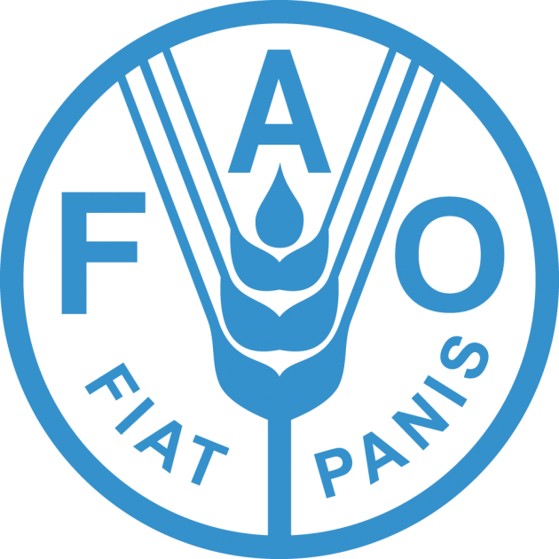

Statement delivered by Ms. Xiangjun YAO, Director, FAO Liaison Office in Geneva
6 March 2015

Your Excellency Mr. President,
Dear Panelists,
Mr. Knox, Ms. Robinson
Excellences,
Ladies and Gentlemen,

First of all, I would like to thank you for the invitation to participate in this Panel discussion. It is an honor to discuss such a relevant and topical subject with you.

Most of the elements for the realization of the right to adequate food are directly or indirectly affected by climate change, and I am confident that our discussions today are of the outmost importance to better understand this issue and think of actions to be taken by the International Community to progressively realize the right to food in perspectives of climate change.

We live in a world that still has more than 800 million people suffering from hunger and 2 billion people affected by the diverse forms of malnutrition. Moreover, estimates indicate that 60% increase in production will be required to feed nine billion people by 2050.

Especially considering the disproportionately adverse impacts of climate change, this is an issue that might become even more challenging to overcome: livelihoods are endangered, natural resources for agriculture production are reducing and degrading physical access to food is hampered, while food prices rise and are volatile time after time.

***

Despite the difficult road ahead, some lessons are learned and innovative practices have been developed and implemented over the past years which could help in addressing these adversities.

When analyzing, for instance, how countries have succeeded in achieving the Hunger Target of the Millennium Development Goal 1, we learned that four key areas of intervention should be prioritized, which are: emphasis on nutrition and education; social protection; equitable access to resources and assets; and awareness-raising.

Moreover, we have realized the importance of strengthening comprehensive, nationally owned and context-sensitive social protection systems that embrace a “twin-track” strategy that will impact food and nutrition security as well as resilience. This includes:

- The provision of essential assistance in the short-term while simultaneously protecting or building productive assets and infrastructure that support livelihoods and development in the long-term;
- Fostering integrated programmes which directly support livelihoods and productivity, particularly smallholder farmers and small-scale food producers;
- The establishment of strong linkages amongst sectors such as education, health and agriculture to ensure decent employment and social welfare, including enhancing men and women access to markets and financial services.

We could give many examples of actions which are already being undertaken.

In the Northeast of Brazil, for instance, the Garantia-Safra program support farmers in case of drought;

India with its National Rural Employment Guarantee Act that provides social protection entitlements;

Ethiopia with the Productive Safety Net Programme;

Kenya through the rights-based Hunger Safety Net Programme;

Samoa and its consensus approach under its National Adaptation Programme of Action, and many others.

***

Looking ahead, it is crucial that future measures are adapted to the situation and conditions of those most affected by climate change. Solutions require an integrated approach, developed with the involvement of all stakeholders. One of the priorities, for instance, is the strengthening of mechanisms that enable communities to provide their knowledges and inputs, so as to facilitate inclusive decision making, monitoring and accountability processes.

At the International Forum on Agriculture and Climate Change in February, FAO’s Director General noted promising new approaches, such as climate-smart agriculture, which is the adjustment of farming practices to make them more adaptive to environmental pressure, while at the same time decreasing farming own impacts on the environment. For this, a Global Alliance on Climate-Smart Agriculture was created, a broad coalition of stakeholders – ranging from civil society organizations to governments to the private sector - established last September by the UN General Assembly. The Alliance is working to promote sustainable and equitable increases in agricultural productivity and incomes, build resilience of food systems and farming livelihoods, and achieve reductions or removals of greenhouse gas emissions by agriculture.

Additionally, the international community, notably under the auspice of the Committee on World Food Security, has developed several important tools that propose ways to realize the right to adequate food amid the impacts of climate change. As such, it is important to promptly work in the implementation of consensually adopted documents such as the Right to Food Guidelines, the Voluntary Guidelines on the governance of tenure, and the Principles for Responsible Investment in Agriculture and Food Systems, among others, which all provide human rights-based guidance for actions to achieve the right to food.

In conclusion, the important challenge we face cannot be ignored or postponed any longer; it has to be tackled proactively as evidence keeps mounting on the adverse impacts of climate change on the realization of the right to adequate food. Therefore, a strong commitment has to be made in the post-2015 development agenda so as to ensure that the proper attention is given to empowering key actors, especially women who represent half of the world population and play a crucial role in ensuring the right to adequate food, so as to guarantee that every human being enjoys its fundamental human rights. Only then, with the most vulnerable and affected by climate change and food insecurity central to any policy process put forth, will a solution be possible and sustainable.

