Annex 1 – ICOMOS and COVID-19: Heritage as a cornerstone of human, social and economic recovery Statement by Toshiyuki Kono, President of ICOMOS and Mikel Landa, President of the ICOMOS Advisory Committee, May 4th 2020

ICOMOS and COVID-19: Heritage as a cornerstone of human, social and economic recovery

Written on 04 May 2020.
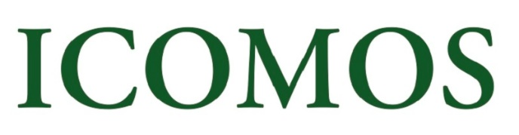
Among the mass of information circulating concerning COVID-19, one hopeful message issued by credible medical publications is that an effective vaccine could probably be developed within the next 18 months. This would be the shortest development period for a vaccine in human history. Nevertheless, 18 months is still a very long way to go - a marathon race with the zero-infections stage as its finish line. To make this race sustainable, some countries are already relaxing the restrictions they have imposed and gradually allowing economic activities to resume, while others will have to maintain or introduce strict measures.
The International Monetary Fund (IMF) predicts a V-shaped recovery with a rapid return to growth in 2021 following a sharp drop of global GDP in 2020, while a number of economists make more pessimistic forecasts. The IMF scenario may change, if a second wave of infections arrives or the availability of a vaccine is delayed.
In order to overcome what is expected to be the deepest recession since the Great Depression, unprecedented economic stimulus packages are being rolled out in rich countries. On the other hand, many developing countries will need international assistance.
However, the challenges of recovery are not only economic, but also human and social. The importance of social justice will be re-visited and re-evaluated at many levels, also nationally and internationally, and it will be a central issue in the process of recovery and the post-COVID world.
ICOMOS believes that heritage is not only a driver of sustainable development, but also a cornerstone of human and social recovery following disasters, and our organization intends to make its contribution during and after this pandemic. We live in a world of unparalleled, unpredictable and complex circumstances. A one-size-fits-all approach will not work nor will one-off measures suffice in overcoming the impacts of COVID-19. ICOMOS’ is therefore planning two major activities – with a long term perspective:
First, knowing that recovery will be long and will take various forms, ICOMOS through its global networks, Committees and Working Groups and calling on its diverse expertise, will monitor and assess developments and measures taken across countries for at least the coming three years, from the viewpoint of heritage conservation. ICOMOS will publish annually a published on the recovery from the pandemic, covering both pre-vaccine- and post-vaccine phases, and offer a solid basis for policy recommendations.
Second, ICOMOS believes in the power of place. Being in a historic building or at a significant site is a fundamentally different experience from seeing pictures on a screen. Whilst human values may gain new attention, the importance of heritage may not be recognized by governments in the same manner as before, as they will be overwhelmed by the pressures of the recovery process and competing priorities. ICOMOS must be proactive in ensuring that the policies and measures relevant to heritage that are implemented to mitigate the impacts of the pandemic are well balanced - for instance, that economic stimulus packages take into account the significant role that can be played by heritage and conservation. Such measures, will not only protect heritage, but also the communities that are linked to it. In this context, ICOMOS is launching a series of webinars, covering diverse aspects and issues related to heritage conservation, including impacts of the pandemic, with sessions aimed both at heritage professionals and the wider public.
Finally, how this pandemic affects ICOMOS as an organization, needs to be carefully monitored beyond 2020. The cancellation of the GA 2020 in Sydney is a deeply felt first consequence, and we are moving to adapt the format of our customary events, making better use of digital tools.
ICOMOS believes that our actions today shape our tomorrow.
We thank you for your continued support which is highly appreciated.
Please be safe!
Toshiyuki Kono, President of ICOMOS
Mikel Landa, President of the ICOMOS Advisory Committee

