Music and solidarity as a collective response to COVID-19 launched by Minority Rights Defenders and artists

“When The World Pauses, Music And Dance Continue” - this motto of the campaign launched by the OHCHR Former Minority Fellow Mostafa Betaree and his colleagues from the Netherlands-based NGO Spotlight Team International Art (STIA) which unites artists from different backgrounds and regions of the world. The campaign is supported by the Informal network of OHCHR Minority Fellows and encourages artists from different communities to celebrate solidarity and human connection through art.

As part of the campaign, artists are welcome to submit a video with their performance (song, dance, poetry, etc) which is later shared through the social media channels of the STIA and OHCHR Minority Fellows under the hashtags #StandUp4HumanRights and #WhenTheWorldPausesMusic AndDanceContinue. Artists are also encouraged to share a message about their creative process through the text which is also shared as part of the campaign. The organizers hope to reunite with all participants for a concert in the Netherlands once the COVID-19 crisis is over.

Meanwhile the campaign showcased artistic submissions from the Former OHCHR Minority Fellows representing Roma (Argentina/Brasil), African American (the USA), Amazigh (Algeria) and Vlach (Macedonia) minority communities and artists from Germany, Iran, the Netherlands, Italy, Syria, Moldova and Denmark, including artists with minority and refugee backgrounds.

The artistic submissions showcased in the framework of the campaign can be accessed on the Facebook and Instagram pages of the Spotlight Team International Art https://www.facebook.com/Spotlight.Te/ and Facebook page of the OHCHR Minority Fellows https://www.facebook.com/OHCHRMF/.

We encourage artists with diverse backgrounds from all around the world to submit their art works (songs, performances, dance, etc.) to the info@teamspotlight.org. The Spotlight Team together with Informal network of OHCHR Minority Fellows will promote it through our social media channels and we also hope to reunite with all participants for a concert in the Netherlands.

Some examples of the artistic submissions:
- https://www.facebook.com/OHCHRMF/videos/202126384439406/ Traditional Amazigh song by Former OHCHR Minority Fellow Aissa from Algeria
- https://www.facebook.com/OHCHRMF/videos/300188854452055/ Song in Vlach language by Macedonian band “Bona Dea”
- https://www.facebook.com/Spotlight.Te/videos/2677933489131726/ Song on the Romani language performed by Argentine-Brazilian artistic project Kalo Chiriklo
- https://www.facebook.com/Spotlight.Te/videos/559822528045428/ Poem in the Gagauzian language (the language is included in the UNESCO atlas of the World's Languages in Danger) about the mother tongue written and read by Nadejda Manastirli from Moldova
- https://www.facebook.com/OHCHRMF/videos/281593653079194/ Dance performance by the Urban Stomp - an interactive arts-education project from the USA which is centered on hybrid West-Central African traditions, mambo, salsa, and swing includes artistic elements that span the globe.

Below you can find some of the posters revealing the artists who joined the campaign.
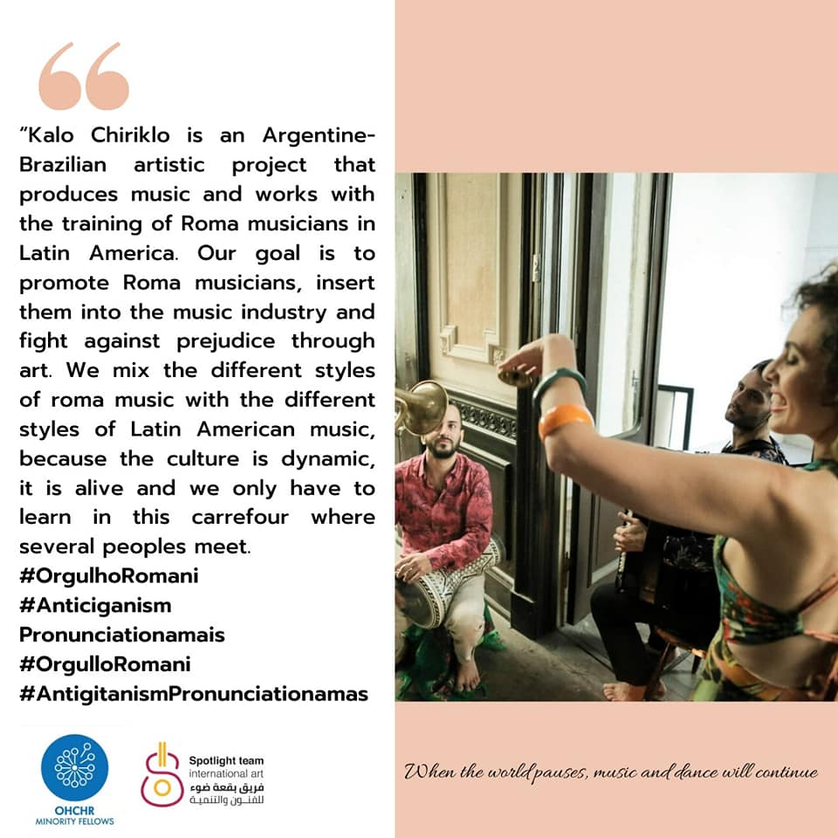

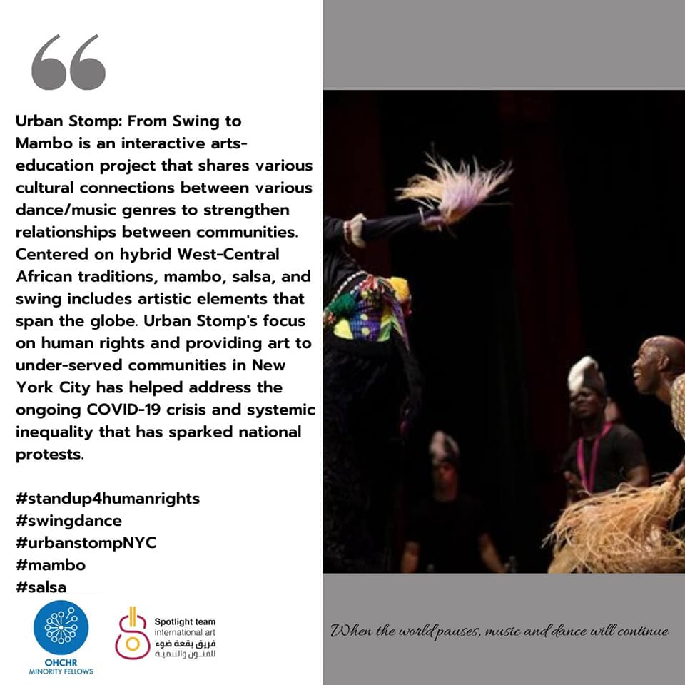

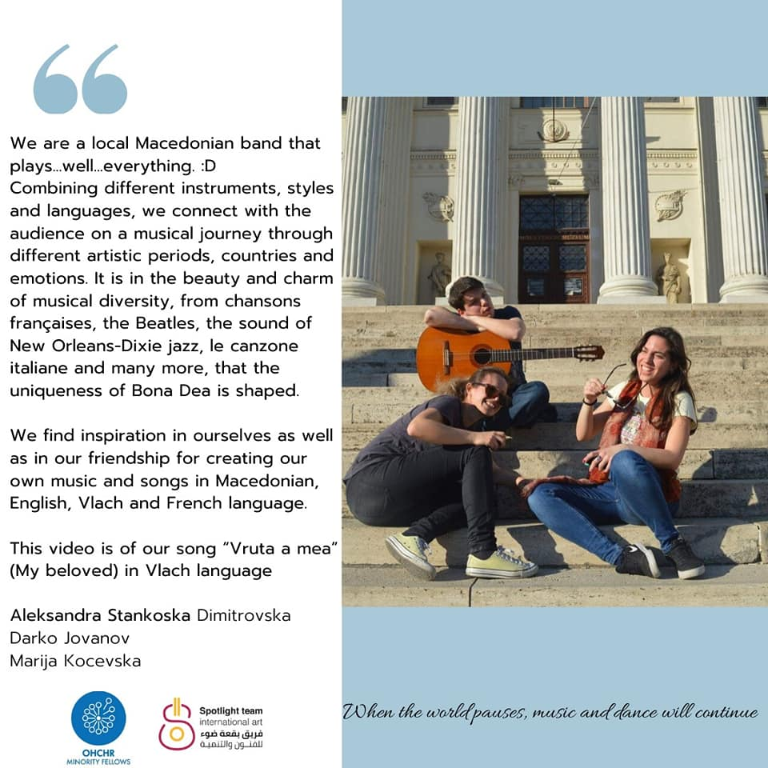

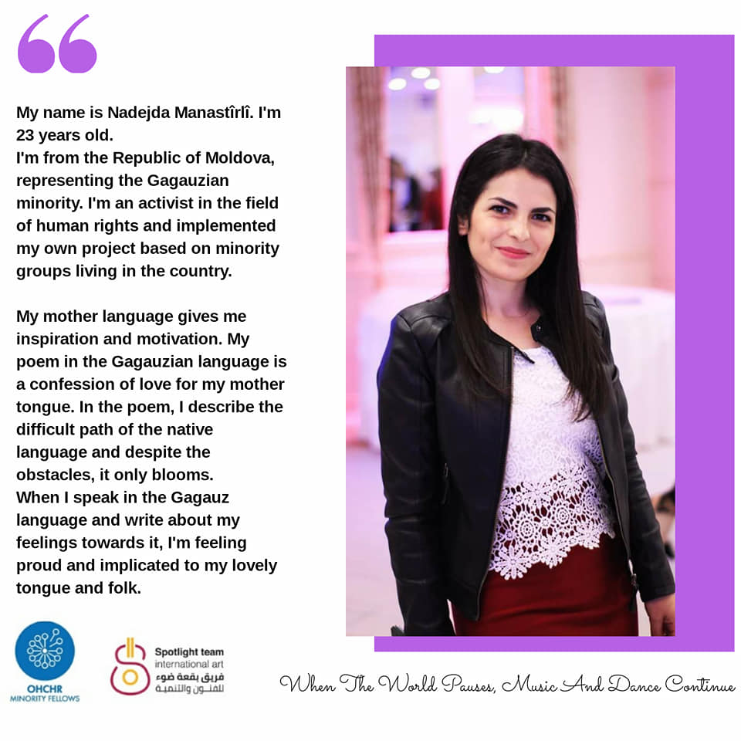

The aim of STIA is to promote human development through art and effective cultural communication. To facilitate and activate coexistence between all cultures in one society through art, moderate cultural, artistic and creative exchanges between different peoples. On the one hand helping newcomers integrate into the host community and support their talent and art skills and create a welcoming host community on the other hand. Facebook page of the NGO: https://www.facebook.com/Spotlight.Te/
The informal network of OHCHR Minority Fellows unites more than 100 minority rights defenders who participated in the OHCHR Minority Fellowship in Geneva. Facebook page of the informal network: https://www.facebook.com/OHCHRMF/

