Questionnaire_eng climate and culture - final (Jeremy Foster)
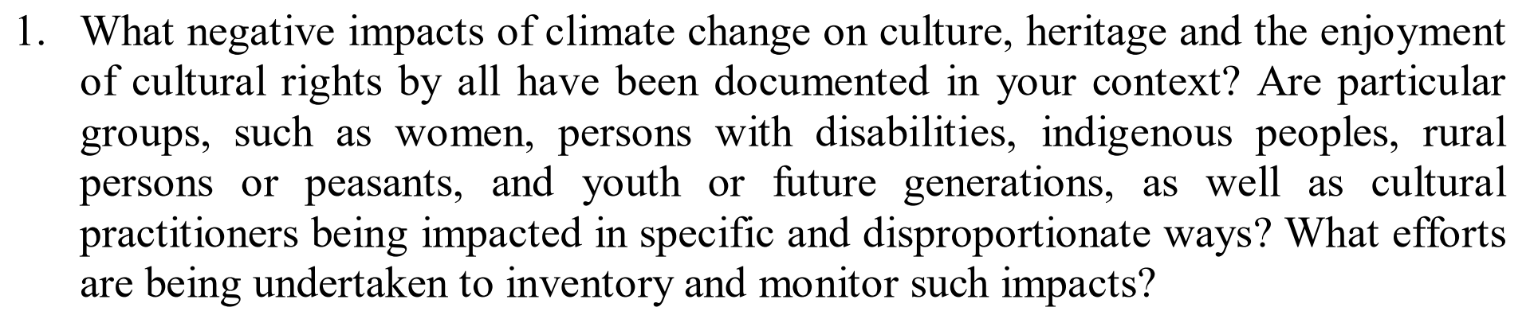
In terms of documentation I would refer to two specific disasters in which I was involved in their response.
Disaster response Tacloban 2013 –
Climate change = Overpopulation of the urban environment. Magnified storm surge following typhoon.
The immediate requirements to re-home people after the devastation of Yolanda was poorly handled. In the first instance much of the siting of temporary accommodation [T-shelters] were positioned incorrectly. The result was that traditional fishing communities were displaced into positions that were unsustainable moving forward and hence the new villages that were formed after the T-shelters were subsequently abandoned. Further the planning of these villages and T-shelters did not consider enough of the needs of minorities creating dangerous and threatening environments. Widely documented, see ‘Learning the lessons from Tacloban.’
Disaster response Nepal 2015 –
Climate change = Overpopulation of the urban environment.
The importance of protecting and preserving cultural and heritage assets in the wake of the earthquakes was overlooked in the first instance.
This has been widely reported upon. Further reference an inventory of the impact of climate change upon culture and vulnerable members of society is documented in the UNESCO and World Bank white paper ‘Culture In City Reconstruction And Recovery’.

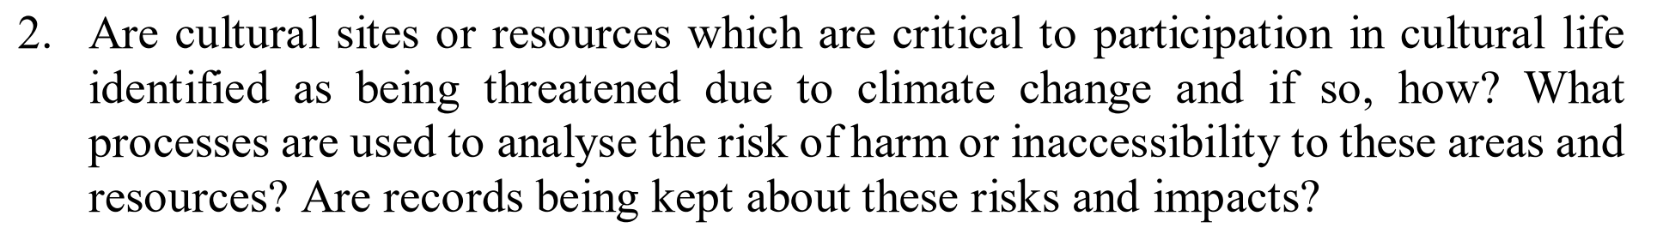
Please refer to the work of ICOMOS ICORP.
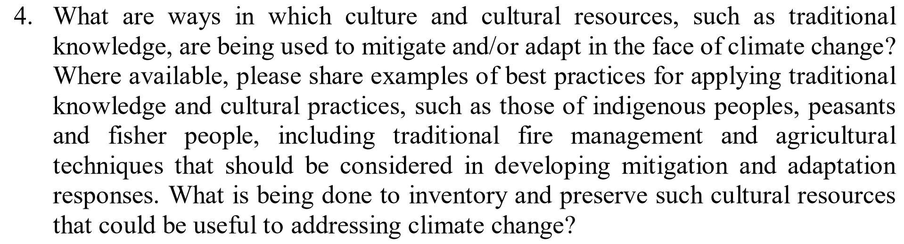
Following the Gorkha earthquakes in 2015 in Nepal the NRA gathered together various international heritage experts and local practitioners to arrive at a common understanding to approach and best preserve the cultural assets that remained and an appropriate process for rebuilding. This was not done in a cohesive or transparent fashion and the influences of corruption ultimately resulted in poor execution.
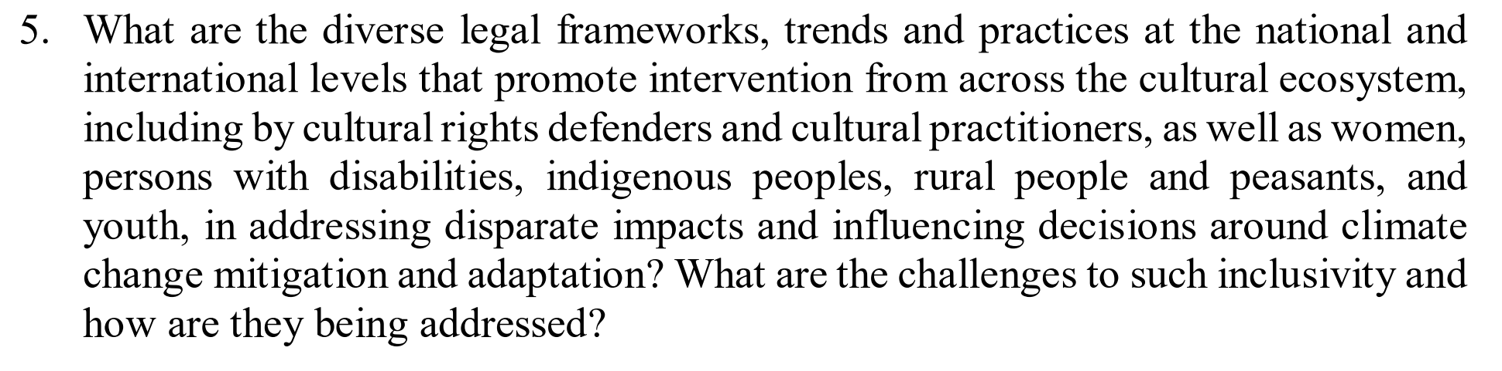
In answer to the first part of this question the World Urban Forum that takes place annually is a international conference that directly relates to developing frameworks and practices at an international level to address climate change and the protection of culture with particular focus towards indigenous people and diversity. See also the work of the Global Alliance for Urban Crises.
The main challenge that we face is funding in the face of corruption. Time and again we see the response to a crisis funded to promote a plan of action only to see that money directed into the pockets of corrupt practices. Nobody wants to have a debate around this subject beyond the aspirational. To do so you have to approach head on a lot of influential organisations that are benefiting directly from this money.
This problem is recognised and can only really be addressed with the political will of governments but inevitably It relies upon the fidelity of municipal authorities. In Nepal they made significant headway in the wake of the Ghorka earthquakes in 2015 to control corruption and yet ultimately the failure in certain notable areas created an atmosphere of mistrust that ultimately resulted in funding being withheld.
There is also the challenge that as a global community the will to fund resilience Is lacking. As a global society we are much more reactive to a disaster than willing to fund the mitigation measures to stave off disaster. Education in part is the key here but requires us to have open, frank and comprehensive discussions to address the barriers, including corruption.
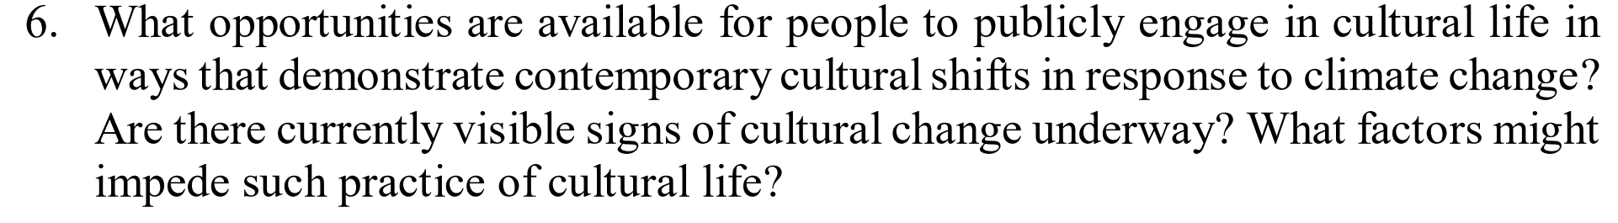
Myriad - Multiple NGOs - There are plethora of websites dedicated to this. Some would say too much. Partially the difficulty is trawling through all this information trying to find out how best to engage. Also, the sheer volume gives the impression that this is well covered. For most people cultural erosion happens by degree and is a lower priority when weighed against the demands of day-to-day today life.
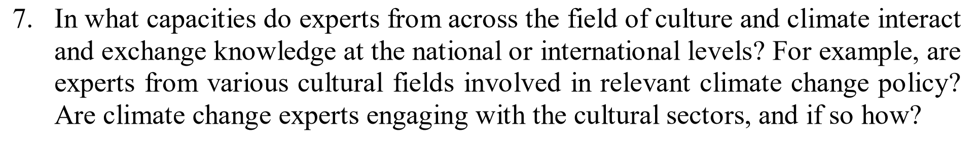
There are several professional organizations active in this arena. I myself am a member of two international scientific committees within the International Council on Monuments and Sites:
ICOMOS – ICORP
ICOMOS - ISCES+CC
Also, the work of Global Alliance for Urban Crises should be considered: GAUC
Consulted, yes, but whether the information is acted upon is something else. Lessons and best practice do not seem to be captured and presented to the wider international community.
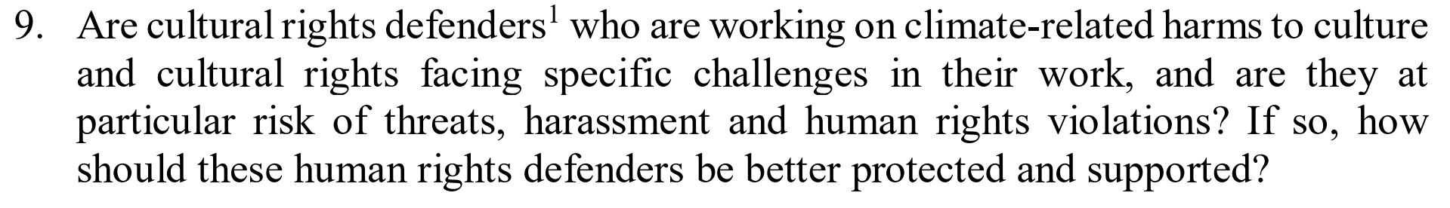
Clearly they are. Unfortunately, until we challenge our own understandings of corruption within our societies throughout the world, we will forever be fighting a losing battle. Throwing money at the problem only fuels the fire without the communal will and mechanism to make sure the money is spent appropriately. Sadly, this is the ‘third rail’ that no one is willing to grasp or lack the political robustness to be of an influence.
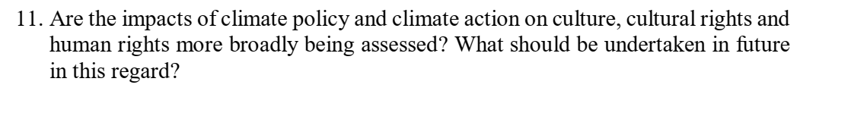See the UNESCO and World Bank white paper ‘Culture In City Reconstruction And Recovery’.

