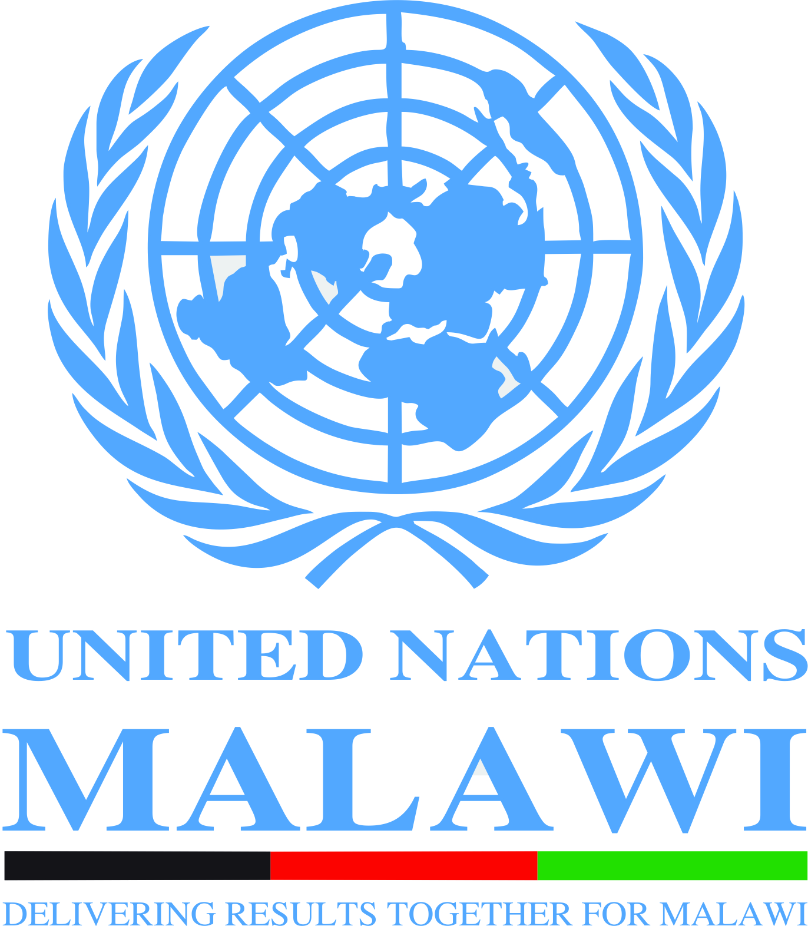

Expert Meeting on “moratorium on the death penalty with a view to its future abolition in Malawi”, 12 November 2015

Venue- Capital Hotel, Lilongwe,

AGENDA

08:30- 09.00 Registrations
9.00 - 10.00 Opening of the Workshop
- Ms Grace Malera, Executive Secretary, Malawi Human Rights Commission
- Hon. Samuel Tembenu, Minister of Justice and Constitutional Affairs
- Ambassador Marchel Gerrmann, EU
- Neal Gilmore, Senior Human Rights Adviser, United Nations, Malawi
- Byson Kaula, former death row inmate

10.00- 11.15 Death Penalty and International Human Rights Law
- Judge Johann van der Westhuizen, Constitutional Court of South Africa
- Ms Alice B. Mogwe, Expert, ACHPR Working Group on the Death Penalty; Executive Director, Botswana Human Rights Centre(developments in Africa)
- Dr Edge Kanyongolo. Faculty of Law, Chancellor College
- Open Discussion

11:15- 11:30 Coffee Break
11:30-13.00 Death Penalty in Malawi: progress since the Kafantayeni decision; including the current situation of the death penalty in Malawi: Kafantayeni and beyond.
- Justice Mwaungulu, Supreme Court of Malawi
- Professor Sandra Babcock, Cornell Law School
- Ministry of Justice and Constitutional Affairs (TBC)
- Open Discussion

13:00-14.00: Lunch
14.00– 15.00 Discussion on the right to seek pardon and commutation. Clemency, pardons and commutations remain critical to the process of the abolition of the death penalty. As stipulated in article 6(4) of ICCPR anyone sentenced to death should have the right to seek pardon or commutation of the sentence. The Head of State and Government and other responsible State authorities should exercise their constitutional and/or legal authority to commute or pardon death sentences.
- Justice Kapindu, High Court of Malawi
- Alice B. Mogwe, Expert, ACHPR Working Group on the Death Penalty; Executive Director, Botswana Human Rights Centre
- Open Discussion

15. 00 – 15.15 Coffee Break
15:15-16:15 Myth of Deterrence and Public Opinion
An extensive body of research disproves any suggestion that the death penalty has a deterrent effect on crime. There is an urgent need to tackle impunity to deter crimes. Impunity is one of the gravest concerns in many regions of the world. Victims want to see that justice is done, and attention should focus on ‘judicial effectiveness’. In other words, the duty of states is to exercise due diligence: to properly investigate, and to ensure that perpetrators can be identified, arrested, and prosecuted. Some may also argue that the death penalty continued to be used in their countries because of public opinion. Public opinion is neither definitive nor static. It is likely to change when people are better informed of the issues.
- Dr. Mai Sato, Reading University.
- Justice Redson Kapindu, High Court of Malawi
Open Discussion

16.15- 17.00 Way forward

END

*******

