Israel’s Ongoing and Systematic Smear Campaign against Al-Haq and its Staff Members, Including Hate Speech and Death Threats

Submission to the United Nations Special Rapporteur on the Situation of Human Rights Defenders, Ms. Mary Lawlor, in Response to a Call for Input on the Killings of Human Rights Defenders

Submitted by:
Al-Haq, Law in the Service of Man
NGO in Special Consultative Status
with the United Nations Economic and Social Council

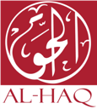

Date: 5 October 2020

Introduction
- For decades, Israel has pursued a policy of silencing those who seek justice and accountability for violations committed against the Palestinian people as a tool to maintain its apartheid regime. Palestinian civil society organisations and human rights defenders have endured systematic intimidation, including death threats, arbitrary arrests, travel bans, residency revocation, and deportation, in an attempt to shrink civil society space, delegitimise, oppress, and dominate them. As Israeli impunity reigns unabated, the safety and rights of Palestinian human rights defenders are continually and frequently violated.
- Critically, Israel through its official bodies within the government, such as its Ministry of Strategic Affairs, has coordinated efforts with several Israeli government-affiliated organisations to carry out ongoing, systematic, and organised attacks, targeted at Palestinian human rights organisations and defenders, in an attempt to construct a key narrative linking Palestinian human rights defenders with ‘terrorism.’
- Implemented and reasserted through a number of reports by Israel and its government-affiliated organisations, such as NGO Monitor, this narrative is designed to obstruct the work of achieving justice and accountability, including by impeding the granting and award of funds from international donors to Palestinian organisations. The publishing of such reports should be understood within the broader context of Israel’s smear campaign orchestrated and led by the Israeli Ministry of Strategic Affairs aimed at organisations and individuals, including those advocating for accountability under international law, especially in relation to business and human rights, and at the International Criminal Court (ICC).
- Since its establishment in 1979, Al-Haq, the mission of which is to protect and promote human rights and the rule of law in the Occupied Palestinian Territory (OPT), has faced various forms of attacks and smear campaigns, with the ultimate goal of delegitimising its work, and intimidating and silencing its staff members. Attempts to drawing links between Al-Haq with the Boycott, Divestment, and Sanctions (BDS) movement and with ‘terrorism’ have escalated in the past few years, following Al-Haq’s prominent work with regards to corporate accountability and international justice and accountability, including at the ICC.
- While Israel has not been held accountable for its smear campaign, its systematic and organised efforts of delegitimising the work of Palestinian human rights defenders has not gone unnoticed. Highlighting Israel’s failure to adhere to legal obligations under the Declaration on Human Rights Defenders, the Special Rapporteur on the situation of human rights on the Palestinian Territories occupied since 1967, Professor Michael Lynk, observed: “[a]s the occupation becomes further entrenched,” human rights defenders “will continue to be among the prime targets of those who are intolerant of their criticisms, yet alarmed by their effectiveness.” More recently, a June 2020 joint statement on behalf of 47 of the United Nations’ (UN) independent Special Procedures mandates, which condemned Israel’s plans to de jure annex further parts of the OPT, underlined how “Palestinian and Israeli human rights defenders, who peacefully bring public attention to these violations, are slandered, criminalised or labeled as terrorists.”
- Accordingly, Al-Haq provides this submission, indicating cases in which the Israeli occupying authorities, and its government-affiliated organisations, have targeted Al-Haq and its staff members, including through incitement to racial hatred, hate speech and death threats. This submission to the UN Special Rapporteur on the situation of human rights defenders (hereinafter the ‘Special Rapporteur’) comes in response to a call for input issued by the Special Rapporteur ahead of her upcoming report on the killings of human rights defenders.

Systematic and Ongoing Smear Campaign
- As a tactic to oppress and silence its opposition, and maintain its apartheid regime, and colonisation of Palestine, the Israeli government, including its official entities, individuals, and government-affiliated organisations, applies policies of both ‘violent’ and ‘non-violent’ domination of the Palestinian people, including by frequently and repeatedly smearing Palestinian human rights organisations and defenders (see Annex I for the list of Al-Haq staff members who were smeared).
- Notably, the attacks of the Israeli Ministry of Strategic Affairs have intensified since 2015, when Gilad Erdan assumed his ministerial position, and Al-Haq, and other Palestinian human rights organisations, submitted their first communication to the Prosecutor of the ICC. Since then, the Israeli Ministry of Strategic Affairs have produced and published four reports, all of which aim to defund and delegitimise Al-Haq.
- In May 2018, the first report of the Israeli Ministry of Strategic Affairs, the Money Trail 1, was published, as it was soon followed by a second report, Money Trial 2, on 23 January 2019, which was claimed to be “updated research.” Both of these reports mount a number of attacks against organisations and named individuals, under the pretext of interrogating the funding sources of Palestinian and European civil society organisations which promote a “delegitimization and boycott campaign” against Israel. In February 2019, the Ministry of Strategic Affairs published another defamatory report, titled ‘Terrorists in Suits,’ focusing on allegations of ‘terrorist’ affiliations. As a follow-up report, the Israeli Ministry of Strategic Affairs published a report titled “Terrorists in Suits: Bloody Money, European-Funded Palestinian NGOs & their Terror Operatives,” in May 2020. While having Addameer as its ‘case study,’ the Israeli Ministry of Strategic Affairs did not fail to take on the opportunity to smear Al-Haq and its General Director.
- The Israeli Ministry of Strategic Affairs’ reports use ‘terrorism’ as an undefined term to attack organisations and individuals. While there is yet no legal definition of terrorism in international law, Israel frequently uses ‘terrorism’ in an ostensibly legal context. Failing to put forward a methodology section that clarifies what is meant by the term ‘terrorism’, these reports rely on utilising it in a rhetorical and ultimately empty manner.
- NGO Monitor, an Israeli proxy organisation which purports to be “an independent and nonpartisan research institute dedicated to promoting transparency and accountability of NGOs claiming human rights agendas, primarily in the context of the Arab-Israeli conflict,” is a leading entity in targeting Al-Haq, among other Palestinian civil society organisations. In an attempt to delegitimise Al-Haq’s legal work, NGO Monitor maintains and continuously updates a profile page in relation to Al-Haq’s activities and staff members, affiliating Al-Haq with ‘terrorism’ and associating it with the BDS movement.
- Inciting against Palestinian human rights organisations and defenders, NGO Monitor further produces dishonest and inaccurate reports. In its ‘Al-Haq and GLAN’s Not-So-Subtle BDS Agenda: Analysis of Submission on “Business and Human Rights in Occupied Territory”’ report, NGO Monitor continues its efforts to associate Al-Haq with the BDS movement. Denying the Business and Human Rights legal framework Al-Haq assumes in its work, including with regards to corporate accountability in which Al-Haq is a prominent actor in and has been recognized internationally for its work, NGO Monitor continues to label Al-Haq as “a leader in BDS and lawfare campaigns targeting Israel, with its advocacy focusing on anti-Israel activities.”
- While Al-Haq supports the rights of other organisations and individuals to support the BDS movement, the organisation has never endorsed the 2005 call for BDS. Rather, Al-Haq continuously advocates for Third States to uphold their obligations under international law in relation to trade and investment with illegal Israeli settlements in the occupied West Bank, including East Jerusalem, including by taking measures to ensure that multinational corporations are not involved in gross human rights abuses, to protect and promote the rule of law, equal access to remedy and adequate accountability, and to protect against human rights abuses within their territory and/or jurisdiction by business enterprises.
- Similarly, Al-Haq’s prominent work with regards to the ICC has also been met with smears. NGO Monitor, similar to the Israeli Ministry of Strategic Affairs, rigorously attempts to link Al-Haq with ‘terrorism,’ with the aim of delegitimising the need for international accountability for the crimes committed against the Palestinian people, including at the ICC.
- In a similar effort, the Jerusalem Center for Public Affairs, “a leading independent research institute specializing in public diplomacy and foreign policy,” published a report in May 2020, which aims to discredit the Prosecutor of the ICC, her office, Al-Haq and other Palestinian civil society organisations. Critically, the report, which is authored by a former Director General of Israel’s Ministry of Strategic Affairs, and a former Secretary General of the World Jewish Congress, fails to provide information on the Situation before the ICC, and instead reuses claims and allegations previously made by the Israeli government, and its proxy organisations, while openly naming Al-Haq staff.
- Alarmingly, the Israeli government, including its Ministry of Strategic Affairs, go beyond publishing reports, as they also lobby politicians and donors, urging and pressuring them to halt their funding to Al-Haq. In 2015, false letters, allegedly sent by the Palestinian Authority (PA), were sent to several European donors that funded Al-Haq, claiming that Al-Haq was being investigated by the consulting firm Ernst & Young for “financial irregularities, corruption, fraud and misuse of donations and 37 funds.” Later on, these allegations were refuted by the Ernst & Young and the PA.
- The Israeli Prime Minister, Benjamin Netanyahu, has repeatedly called on European government officials to halt their funding of Palestinian human rights organisations, including Al-Haq, which he claimed were involved in “anti-Israel incitement and promoting boycotts of the Jewish state,” and thanked Denmark for tightening the conditions for providing its funding. Following this, he met with European officials, including the Norwegian, Irish, and Dutch foreign ministers, smearing the work of Al-Haq.
- On 10 June 2019, Israel’s Ministry of Strategic Affairs claimed to have succeeded in efforts to convince banks in Europe and the United States to close 30 financial accounts associated with Palestinian NGOs, allegedly including those of Al-Haq. Despite the sweeping claims made by the Ministry of Strategic Affairs, Al-Haq as an organization does not hold credit card accounts. As such, there was never an account open that could be closed to begin with.
- Responding to these attacks, Professor Lynk further noted, with particular concern, in his March 2019 report to the UN Human Rights Council, “the harmful practices employed by political leadership and States authorities in Israel to silence human rights defenders’ criticism of certain government policies. This includes verbal attacks, disinformation campaigns and de-legitimization efforts, as well as targeting of civil society funding sources…Those accused included respected European and Palestinian organizations such as Al-Haq, the Palestinian Centre for Human Rights and Al-Mezan.”

Death Threats and Incitement Targeting Al-Haq Staff
- While these aforementioned attempts to silence Al-Haq and its staff members can be labelled as ‘nonviolent,’ it is essential to note that the Israeli-led smear campaign also included ‘violent’ attempts. Alarmingly, Al-Haq’s work for international justice and accountability has been met with intimidation tactics, including arbitrary arrests, imposition of travel bans, office raids, incitement, hate speech and death threats.
- In 2016, coinciding with, and as a result of, the progress achieved at the ICC and decisions at the European Union (EU) level regarding the labelling of settlement products, Ms. Nada Kiswanson, Al-Haq’s, Legal Advocacy Officer in the Hague at the time, and Mr. Shawan Jabarin’s, Al-Haq’s General Director, received death threats. Delivering the death threat from a blocked number, the anonymous caller directly connected the death threat with Al-Haq’s work regarding the ICC. Highlighting the human rights abuses and systematic cyber violence Palestinian human rights defenders endure as a result of challenging Israel’s unlawful occupation, Al-Haq delivered a statement at the 38th Regular Session of UN Human Rights Council, and Front Line Defenders submitted a report to the 29th Session of the Universal Period Review, urging and calling for the protection of human rights defenders.

3.1. Threats Against Mr. Shawan Jabarin
- Critically, this attack is not an isolated incident, as Mr. Jabarin has been - and is continuously and constantly targeted by the Israeli government and its affiliated organisations. The reports of the Israeli Ministry of Strategic Affairs, and other similar reports, deliberately distort and omit crucial information and fail to mention that Mr. Jabarin was administratively detained without charge, during which time he was repeatedly tortured by Israeli officials. Purposely ignoring these facts, the Israeli Ministry of Strategic Affairs continues to smear Mr. Jabarin, promoting hate speech and incitement against him.
- Most recently, Al-Haq staff members, specifically Mr. Jabarin, have endured an online Israeli-led campaign of hate speech and incitement, which resulted in hate speech and death threats by Zionists and supporters. Initiated after Al-Haq marked its 40th anniversary, an event which brought together, inter alia, dozens of distinguished international diplomatic representatives, eminent academics and representatives from different UN and EU bodies, offices and international organisations, 4IL, the official social media account of Israel’s Ministry of Strategic Affairs and calls on members to “be on the front line of defense against Israel hate and antisemitism online,” publicised allegations and misinformation against Al-Haq and its General Director, allowing for unfiltered defamatory comments on its public platforms.
- In four posts on its Facebook page, the Israeli Ministry of Strategic Affairs continued its smear campaign and incitement to violence, including death threats, pursuant to its ‘Terrorists in Suits’ report (see Annex II). The fourth post is of particular concern, including a picture of Mr. Jabarin with his face violently torn down from the middle, portraying him as a terrorist and associating him and Al-Haq with the BDS movement (see Annex II).
- On the 4IL Facebook page, Facebook users launched into unconstrained hate speech against Al-Haq and its staff, including Mr. Jabarin, where they have called for his and the staff’s imprisonment and deportation, while numerous uncensored comments called for the killing of Mr. Jabarin (see Annex III). Addressing this grave threat, Al-Haq submitted an urgent appeal, urging the Special Procedures to take immediate and collective action to halt the ongoing online incitement by Israel, and to intervene directly with Facebook to remove the content that violates international human rights law and Facebook’s own community standards.

Conclusion and Recommendations

Conclusion
- Al-Haq offers the following conclusions:
- The Israeli-led large-scale smear campaign, which has been carried out for years by the Israeli government and its aligned and proxy organisations, is designed to silence Palestinian and other human rights organisations and human rights defenders, maintain its apartheid regime, and frustrate their efforts to monitor and document Israeli violations, and ensure accountability, particularly for perpetrators of war crimes and crimes against humanity, including at the ICC, failing to adhere to its legal obligations, as an Occupying Power.
- As enshrined in Article 13 of the UN Declaration on Human Rights Defenders, everyone has the right to solicit, receive and utilise resources to protect and promote human rights through peaceful means. Yet, Israel continues to repress, silence and intimidate anyone advocating and challenging Israel’s institutionalised regime of racial domination and oppression. Critically, the UN Commission on Human Rights adopted resolution 1993/45, providing that “the International Covenant on Civil and Political Rights states that any propaganda for war or any advocacy of national, racial or religious hatred that constitutes incitement to discrimination, hostility or violence shall be prohibited by law.” Further, the UN Human Rights Committee considered in its General Comment No. 34 of 12 September 2011 on the freedoms of opinion and expression that “[t]he harassment, intimidation or stigmatization of a person… for reasons of the opinions they may hold, constitutes a violation of article 19, paragraph 1” of the International Covenant on Civil and Political Rights.
- Accordingly, and in light of Israel’s culture of impunity, Al-Haq reasserts the need for States to take effective measures to address and put an end to the root causes of Israel’s widespread and systematic violations, including those with regards to human rights defenders.
  - Recommendations
- Al-Haq offers the following recommendations:
- Examine Israel, as Occupying Power, and the manner in which it is acting, notably through its Ministry of Strategic Affairs and government-affiliated organisations, to smear human rights defenders and activists, restrict their work, the right to freedom of expression, and threaten their right to life, among others, both online, including on social media platforms, and offline; and
- Urge Israel to immediately cease any and all practices and policies intended to intimidate and silence human rights defenders, in violation of their right to freedom of expression, including through arbitrary detention, torture and other ill-treatment, institutionalised hate speech and incitement, residency revocation, deportations, and other coercive or punitive measures.

Annexes
Annex I: List of Al-Haq Staff Members and Former Staff Members Who Have Been Smeared
Name | Nationality | Report
Mr. Shawan Jabarin | Palestinian | **Death threats  The Money Trail: the Millions Given by EU Institutions to NGOs with Ties to Terror and Boycotts against Israel, page 29  Terrorists in Suits: the Ties between NGOs Promoting BDS and Terrorist Organizations, page 37 and throughout  Legal Assault: How the ICC Has Been Weaponsized Against the U.S. and Israel, page 28 and throughout  Terrorists in Suits: Bloody Money, European-Funded Palestinian NGOs & their Terror Operatives, page 27  Bias in ICC Prosecutor Bensouda’s Meetings and Citations  Special Rapporteur on Israel: The UN’s Weakest Lynk  NGO Monitor website: https://www.ngo-monitor.org/ngos/al_haq/.
Ms. Nada Kiswanson | Palestinian-Swedish | **Death threats  Legal Assault: How the ICC Has Been Weaponsized Against the U.S. and Israel
Dr. Susan Power | Irish | Legal Assault: How the ICC Has Been Weaponsized Against the U.S. and Israel, page 37  Bias in ICC Prosecutor Bensouda’s Meetings and Citations  Al-Haq and GLAN’s Not-So-Subtle BDS Agenda: Analysis of Submission on “Business and Human Rights in Occupied Territory”  Special Rapporteur on Israel: The UN’s Weakest Lynk  NGO Monitor Website: https://www.ngo-monitor.org/funder/christian_aid_uk_/
Mr. Ali Jaradat | Palestinian | Legal Assault: How the ICC Has Been Weaponsized Against the U.S. and Israel, page 29
Ms. Suha Jarrar | Palestinian | Legal Assault: How the ICC Has Been Weaponsized Against the U.S. and Israel, page 29
Mr. Manaf Abbas | Palestinian | Legal Assault: How the ICC Has Been Weaponsized Against the U.S. and Israel, page 30
Mr. Zahi Jaradat | Palestinian | Terrorists in Suits: the Ties between NGOs Promoting BDS and Terrorist Organizations, page 38
Mr. Ziad Hamdan | Palestinian | Terrorists in Suits: the Ties between NGOs Promoting BDS and Terrorist Organizations, page 38  Legal Assault: How the ICC Has Been Weaponsized Against the U.S. and Israel, page 31
Mr. Majed Abbadi | Palestinian | Terrorists in Suits: the Ties between NGOs Promoting BDS and Terrorist Organizations, page 39
Mr. Wesam Ahmad | Palestinian-American | NGO Monitor website: https://www.ngo-monitor.org/ngos/al_haq/.
Mr. Raja Shehadeh | Palestinian | NGO Monitor website: https://www.ngo-monitor.org/ngos/al_haq/.
Mr. Jonathan Kuttab | Palestinian-American | NGO Monitor website: https://www.ngo-monitor.org/ngos/al_haq/.
Ms. Maureen Clare Murphy | American | NGO Monitor website: https://www.ngo-monitor.org/ngos/al_haq/.
Ms. Marya Farah | Palestinian-American | Al-Haq and GLAN’s Not-So-Subtle BDS Agenda: Analysis of Submission on “Business and Human Rights in Occupied Territory”
Annex II: Impugned Facebook Posts
Post NO. | URL | Date and Time
1 | https://www.facebook.com/4IL.org/posts/2236892646621890 | 19 July 2019 at 9:00 am  (local time)
2 | https://www.facebook.com/4IL.org/posts/2236206106690544 | 17 July 2019 at 1:23 pm  (local time)
3 | https://www.facebook.com/4IL.org/posts/2234828366828318 | 15 July 2019 at 3:47 pm  (local time)
4 | https://www.facebook.com/4IL.org/posts/2234827600161728 | 15 July 2019 at 2:34 pm (local time)

Post 1:

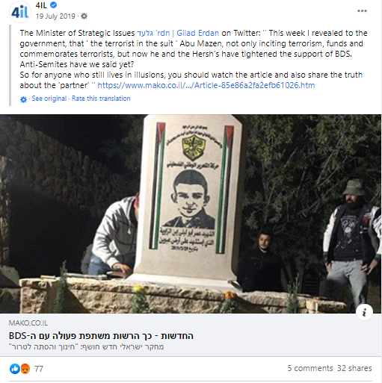

Post 2:

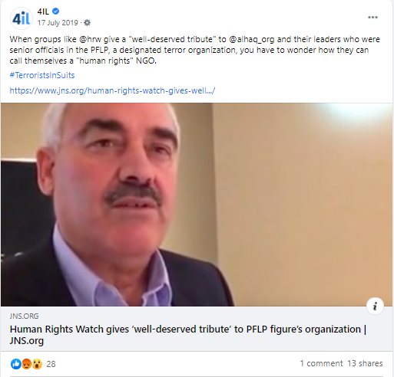

Post 3:

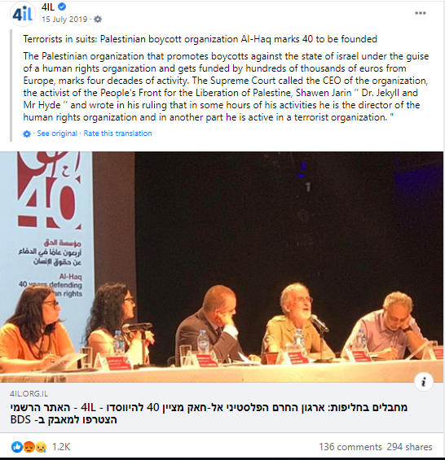

Post 4:

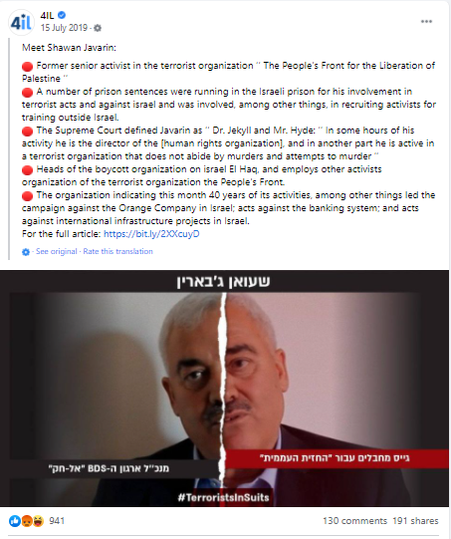

Annex III: Hateful Comments
Comments on Post 3:
Comment 1
Comments 2,3, and 4
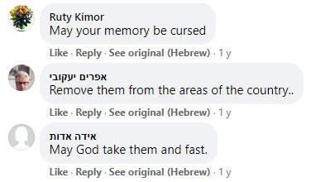
Comment 5
Comment 6

Comment 7
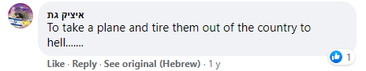
Comment 8
Comment 9
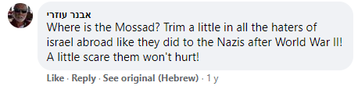
Comment 10

Comments on Post 4
Comment 10
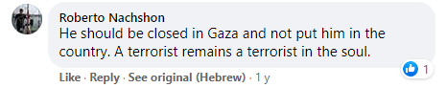
Comment 11
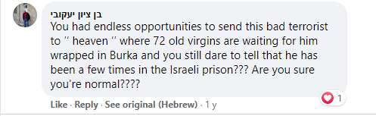
Comments 12 and 13
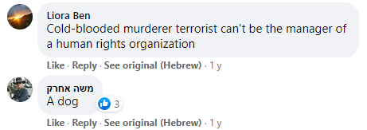
Comment 14
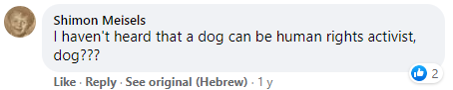
Comment 15
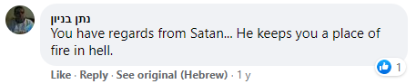

Comment 16
Comment 17
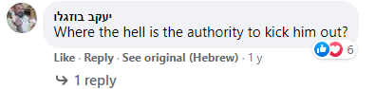

Al-Haq, “Joint Parallel Report to the United Nations Committee on the Elimination of Racial Discrimination on Israel’s Seventeenth to Nineteenth Periodic Reports,” 10 November 2019, available at: http://www.alhaq.org/cached_uploads/download/2019/11/12/joint-parallel-report-to-cerd-on-israel-s-17th-19th-periodic-reports-10-november-2019-final-1573563352.pdf.
Al-Haq, “Al-Haq Under Attack – Staff Member’s Life Threatened,” 3 March 2016, at: http://www.alhaq.org/advocacy/6432.html.
See, for example, Al-Haq, “Israel’s Policy of Arbitrary Arrest of Human Rights Defenders Continues,” 24 July 2008, available at: http://www.alhaq.org/advocacy/7256.html, Al-Haq, “Israeli Attacks on Human Rights Defenders Must End,” 16 February 2010, available at: http://www.alhaq.org/advocacy/7161.html, Al-Haq, Palestinian Human Rights Organisations Condemn the Imprisonment of Human Rights Defender Ramy Shaath & Call for his Immediate Release,” 24 September 2019, available at: http://www.alhaq.org/palestinian-human-rights-organizations-council/15238.html, and Al-Haq, “PHROC Condemns the Arrest of Human Rights Defender Mahmoud Nawajaa,” 6 August 2020, available at: http://www.alhaq.org/palestinian-human-rights-organizations-council/17191.html.
See, for example, Al-Haq, “Human rights organisations call on Israel to lift travel ban on Shawan Jabarin,” 29 November 2011, available at: http://www.alhaq.org/advocacy/6959.html, “PHROC Condemns Israel’s Policy of Silencing Those Who Raise the Voice of Justice,” 8 June 2020, available at: http://www.alhaq.org/palestinian-human-rights-organizations-council/16957.html, and Al-Haq, “PHROC Condemns Israeli Imposed Movement Restrictions and Travel Ban against Amnesty International Staff Laith Abu Zeyad,” 6 November 2019, available at: http://www.alhaq.org/advocacy/16170.html.
See, for example, Al-Haq, “Omar Barghouti at Imminent Risk of Deportation as Israeli Interior Minister Initiates Proceedings to Punitively Revoke his Residency Status,” 4 November 2019, available at: http://www.alhaq.org/advocacy/16156.html, and Al-Haq, “Palestinian and regional groups send joint urgent appeal to UN special procedures warning against the imminent deportation of Omar Barghouti,” 8 November 2019, available at: http://www.alhaq.org/advocacy/16181.html.
See, for example, Al-Haq, “Statement: Israeli Court Orders the Deportation of Human Rights Watch Director Omar Shakir,” 17 April 2019, available at: http://www.alhaq.org/advocacy/6067.html, and Al-Haq, “PHROC Condemns Israel’s Order to Deport Human Rights Watch Director, Omar Shakir, as a Grave Violation of Right to Freedom of Expression, and Systematic Shrinking of Civil Society Space,” 23 May 2018, available at: http://www.alhaq.org/advocacy/6199.html.
Al-Haq, “Joint Submission to the United Nations Special Rapporteur on the Situation of Human Rights in the Palestinian Territories Occupied Since 1967, Mr Michael Lynk, on Accountability,” 31 May 2020, available at: http://www.alhaq.org/cached_uploads/download/2020/06/03/joint-submission-to-unsr-michael-lynk-on-accountability-1591163396.pdf.
OHCHR, Report of the Special Rapporteur on the situation of human rights in the Palestinian territories occupied since 1967, UN Doc A/HRC/34/70, 13 April 2017, para. 64.
OHCHR, “Israeli annexation of parts of the Palestinian West Bank would break international law – UN experts call on the international community to ensure accountability”, 16 June 2020, available at: https://www.ohchr.org/EN/NewsEvents/Pages/DisplayNews.aspx?NewsID=25960
OHCHR, “Call for input to a report on killings of human rights defenders,” available at: https://www.ohchr.org/EN/Issues/SRHRDefenders/Pages/CFI-killings-human-rights-defenders.aspx.
Al-Haq, “Palestinian Human Rights Organisations Deliver Submission to the International Criminal Court on Alleged Israeli War Crimes and Crimes against Humanity during 2014 Gaza offensive,” 23 November 2015, available at: http://www.alhaq.org/advocacy/6460.html.
Badil, “PNGO & PHROC Position Paper on the Ongoing Campaign to Silence, Delegitimize, and De-Fund Palestinian Civil Society Organizations and Human Rights Defenders,” 22 March 2020, available at: https://badil.org/en/publication/press-releases/87-2018/4852-pr-en-220318-06.html.
The Israeli Ministry of Strategic Affairs and Public Diplomacy, “The Money Trail: the Millions Given by EU Institutions to NGOs with Ties to Terror and Boycotts against Israel,” May 2018, available at: https://www.jewishvirtuallibrary.org/jsource/images/bdsmoneytrail.pdf.
The Israeli Ministry of Strategic Affairs and Public Diplomacy, “The Money Trail: European Union Financing of Organizations Promoting Boycotts against the State of Israel,” January 2019.
The Israeli Ministry of Strategic Affairs, “Terrorists in Suits: the Ties between NGOs Promoting BDS and Terrorist Organizations,” February 2019, available at: https://www.gov.il/BlobFolder/generalpage/terrorists_in_suits/en/De-Legitimization%20Brochure.pdf.
The Israeli Ministry of Strategic Affairs and Public Diplomacy, “Terrorists in Suits: Bloody Money, European-Funded Palestinian NGOs & their Terror Operatives,” May 2020.
NGO Monitor, Official Website, FAQs Section, available at: https://www.ngo-monitor.org/about/faqs/.
See, for example, NGO Monitor, Official Website, Al-Haq, last updated 17 September 2020, available at: https://www.ngo-monitor.org/ngos/al_haq/, and NGO Monitor, “EU Funding to Terror-Linked Palestinian NGOs Since 2011,” 11 June 2020, available at: https://www.ngo-monitor.org/reports/eu-funding-to-terror-linked-palestinian-ngos-since-2011/.
NGO Monitor, “Al-Haq and GLAN’s Not-So-Subtle BDS Agenda: Analysis of Submission on ‘Business and Human Rights in Occupied Territory,’” 10 September 2020, available at: https://www.ngo-monitor.org/reports/al-haq-and-glan-bds-agenda-business-human-rights/.
Al-Haq, “Al-Haq Receives the Gwynne Skinner Human Rights Award,” 1 October 2020, available at: http://www.alhaq.org/advocacy/17372.html, and Al-Haq, “Al-Haq Attends 8th Annual UN Forum on Business and Human Rights, Receives the Human Rights and Business Award,” 3 December 2019, available at: http://www.alhaq.org/advocacy/16269.html.
NGO Monitor, “Al-Haq and GLAN’s Not-So-Subtle BDS Agenda: Analysis of Submission on ‘Business and Human Rights in Occupied Territory,’” 10 September 2020, available at: https://www.ngo-monitor.org/reports/al-haq-and-glan-bds-agenda-business-human-rights/.
See, for example, Al-Haq, “Database Letters: Al-Haq Calls on Home States to Businesses Listed in the United Nations Database as Engaged in Activities with Israeli Settlements to Take Action,” 1 July 2020, available at: http://www.alhaq.org/advocacy/17042.html, and Al-Haq, “World Tourism Day: Al-Haq calls for Corporate Accountability for Adverse Human Rights Impacts on Palestinian Host Communities,” 26 September 2020, available at: http://www.alhaq.org/advocacy/17360.html.
NGO Monitor, Key Issue: International Criminal Court (ICC) and NGOs, available at: https://www.ngo-monitor.org/key-issues/international-criminal-court-icc-and-ngos/which-ngos-are-involved-in-lobbying-the-icc/.
The Jerusalem Center for Public Affairs, About the Jerusalem Center for Public Affairs, available at: https://jcpa.org/about/.
The Jerusalem Center for Public Affairs, “Legal Assault: How the ICC Has Been Weaponized Against the U.S. and Israel,” 5 May 2020, available at: https://jcpa.org/legal-assault-how-the-icc-has-been-weaponized-against-the-u-s-and-israel/.
Al-Haq, “Al-Haq Condemns Attempt to Smear Al-Haq, Its Staff, and Partners in Recent Report,” 11 May 2020, available at: http://www.alhaq.org/advocacy/16854.html.
See, for example, OHCHR, Report of the Special Rapporteur on the situation of human rights in the Palestinian territories occupied since 1967, UN Doc A/HRC/34/70, 13 April 2017, para. 40, Al-Haq, “Al-Haq Under Attack – Staff Member’s Life Threatened,” 3 March 2016, available at: http://www.alhaq.org/advocacy/6432.html, and FIDH/OMCT, “Ongoing smear campaign against Al-Haq staff members Mr. Shawan Jabarin and Ms. Nada Kiswanson,” 10 November 2017, available at: https://www.fidh.org/en/issues/human-rights-defenders/israel-occupied-palestinian-territory-ongoing-smear-campaign-against#nh6-1.
Middle East Monitor, “Netanyahu thanks Denmark for cutting aid to Palestinian NGOs,” 25 December 2017, available at: https://www.middleeastmonitor.com/20171225-netanyahu-thanks-denmark-for-cutting-aid-to-palestinian-ngos/.
Herb Keinon, Greer Fay Cashman, “Netanyahu, Norwegian FM at odds over Palestinian NGO,” the Jerusalem Post, 7 January 2018, available at: https://www.jpost.com/Arab-Israeli-Conflict/Netanyahu-Norwegian-FM-at-odds-over-Palestinian-NGO-533054.
Maayan Jaffe-Hoffman, “30 Financial Accounts Associated With BDS-Promoting NGOs Shut Down,” Jerusalem Post, 11 June 2019, available at: https://www.jpost.com/Israel-News/Report-30-financial-accounts-associated-with-BDS-promoting-NGOs-close-592073.
Al-Haq, “Israeli Ministry of Strategic Affairs Campaign of Institutionalised Harassment Continues with the Alleged Closure of Palestinian NGOs’ Financial Accounts,” 19 June 2019, available at: http://www.alhaq.org/advocacy/6039.html.
OHCHR, Report of the Special Rapporteur on the situation of human rights in the Palestinian territories occupied since 1967, UN Doc A/HRC/40/73, 15 March 2019, para. 24.
See, Al-Haq, “Al-Haq Under Attack – Staff Member’s Life Threatened,” 3 March 2016, available at: http://www.alhaq.org/advocacy/6432.html, Al-Haq, “Update: Attacks Against Al-Haq Continue,” 4 June 2016, available at: http://www.alhaq.org/advocacy/6408.html, Al-Haq, “Dutch paper highlights attacks against Al-Haq,” 11 August 2016, available at: http://www.alhaq.org/advocacy/6395.html, and ESCR-Net, “Al-Haq staff member faces ongoing death threats in connection with human rights defense for Palestinians,” 2016, available at: https://www.escr-net.org/news/2016/al-haq-staff-member-faces-ongoing-death-threats-connection-human-rights-defense.
Al-Haq, “Al-Haq Under Attack – Staff Member’s Life Threatened,” 3 March 2016, available at: http://www.alhaq.org/advocacy/6432.html.
Al-Haq, “Al-Haq Delivers Oral Statement at the 38th Regular Session of the United Nations Human Rights Council on Palestinian Women Human Rights Defenders Facing Online Violence,” 26 June 2018, available at: http://www.alhaq.org/advocacy/6183.html.
Front Line Defenders, “Submission to the 29th Session of the Universal Period Review, May 2018, 29 June 2017, available at: https://www.frontlinedefenders.org/en/statement-report/upr-submission-israel-2017.
Anthony Lewis, “Abroad at Home; One Step for Justice,” New York Times, 27 February 1990, available at: https://www.nytimes.com/1990/02/27/opinion/abroad-at-home-one-step-for-justice.html.
Al-Haq, “Al-Haq submits a joint urgent appeal to the United Nations Special Procedures on the ongoing Israeli smear campaign against Al-Haq,” 24 August 2020, available at: http://www.alhaq.org/advocacy/14857.html.
Ibid.
UN Declaration on Human Rights Defenders (8 March 1999), Article 13.
UN Commission on Human Rights, Resolution 1993/45 on the right to freedom of opinion and expression, 5 March 1993, third preambular paragraph.
UN Human Rights Committee, General Comment No. 34 on Article 19: Freedoms of opinion and expression, UN Doc. CCPR/C/GC/34, 12 September 2011, para. 9.

