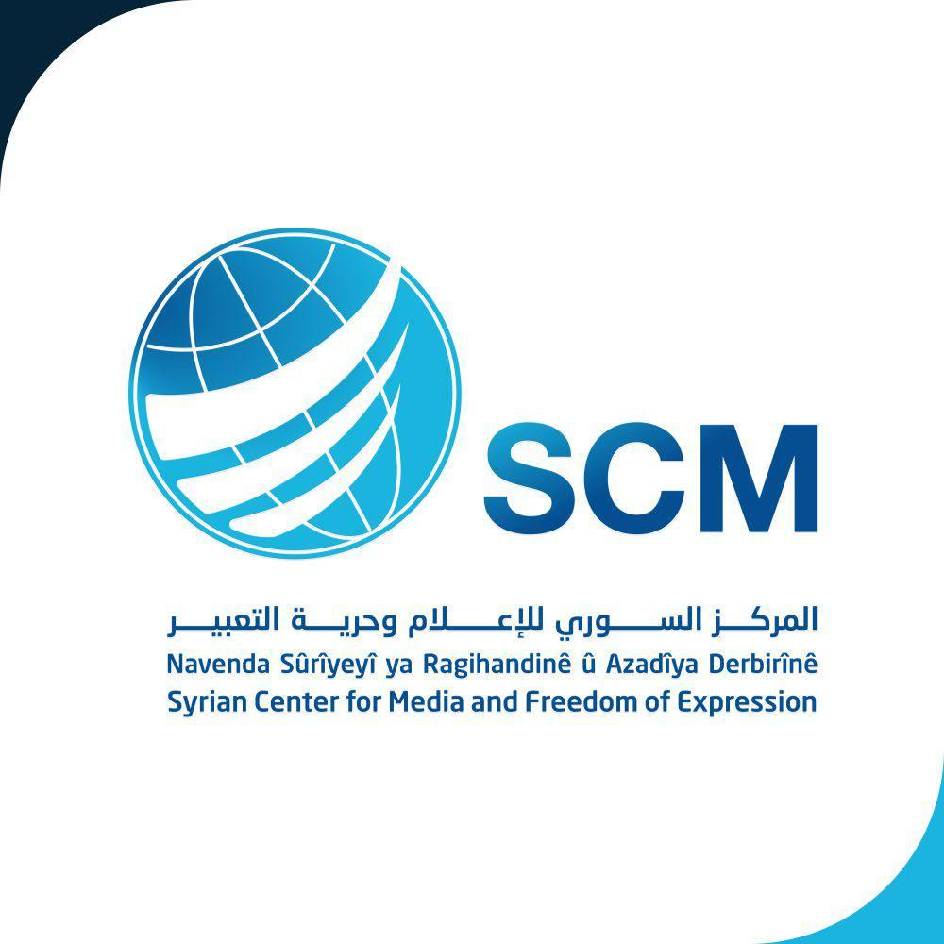

Syrian Arab Republic

Answers to the questionnaire for Civil Society by the UN Special Rapporteur on the situation of human rights defenders Mary Lawlor, August 2020

Submitted by:
Syrian Centre for Media and Freedom of Expression (SCM)
A non-governmental organization in special consultative status with ECOSOC since 2011

Date: 05 October 2020

Introduction
The Syrian Center for Media and Freedom of Expression (hereinafter SCM) is pleased to present this submission to the UN Special Rapporteur on the situation of human rights defenders Mary Lawlor to contribute to her upcoming thematic report on the issue of killings of human rights defenders, which will be presented to the UN Human Rights Council in March 2021.
This submission comes within the framework of the Syrian Center for media and freedom of expression commitment to promote and protect the rights of the Syrian people and human rights defenders (hereinafter HRDs).
The submission is based on the ongoing work of SCM Violations Documentation Center (VDC) of monitoring and documenting the situation of HRDs in Syria, and based on first-hand information gained from eyewitnesses and the victims’ families to ensure the reliability, accuracy and comprehensiveness of the provided information.

Organization
The Syrian Center for Media and Freedom of Expression (SCM) is a leading Syrian non-profit and independent non-governmental organization aimed at defending human rights, protecting freedom and achieving justice in Syria. The SCM was founded in 2004.
SCM strives for a world where democracy, justice, freedom, equality, dignity and human rights are respected. SCM’s actions are guided by the principles of credibility, integrity, transparency, professionalism and independence.
SCM developed three concrete and unique programs aimed at:
- Having democratic societies guaranteeing freedom of expression and belief;
- Ensuring respect of human rights, fighting impunity and enabling victims to reach justice;
- Supporting citizenship and empowering civil society actors in policy making and justice processes.
Since 2011, SCM benefits from a consultative status with the United Nations. It is the only Syrian NGO with such status at the United Nations. Furthermore, SCM has a solid international partners’ network such as IIIM & COI.

Contact Details

Please provide your contact details in case we need to contact you in connection with this survey. Note that this is optional. (edited for public release)

Type of Stakeholder (please select one) | X Civil Society Group or Organisation  Individual human rights defender  Academic/training or research institution  Other (please specify):
Name of Stakeholder/Organization (if applicable)  Name of Survey Respondent | The Syrian Center for Media and Freedom of Expression (SCM).
Email

Telephone

Address

Can we attribute responses to this questionnaire to you or your organization publicly? | X Yes No  Comments (if any):

Human Rights Defenders in Syria

HRDs, have always been victims of the government systematic policy of threats and repression to deter them from remaining active under a highly repressive regime. For several decades they are still at even higher risk of direct targeting and prosecution, including arbitrary arrest and detention, prosecution, death threats, restrictions on their freedom of movement, abduction, defamation, other forms of intimidation and harassment.

The situation of human rights defenders (HRDs) in Syria has significantly deteriorated as a result of the government’s violent crackdown policy against the large-scale peaceful protests which erupted in March 2011. Since that time, Syria has become one of the most dangerous countries in the Middle East for HRDs monitoring and reporting on human rights blatant violations and abuses and advocating on behalf of the victims.
The deterioration in the situation of HRDs is as much related to intensified use of violence by the government security forces and the offensive of the armed groups of non-state actors which control civil society in the areas under their control. Similar to the Syrian government forces, non-state actors pursue policies and tactics of abduction, killing, incommunicado detention, defamation, death threats, intimidation, against HRDs because their involvement in monitoring and documenting serious violations and abuses committed by these groups. This situation enforced a very significant number of HRDs to leave Syria or to go into hiding for fear of their lives and the fate of their families and loved ones as well.

Syrian security forces also continue to hold thousands of detainees arrested since March 2011 without trial, often in conditions that amounted to enforced disappearance, where tens of thousands of people remained disappeared. HRDs are particularly targeted just because of their peaceful work to promote and protect universally recognized human rights and fundamental freedoms, in accordance with the UN Declaration on Human Rights Defenders. They included humanitarian workers, lawyers, journalists, government critics and opponents and others who are engaged in defending and promoting of human rights. Families of the disappeared endured emotional and psychological consequences of living in uncertainty, compounded by the devastating economic impact.

Killing of HRDs during January 2019-june 2020

Among SCM core activities are regular report of death threats, killings, and enforced disappearances, mainly when it comes to human rights defenders. In the course of following up hundreds of cases of killings and enforced disappearances, SCM with the support of many international and regional human rights organizations succeeded to release its founder and director Mazen Darwish after about 4 years of arbitrary detention in the Syrian Government persons. SCM is still working to obtain reliable information on the fate of his members and HRDs Razan Zaitouneh, head of the Violations Documentation Centre in Syria (VDC), Samira Khalil, Nazem Hamadi and Wa’el Hamada, collectively known the “Duma four”, who have been missing since 9 December 2013, presumed kidnapped by extremist militias, As well as Ayham Mustafa Gazzoul, Khalia Ma’touk who remain missing, killed, and forcibly disappeared in both government prisons or in detention by armed groups.

The SCM has documented during 2019 9 cases of killing of HRDs. 4 HRDs were killed by both the Syrian and Russian forces, and 4 were killed by the Turkish forces, and one case was recorded against unidentified party.

No. | Full name | Occupation | Details
1 | Mahmud Abd Ala’l | Correspondent for the Civil Defence Organization | killed on 3/9/2019 as a result of a Russian air raid which targeted the civil society organization's team in the city of Jisr Al-Shughour
2 | Omar Aldimashqi | works as a photographer with the media office of an organizations called “Alrahemon Yarhamohum Allah”. | He was killed on 24/6/2019 in Sarmada village in Idlib countryside, as a result of the explosion of an explosive device placed in a car by an unidentified party.
3 | Amjad Hasan Bakir | Woks as a Photographer with the Free Idlib Army of the National Liberation Front | Killed on 18/6/2019 when he was targeted by the Syrian government forces while covering the clashes in the northern Hama countryside
4 | Anas Abd Emajeed Diab | Volunteer in the media office of the Civil defence Organization | He was killed on 21/7/2019 during an aerial bombardment of the city of Khan Sheikhoun, while he was commencing work for the Civil Defence Oragnization.
5 | Saa’d Mohammad Said Shchmus | Reporter for Hawar ANHA | He was killed on 13/10/2019 as a result of a Turkish air raid against a convoy that Saad was following.
6 | Mohammad Husen Rasho | Correspondent of the Kurdish-Yazidi channel "JRA" | He was killed on 14/10/2019 as a result of an explosion, while he was heading with a group of Journalists to cover the events in Ras Al-Ain "Sere Kaniye".
7 | Abd alhameed Khader elyosuf | Correspondent of "Kfroma Media Office” | A media activist in the Kafroma media office. and was killed during its media coverage of the government forces ’bombing in the western neighborhood of Kafr Ruma town, and according to her information, there was no military connection.He was killed on 10/11/2019 as a result of artillery shelling by the government forces while covering a Russian aerial bombardment on the town of Kafr Roma. He was hit directly in the head and stomach and killed instantly.
8 | Dilan abdallah | Reporter at the Media Office of the “Women's Protection Units” | She was killed on 13/10/2019 while covering a Turkish attack on northern-east Syria. She was hit by shelling of the Turkish forces and the military factions loyal to them
9 | Saad Ahmad | Correspondent “Hawar News Agency” | He was killed on 13/10/2019 as a result of an explosion in the city of Ras Al-Ain "Sere Kaniye", where he was accompanied by a group of journalists who were headed to the neighbouring city
10 | Jihad Jamal "Milan" | Journalist | Killed on 13/4/2020 under torture in a government detention center.
11 | Mohammed Hussein Rashu | Journalist | Killed on 14/10/2019 during a Turkish warplane shelling
12 | Ahmad Alahmad | Lawyer | Killed on 9/8/2019 after being abducted by an unidentified party
13 | Mahmoud Ali Meree | Lawyer | Killed on 12/2/2019 under torture by the Syrian government forces
14 | Alaa Nayef Khader Khalidi | Media Activist | Killed on 12/7/2019 under torture by the Syrian government forces
15 | Nassif Sarmani | Media Activist | Killed on 10/3/2019 as a result of shelling conducted by the Syrian government forces
16 | Abdulnasser Hamidan | Photographer | Killed on 20/2/2020 during a Russian warplane bombardment of Idlib
17 | Abdulhamid Yousuf | Photographer | Killed on 10/11/2019 during shelling of Idlib while covering the bombardment of Idlib by Syrian government forces

Anther three HRDs killed under torture

The Center has documented another three HRDs who were killed under torture. During 2019 journalist Samer Al-Salloum was killed on 12/8/2019 after being tortured by the “Al-Nusra Front”. Another two media activists were killed under torture in the prisons of the Syrian government, Bilal Abdul Kafi Muhammad, also known as “Abu Orouba”, was arbitrarily arrested on 28/8/2019 at the Turkish-Syrian border, and forcibly disappeared since then. At the beginning of February 2019, his family obtained a death certificate stating his death since 2015. Ali Muhammad Othman, known as "the grandfather", was also arbitrarily detained since March 2013. Ali had a prominent role in supporting and assisting journalists in the city of Homs, especially the journalists who survived the targeting of the "Baba Amr" media center in February 2012 according to the testimony published by the British journalist Paul Connery about him after announcing his death. Alis’ death was disclosed when his family obtained a death certificate stating that his death was included in government records since 2015.

