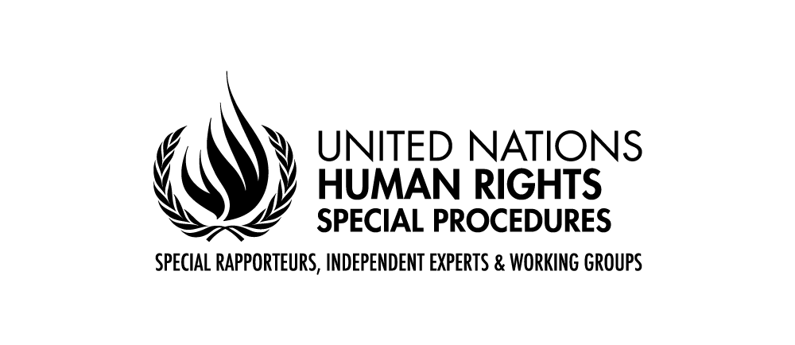
PALAIS DES NATIONS • 1211 GENEVA 10, SWITZERLAND
www.ohchr.org • TEL: +41 22 917 9000 • FAX: +41 22 917 9008 • E-MAIL: registry@ohchr.org

The Situation of Women Human Rights Defenders
A Survey by the UN Special Rapporteur
on the Situation of Human Rights Defenders
Michel Forst

August 2018
You are invited by the UN Special Rapporteur on the situation of human rights defenders, Mr. Michel Forst, to share information on women human rights defenders.
Women human rights defenders are women who “promote and… strive for the protection and realisation of human rights and fundamental freedoms at the national and international levels” through peaceful means (Article 1, 5, 12 and 13 Declaration on the Right and Responsibility of Individuals, Groups and Organs of Society to Promote and Protect Universally Recognized Human Rights and Fundamental Freedoms). Because of their work, women human rights defenders often face risks and suffer violations of their rights, including gender specific ones.

The data collected through this survey will inform the report of the UN Special Rapporteur, which will focus on the situation of women human rights defenders and will be presented to the UN Human Rights Council in March 2019.

The report will be made publicly available at the OHCHR website (https://www.ohchr.org/EN/Issues/SRHRDefenders/Pages/SRHRDefendersIndex.aspx) and on the website of the Special Rapporteur (https://www.protecting-defenders.org/). For more information on this report, see the related Concept Note also provided for your convenience in English, French and Spanish, on the abovementioned OHCHR website.

This survey will take around 25 minutes or more to complete, depending on the level of detail you wish to provide. There are six main questions in this survey.

Your responses will be held confidentially and they will not be attributed to you unless you give us permission to do so.

This survey is prepared by the mandate of the Special Rapporteur with technical support from the Centre for Applied Human Rights of the University of York.

States, international and regional organizations, National Human Rights Institutions and civil society are requested to submit their response as a Word or PDF file from their official email address to defenders@ohchr.org. For this purpose, a downloadable version of the questionnaire is available in English, French and Spanish, on the abovementioned OHCHR’s website link. Civil society stakeholders can and are encouraged to also submit this form online through this link: https://york.qualtrics.com/jfe/form/SV_aXgS3GlNLWAV2Sx

The survey will be open until 28 September 2018.

Contact Details

Please provide your contact details in case we need to contact you in connection with this survey. Note that this is optional.

Type of Stakeholder (please select one) | State  National Human Rights Institution (NHRI)  International or Inter-governmental Organisation  Civil Society Group or Organisation  Individual human rights defender  Other (please specify):
Name of Stakeholder/Organization (if applicable)

Name of Survey Respondent

Email

Telephone

Address

Can we attribute these responses to you or your organisation publicly? | Yes / No  Comments (if any):

In what country or countries are you primarily active? (Note: Not applicable for States or NHRIs)

Questions

- What recent trends or issues related to women human rights defenders should the Special Rapporteur focus on in his report? Please explain how they affect women human rights defenders, providing specific examples. Are there any country specific or regional trends or issues that the Special Rapporteur should refer to?

- Are there groups of women human rights defenders who face higher or specific risks that the Special Rapporteur should focus on in his report? Please describe their human rights work and the specific risks they face, adding country or regional specific information as appropriate.

- What are the main concerns and challenges that women human rights defenders face when carrying out human rights-related activities both in the private and public sphere, including through digital means?

- Are there good practices (legal, administrative, policy, and others) that enable women human rights defenders to carry out their human rights work safely? How can protection measures and practices be made gender-sensitive and more effective? What other dimensions of difference (e.g. race, class, etc.) need to be considered in the design of protection practices, and how? If possible, please provide specific examples.

- More broadly, how can the movement for women’s rights be strengthened around the world? How can women be better enabled to participate in the promotion and protection of human rights?

- What recommendations should the Special Rapporteur include in his report? What opportunities for advocacy on women human rights defenders are presented by this report?

Thank you for participating in this survey!

Please attach any relevant resources (e.g. reports, case studies, urgent alerts) that might be helpful for this report.

If you have any questions or want to provide feedback about this survey please email defenders@ohchr.org

