Submitted by Montagnards Stand for Justice (MSFJ)

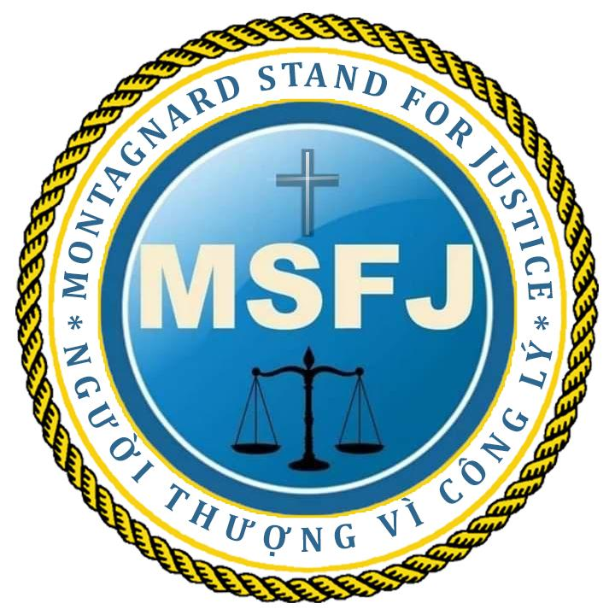

Questionnaire for International Organizations and Civil Society by the
UN Special Rapporteur on the situation of human rights defenders
Mary Lawlor, 9 February 2021

The UN Special Rapporteur on the situation of human rights defenders, Ms. Mary
Lawlor invites you or your organization to respond to the questionnaire below. Submissions received will inform the thematic report of the Special Rapporteur on the issue of long term detention of human rights defenders, which will be presented to the UN General Assembly in October 2021.

The questionnaire on the report is available at OHCHR website in English (original
language) as well as in French, Spanish, Russian and Arabic (unofficial translations): (https://www.ohchr.org/EN/Issues/SRHRDefenders/Pages/SRHRDefendersIndex.aspx).

Please submit the completed questionnaire to defenders@ohchr.org

Contact Details

Please provide your contact details in case we need to contact you in connection with this survey. Note that this is optional.

Type of Stakeholder  (please select one) | ☐ International or Inter-governmental Organisations  ☒ Civil Society Groups or Organisations  ☐ Individual human rights defender  ☐ Academic/training or research institution  ☐ Other (please specify)
Name of Stakeholder/  Organization (if applicable)  Name of Survey Respondent | Montagnards Stand for Justice (MSFJ)
Email | rebecca.dang@pspfoundation.org
Can we attribute responses to this questionnaire to you or your  organization publicly*?  *On OHCHR website, under the section of SR on human rights defenders. | Yes  Comments (if any):
Questions

Human rights defenders are persons, who individually, or in association with others, work peacefully to promote and protect universally recognized human rights and fundamental
freedoms, in accordance with the UN Declaration on Human Rights Defenders.

Defenders around the world peacefully promoting and defending human rights operate under national legal frameworks not always fully consistent with the United Nations Charter and international human rights law. In some instances, as echoed in multiple Human Rights Council and General Assembly resolutions^{,[1]} national legislation, in particular national
security and counter-terrorism laws, or regulations on civil society and public freedoms have been misused to target defenders in a manner contrary to international law, that might result in long-term arbitrary deprivation of liberty.

- Do you know of any human rights defender(s) currently detained by States, who have been imprisoned on charges that carry a prison sentences of at least 10 years or more? Please provide a list of cases.

Yes. The Vietnamese government has suppressed and imprisoned Protestant Church leaders in the Central Highlands, especially imposing long-term prison sentences on indigenous Montagnards.

Specifically, see the cases below:
- Christian Missionary Alliance – CMA: convicted on a charge of ‘undermining national unity policy’ under Article 87 of the criminal code (1999), (2013)
- Y Min Ksor, born on May 12, 1954, resides at Ea Kjoh Village, Ea Drong Commune, Buon Ho Town, Dak lak Province. A Montagnard Protestant Deacon of Ede tribe in the central highlands of Vietnam, he was serving God as a Deacon for a small congregation of his village where he resides. Y Min Ksor was known as a person who has many years in serving the Lord; being in the field of teaching, promoting FoRB for years, he experienced the injustice of the Vietnamese authorities in prohibiting believers to worship God. As a result, he spoke up for freedom of religion and belief and human rights issues for ethnic minority people.
In 2001 and 2004, he participated in peaceful demonstrations demanding freedom of religion, human rights for indigenous people, and demanding the release for prisoners of conscience. He was arrested several times, taken to the police station for questioning and was beaten up each time at Buon Ho Town police station over religious and land issues. The police and authorities accused him of being involved with the Fulro movement.

Since 2016, he started collecting information about human rights violations of the Vietnamese government, providing to human rights activists abroad, drafting reports for the activists to send to the United Nations. He strongly worked on the issue of religious freedom and asking for the return of confiscated lands of the indigenous peoples in the Central Highlands.

On April 10, 2018, Deacon Y Min Ksor was arrested at his own house in Ea Kjoh Village while conducting a worship service in his house. He was tortured and charged with ‘undermining national unity policy’ under Article 87 of the Criminal Code in a trial on January 31, 2019 and was sentenced to nine years in prison and five years' probation. He is imprisoned in Xuan Phuoc Prison, Phu Yen Province.
https://www.uscirf.gov/y-min-ksor

- FoRB and indigenous rights: “Undermining national policy” under article 116 (2015 Code)
- Rahlan Hip, born in 1981, is a Montagnard of the J’rai tribe who advocated for environmental rights, FoRB, and indigenous rights.
In 2017, Rah Lan Hip spoke up for the return of the lands taken by the government of Plei Ku City through beating indigenous landowners in the Central Highland on July 26, 2017. He was arrested in 2019. Rah Lan Hip had since then been monitored by the local authorities and was falsely alleged to use Facebook to connect with reactionaries in the United State in order to promote Degar Protestantism among indigenous people. Rah Lan Hip was prohibited from communicating and associating with other Christian believers in his village and was also threatened with arrest if he was caught joining a prayer group. His arrest was mainly based on practicing religious rituals and promoting religious freedom in his village. Moreover, the Vietnamese national mainstream media kept reporting that from late 2018 to early 2019, Rah Lan Hip enticed others in supporting the defunct FULRO self-autonomy movement (a baseless accusation).

On May 15, 2019, Rahlan Hip was arrested. The People’s Court of Gia Lai Province convicted and sentenced him to seven years in prison and three years of post-prison probation for ‘Undermining national policy” under article 116 (2015 Criminal Code). He is currently T20 Prison of Gia lai Province.
https://the88project.org/profile/436/rah-lan-hip/

- Mr. Ksor Ruk, born in 1975, is a Montagnard of the J’rai tribe who advocated for FoRB and indigenous rights. He was a Protestant missionary. His home was in Krong Pa District, Gia Lai Province. Following his first arrest in 2007, he was charged with ‘undermining unity policy’ and sentenced to 6 years in prison. After being released in 2013, he continued his missionary work in his local area.
From October 2017 to September 2018, Ksor Ruk was allegedly responsible for reviving “Degar Protestantism” and leading others in many areas within Gia Lai Province.
On October 30, 2018, was detained for four months. On March 15, 2019, the People’s Court of Gia Lai Province sentenced him to ten years in prison and four years of post-prison probation for ‘undermining unity policy’ under Article 116 of the country’s 2015 Penal Code. He is in T20 Prison, Gia Lai Province.
https://the88project.org/profile/322/ksor-ruk/

- Siu Doang, born in 1986, is a Montagnard Christian promoting freedom of religion and belief and indigeneous land rights. His home is in Bo 1 Village, Ia Phang Commune, Chu Puh District, Gia Lai Province. He was arrested on January 25, 2016 and sentenced to eight years in prison and 3 years’ probation.
- Pup Ksor, born in 1993, is a Montagnard Christian promoting freedom of religion and belief and indigeneous land rights. His home is in Bo 2 Village, Ia Phang Commune, Chu Puh District, Gia Lai Province. He was arrested on January 16, 2015 and sentenced to eight years in prison and three years’ probation.
- Kopa Chin, a preacher serving the small congregation of his village and an indigenous rights activist, is from Tai Glai Village, Ia Ko Commune, Chu Se District, Gia Lai Province. He was arrested on September 16, 2006 and sentenced to 17 years in prison and five years probation.
- Dick Siu, born in 1965 in Tai Per Village, Ia Hla Commune, Chu Puh District, Gia Lai Province, is a Montagnard Christian promoting FoRB and indigenous rights for J’rai people. He was arrested on December 15, 2015 and sentenced to eight years in prison and three years probation.
- Ngiang Phich, born in 1972 in Nang Hra Village, Ia Hla Commune, Chu Puh District, Gia Lai Province. He was a leader of the Nang Hra house church. He was arrested on 20 December 2015 and sentenced to 12 years in prison and three years probation.
- Do you know of any human rights defender(s) currently detained by States, who have been imprisoned on continuous sentences amounting to 10 years or more? For example, a defender who completes a sentence of four years in detention but instead of being released is given another six year sentence? Please provide a list of cases or examples if possible.
No.

- Do you know of any human rights defender(s) whose time in pre-trial detention and/or administrative detention by States combines with a sentence that amounts, or would amount to 10 years or more? Please provide a list of cases.

Yes. See attached list

- Good News Mission Church: convicted of ‘undermining national unity policy’ under Article 87 of the criminal code (1999), (2013)
- Y Pum Bya, born in 1964, resides at Kmien Village, Ea Drong Commune, Buon Ho District, Dak Lak Province. A Montagnard Protestant and preacher serving the Ede tribe in the Central Highlands of Vietnam, Y Pum Bya started to promote human rights and freedom of religion or belief for indigenous people in Central Highland in 2000. He joined a few peaceful demonstrations in 2000 through 2002.
On February 28, 2002 he was arrested for the first time, and his trial took place on July 18, 2003. On September 1, 2003, he was sentenced to eight years in prison and four years of probation for ‘undermining the policy of unity’ under article 87 of the criminal code of 1999, He is in Nam Ha Prison in Ha Nam Province (northern Vietnam).

On May 26, 2009, he was released and returned to his home in Kmien Village, Ea Drong Commune, Buon Ho Town, Dak Lak Province where he served his probation. Local police officers constantly harassed and threatened to to arrest him again if he resumed serving his congregation.

In 2016, he attended a Bible class in Saigon. The police often threatened him with arrest and imprisonment unless he stopped serving his congregation. They suspected that Deacon Y Pum Bya had been collecting government violation information and forwarded to others for international advocacy.
On April 10, 2018, he was arrested for the second time and sentenced in 2019 to 14 years in prison for undermining unity policy.

Details of his arrest and imprisonment
On April 10, 2018, at approximately 9 a.m., Ea Drong Commune police and Buon Ho Town police, 6 men in all, rode in 2 police vans with guns, rubber, and electric batons, and manacles, to house church where Y Pum Bya and his colleague were hosting a worship session. The police seized Bibles and other religious materials and took Y Pum Bya and his colleague, Y Min Ksor, to the Ea Drong Commune police station. There, they tortured the two during interrogation to force them to sign commitments to stop worshipping in a group while belonging to the Good News Mission Church. The interrogators ordered them to join the government-approved Evangelical Church of Vietnam (Southern Region) instead.
https://www.uscirf.gov/y-pum-bya

- Y Ngun Knul, was a youth group leader of Ea Khit Village, Ea Bhok Town, Cu Kuin District, Dak Lak Province. He was arrested on April 29, 2004 and sentenced to 18 years in prison and five years probation. He was detained in Nam Ha Prison in Ha Nam Province. He was released two years early on February 29, 2020, but subjected to intense government surveillance in his community

- Do you know of any human rights defender(s) falling under any of the previous categories above, who were released before ending their long-term prison sentences for any reasons (e.g. granted a pardon, as a result of an appeal, or released on humanitarian or other grounds)? Please provide a list of cases. Y Ngun Knul (above) and Y Pum Bya (above, released early from his first imprisonment).

5) What actions do you suggest the Special Rapporteur can take to:

- Prevent defenders from being detained for long terms in connection to their human rights work? and
Rapid and intense response: As soon as a human rights defender is arrested, the UN Special Rapporteur should immediately mobilize intense attention and assertive intervention on behalf of the detainee. First, there should be enhanced coordination among the different UN mandate holders to collectively focus on cases that are likely to receive severe prison sentences. At the same time, the Office of the UN Resident Coordinator in Vietnam should immediately contact diplomatic missions that care about human rights to start building international pressure on the Vietnamese government. In cases involving religious freedom, the UN Special Rapporteur should also engage the International Religious Freedom or Belief Alliance, which has 32 participating countries and about five countries with observer status.

- Have those human rights defenders arbitrarily detained under long sentences been released?

Raising the stake: In many countries, parliamentarians and institutions have adopted prisoners of conscience. For example, the Tom Lantos Human Rights Commission of the US Congress has encouraged members of Congress to adopt prisoners of conscience. Similarly, the US Commissioner for International Religious Freedom (USCIRF) has its commissioners adopt each one or more religious prisoners of conscience. Many German parliamentarians have also adopted prisoners of conscience. We recommend that the UN Special Rapporteur maintains a list of such adoptions and coordinates with adopting parliamentarians to advocate for the release of each adopted prisoner of conscience. Advocacy activities may include:

- Prison visits
- Invitation for a close relative of the prisoner of conscience to speak at international forums
- Writing an op-ed or sending a tweet on the anniversary of the prisoner of conscience’s arrest
- Including prisoner of conscience in reports on human rights published by governments
- Challenging Vietnam to prove itself to be a serious candidate for the UN Human Rights Council by releasing the prisoner of conscience

NOTE: When providing the list of cases/examples under each question, please include: the name of the human rights defender(s), a summary of their human rights work, history of
detention (date of arrest(s), charges and conviction including articles of the relevant law(s)), a brief explanation of facts relevant to their case).

^{[1]} See A/HRC/RES 22/6 (2013) and A/RES/68/181(2014). See also: A/HRC/RES/25/18 (2014), A/HRC/RES/27/31 (2014), A/HRC/RES/32/31 (2016) and A/HRC/RES/34/5 (2017)

