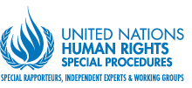
United Nations Working Group on Arbitrary Detention releases 27 opinions concerning deprivation of liberty in 22 countries
The United Nations Working Group on Arbitrary Detention held its 83rd session from 19 to 23 November 2018 in Geneva. During this period, the expert group adopted 27 opinions concerning deprivation of liberty in 22 countries. These opinions will be made available in due course on the website of the Working Group (http://www.ohchr.org/EN/Issues/Detention/Pages/WGADIndex.aspx).
The Working Group has a mandate to investigate allegations of individuals being deprived of their liberty in an arbitrary way or inconsistently with international human rights standards, and to recommend remedies, including release from detention and compensation, when appropriate.

