BIOGRAPHIES OF PANELLISTS
Ms. Jayati Ghosh
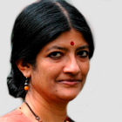
Dr. Jayati Ghosh is one of the world's leading economists. She is Professor of Economics at Jawaharlal Nehru University, New Delhi, India, and Executive Secretary of International Development Economics Associates (Ideas). She is a regular columnist for several Indian journals and newspapers, a member of the National Knowledge Commission advising the Prime Minister of India, and is closely involved with several progressive organizations and social movements. She is co-recipient of the International Labor Organization's 2010 Decent Work Research Prize. Her specialties include globalization, international finance, employment patterns in developing countries, macroeconomic policy, and gender and development.

Mr. Manuel Montes
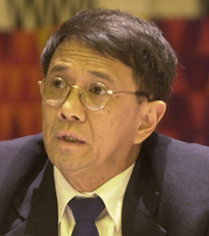
Dr. Manuel Montes is Senior Advisor on Finance and Development at the South Centre in Geneva. Among the many positions he has previously held, he has functioned as Chief of Development Strategies and Chief of Policy Analysis and Development at UNDESA; Regional Programme Coordinator at UNDP’s Asia Pacific Trade and Investment Initiative; Programme Officer for International Economic Policy at the Ford Foundation in New York; Senior Fellow and Coordinator for Economics Studies at the East-West Centre in Honolulu; Associate Professor of Economics at the University of the Philippines; and Visiting Scholar at the Institute for Developing Economies in Tokyo, United Nations University/World Institute for Development Economics Research (UNU/IWDER) in Helsinki.

Ms. Jumoke Oduwole
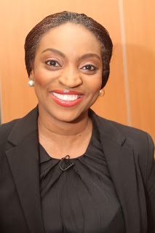
Dr. Jumoke Oduwole is a lecturer at the Department of Jurisprudence and International Law, Faculty of Law, University of Lagos, Nigeria, and holder of the Prince Claus Chair in Development and Equity 2013-2015 at the International Institute of Social Studies (ISS, The Hague) of Erasmus University Rotterdam, the Netherlands. She is the Vice President (West Africa) of the African Association of International Law and serves on the Executive Committee of the African International Economic Law Network. She was a 2013 Archbishop Desmond Tutu Fellow of the African Institute of Leadership. Dr. Oduwole volunteers her time for the advancement of several social causes and has mentored Nigerian youth in various capacities for over 15 years.

Monsignor Silvano Tomasi
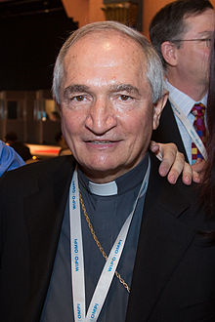
Archbishop Silvano Tomasi is the Permanent Observer of the Holy See to the United Nations, its specialised agencies and the World Trade Organisation in Geneva since 2003. Previously he carried out pastoral work in Italy and New York where he also served as Professor. He has held several posts including Director of the Office of Pastoral Care for Migrants; Secretary of the Pontifical Council for Pastoral Care of Migrants and Itinerant People; Apostolic Nuncio to Ethiopia, Eritrea and Djibouti and Observer to the African Union in Addis Ababa.

Mr. N.D. Jayaprakash
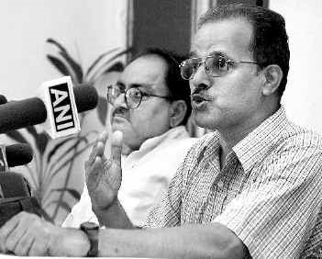
Mr. Jayaprakash is Joint Secretary of the Delhi Science Forum and Co-Convener of the Bhopal Gas Peedith Sangharsh Sahayog Samiti (BPGSSS) a national coalition of organizations for supporting the cause of the Bhopal gas victims. The BGPSSS together with other organisations has been at the forefront of litigation and actions seeking justice for victims of the Bhopal gas leak and advocating for the government to provide better and adequate medical care to the gas victims and to ensure that their health records are properly maintained. He is also an activist against nuclear weapon proliferation.

Mr. Baskut Tuncak
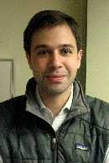
Mr. Baskut Tuncak is UN Special Rapporteur on the implications for human rights of the environmentally sound management and disposal of hazardous substances and wastes. He is also an international environmental lawyer and serves as Vice Chair of the American Bar Association Committee on Pesticides, Chemicals Regulation and the Right-to-know. His current professional legal practice lies at the intersection of human rights law, human health and chemicals and hazardous waste laws and policies. He has provided legal advice to governments and organisations on the development of national, regional and global laws on hazardous substances and wastes.
Ms. Karin Arts
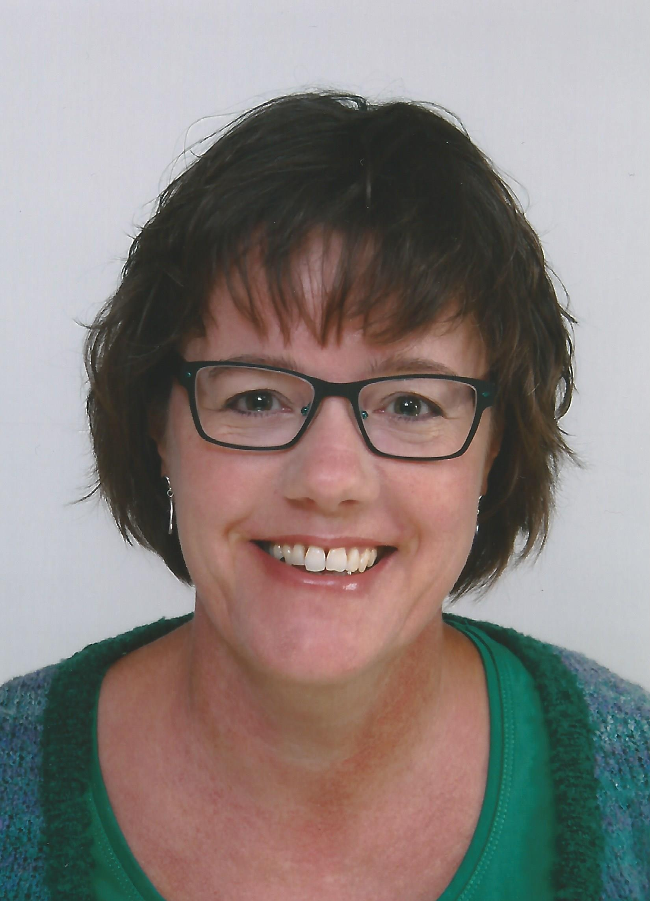
Dr. Karin Arts is Professor of International Law and Development at the International Institute of Social Studies (ISS, The Hague) of Erasmus University Rotterdam, the Netherlands. She does post-graduate teaching, research, capacity building projects and advisory services in international law, human rights and development, children’s rights, and EU development cooperation policy. She is a co-founder of the KidsRights Index, a meta-index measuring children’s rights and assessing governments’ performance in implementing the UN Convention on the Rights of the Child. Karin is also: a member of the Human Rights Committee of the Advisory Council on International Affairs which advises the Dutch government and Parliament; an editorial board member of the Netherlands Human Rights Quarterly and the East African Journal of Human Rights; a regular contributor to the Asian Yearbook of International Law. Karin regularly works with development and human rights NGOs as well.

Ms. Ariel King
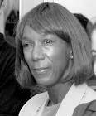
Dr. Ariel King is the Founder and President of Ariel Consulting International, a company that creates and enhances Public-Private Partnerships in international health. She also founded Ariel Foundation International, a non-profit organization with an international focus on children and youth in Leadership, Entrepreneurship and Community Service world-wide. She has over 35 years of experience in intenational health, international public health policy and management in government, businesses and NGOs.

Mr. Roberto Bissio
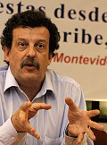
Mr. Roberto Bissio is Executive Director of the Instituto Del Tercer Mundo (Third World Institute), a non-profit research and advocacy organization based in Uruguay. He coordinates the Secretariat of Social Watch, an international network of citizen organizations from around the world that report every year on how governments and international organizations implement their commitments on poverty eradication and the computation of the Basic Capabilities and Gender Equity indexes aimed at providing quantitative tools for civil society monitoring of the MDGs and gender goals. Roberto is a member of Third World Network's international committee and of the civil society advisory group to the UNDP Administrator. As a journalist he has worked on development issues since 1973. He established “The World Guide”, a reference book with a Southern perspective, published every two years in Spanish and English.

************************

