Intersessional Seminar on the role of good governance in the promotion and protection of human rights and best practices for implementing the Sustainable Development Goals, including Goal 16 in this regard.

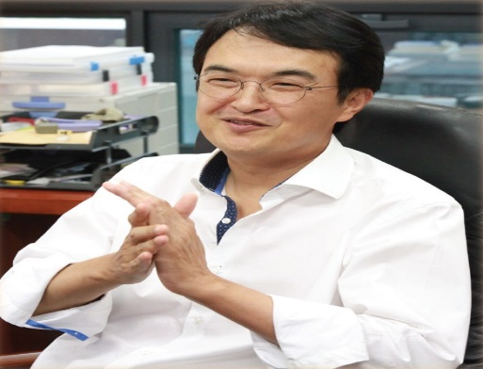
Mr. Changrok Soh (Moderator)
Mr. Soh is Professor of Korea University Graduate School of International Studies and the Director of Human Rights Center. He is a member of the Human Rights Council Advisory Committee and the President of Human Asia, a UN DPI accredited Human Rights NGO. He also serves as the President of Korea Academic Council on the United Nations System (KACUNS), and the Director of SSK (Social Science Korea) Human Rights Forum, an inter-university research group on human rights funded by the National Research Foundation of Korea. He has a special interest in the field of human rights and human security, especially in East Asia, where he has published many notable articles including “Multilateral Cooperation to Advocate Human Security in East Asia,” “Extending Corporate Liability of Human Rights Violations in Asia,” and “Regional Governance of North Korean Human Rights”. Professor Soh has integrated his academic research into human rights policy through his role in the HRC Advisory Committee, where he provides expertise to the Council. In order to protect and promote human rights in the Asian region, he has led human rights advocacy campaigns and community development projects in many Asian countries such as Nepal and India. After graduating from the Department of International Relations at Seoul National University, he received his PhD as well as MALD from the Fletcher School of Law and Diplomacy at Tufts University in the US.

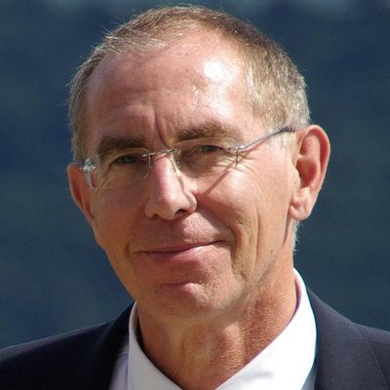
Mr. Louis Meuleman
Louis Meuleman is a member of the UN Committee of Experts on Public Administration (CEPA) and works at the European Commission in Brussels as coordinator of the Environmental Implementation Review and of the greening of the European Union’s economic and social governance. As a part-time academic, he publishes on sustainability, metagovernance and public management. He is visiting professor at the Public Governance Institute of the University of Leuven, in Belgium, senior fellow at the Center for Governance and Sustainability of the University of Massachusetts, in Boston, United States of America, and research associate at the University of Wageningen, in the Netherlands. He has 35 years of public sector management experience, handling subnational, national, regional and international issues, mainly in the fields of the environment and sustainable development. He was director of the Netherlands Advisory Council for Research on Spatial Planning, Nature and Environment, and Chair of the Netherlands Association for Public Management. Mr. Meuleman has authored a number of publications, including his PhD dissertation, Public Management and the Metagovernance of Hierarchies, Networks and Markets (Springer, 2008) and the practitioners’ case study entitled The Pegasus Principle: Reinventing a Credible Public Sector (2003). His most recent book is Metagovernance for Sustainability: A framework for implementing the SDGs (Routledge, 2018). He has a PhD in public administration and an MSc in environmental biology.

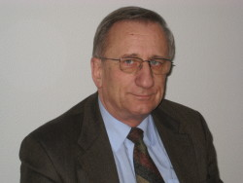
Mr. Dzidek Kedzia
Prof. Kedzia, is a member of the UN Committee on Economic, Social and Cultural Rights. He teaches International Human Rights law and Constitutional Law at the Adam Mickiewicz University in Poznań (Poland), he is also the Polish national director for the European Masters in Human Rights and Democratization (E.MA), at the European Inter-University Centre for HumanRights and Democratization EIUC Venice.

He has been the Minister-Counsellor in the Permanent Mission of Poland to the United Nations in Geneva (1991-1994) among others: General Rapporteur of the II World Conference on Human Rights (1993), Rapporteur of the 54th session of the Commission on Human Rights, Chairman-Rapporteur of the Drafting Group of the Optional Protocol to the Convention against Torture. 1994-2005 – Senior Adviser to the High Commissioner for Human Rights, director of the Activities and Programmes Branch and of the Research and Right to Development Branch.

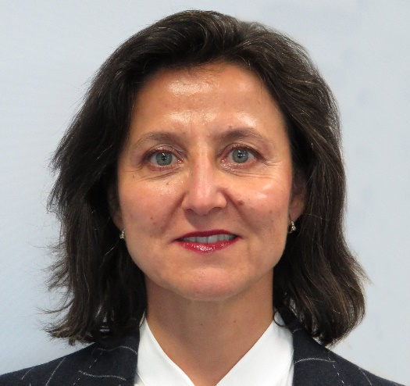
Ms. Maria Luisa Silva
Maria Luisa Silva is the Director of the UNDP Office in Geneva. She has over 25 years’ experience in UNDP and the UN system, most recently as UN Resident Coordinator/UNDP Resident Representative in Peru (2014-2015). From 2009-14 she served in UNEP as Executive Secretary of the Convention for the Protection of the Marine and Coastal Environment in the Mediterranean and its Commission on Sustainable Development. From 2006-09 she was UN Resident Coordinator/UNDP Resident Representative in the Former Yugoslav Republic of Macedonia. From 1999-2006 she was seconded to OHCHR in Geneva, where she was Team Leader with the Research and Right to Development Branch (RRDB). Before this, she was UNDP Deputy Resident Representative in Peru from 1996-1998, and held other UNDP assignments in New York, Costa Rica, El Salvador and Belize. Prior to joining the United Nations, she was consultant on European Affairs with Deloitte at their Brussels office, and teached international law at the University of Seville (Spain). She holds a Master’s Degree in International and Public Law from the University of Seville, and a postgraduate certificate on European Integration from the College of Europe, in Bruges (Belgium). She is fluent in English, French and Spanish.
Ms. Carina Lindberg
Carina Lindberg is a Policy Advisor in the Policy Coherence for Sustainable Development Unit of the OECD Directorate for Public Governance, where she supports the work on institutional and governance mechanisms for policy coherence and integrated approaches to SDG implementation. She first joined the OECD in 2007 as a Research Associate at the Development Centre and has also gained experience as an analyst in the Development Co-operation Directorate and the Office of the Secretary-General. Prior to joining the OECD, Ms. Lindberg worked for the Swedish Board of Agriculture where she oversaw the administration of preferential trade agreements with developing countries. Ms. Lindberg holds a Masters Degree in International Economics from Jönköping University in Sweden.

