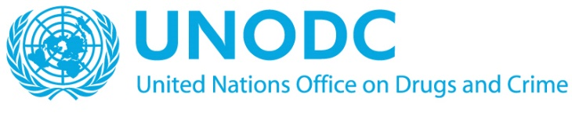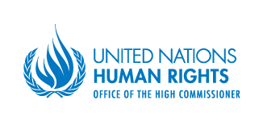

Expert Workshop on Good Practices of United Nations-System Support to States in Preventing and Fighting Against Corruption, with a Focus on Human Rights

Opening statement by
Mr. Ayuush Bat-Erdene

On behalf of the
Office of the United Nations High Commissioner for Human Rights and the United Nations Office on Drugs and Crime

Geneva, 11 June 2018
Palais des Nations, Conference Room VII

Excellencies,
Distinguished delegates,
Ladies and gentlemen,
It is an honour to welcome you, on behalf of the Office of the United Nations High Commissioner for Human Right and the United Nations Office on Drugs and Crime, to this Expert Workshop on Good Practices of United Nations-System Support to States in Preventing and Fighting against Corruption, with a Focus on Human Rights.
At the outset, I would like to thank our moderator and panellists for being here with us today.
Corruption is said to have existed since the beginning of human history. Efforts to combat corruption at the national level likewise have a long history. It was not until the mid-1970s, however, that the United Nations began to consider the problem of corruption. These efforts culminated in the adoption of the United Nations Convention against Corruption in 2003, fifteen years ago, and subsequent efforts for its implementation. The Convention against Corruption is one of the most widely ratified international treaties, with 185 parties. This number exemplifies the almost universal reach of the Convention, as well as the importance given worldwide to addressing corruption.
Linking corruption and human rights is a relatively recent development, starting, at the level of the United Nations, in the early-1990s. The preamble of the Convention against Corruption acknowledges the importance of addressing corruption to adequately protect democracy, the rule of law, sustainable development and, consequently, human rights. The Convention also calls for the active engagement of individuals and groups, including civil society organizations and the private sector. Public participation is also a basic right under the International Covenant on Civil and Political Rights, as well as a target under the Sustainable Development Goals. Participation of civil society is equally important in international settings, including in human rights and anti-corruption mechanisms.
Transparency and accountability are key principles of a human rights-based approach to development cooperation. They are also integral to successful anti-corruption strategies. The Convention against Corruption also addresses the right to information as well as freedom of expression, particularly with regard to publishing and disseminating information regarding corruption.
The Convention against Corruption also gives due consideration to victims of corruption. It addresses the need to protect and compensate them, as appropriate, through the return of stolen assets.
Moreover, the Convention is sensitive to the need to respect due process and the rights of the accused.
The Convention has a mandatory review mechanism, which periodically reviews its implementation by States parties.
Over the years, the international human rights mechanisms have increasingly paid attention to the impact of corruption on human rights, both in political bodies, such as the Human Rights Council and its Universal Periodic Review mechanism, and in the expert mechanisms, both treaty bodies and special procedures.
Let me give you just one example. The Committee on Economic, Social and Cultural Rights, in its general comment on State obligations in the context of business activities, observed that corruption constitutes a major obstacle to the effective protection of human rights […]. It added that corruption undermines a State’s ability to mobilize resources for the delivery of services essential for the realization of economic, social and cultural rights and leads to discriminatory access to public services in favour of those able to influence authorities, including by offering bribes or resorting to political pressure. The Committee also emphasized that violations of the State duty to protect Covenant rights are facilitated where insufficient safeguards exist to address corruption of public officials or private-to-private corruption, or where, as a result of corruption of judges, human rights abuses are left unremedied. It recommended that whistle-blowers should be protected and specialized mechanisms against corruption should be established, their independence should be guaranteed and they should be sufficiently well resourced.
The fight against corruption is also part and parcel of the 2030 Development Agenda.
Goal 16.5 calls upon Member States to substantially reduce corruption and bribery in all their forms and goal 16.4 requires them to significantly reduce illicit financial flows and to strengthen the recovery and return of stolen assets. In addition, goal 16.6 calls upon Member States to develop effective, accountable and transparent institutions at all levels.
It is estimated that businesses and individuals pay $1.5 trillion in bribes each year. This is about 2% of global GDP—and 10 times the value of overseas development assistance. Another estimate is that more than $2 trillion are wasted in corruption each year, enough to wipe out hunger, eradicate malaria, bridge the global infrastructure gap and provide basic education to all children.
Illicit cross-border financial flows have been estimated at $1-1.6 trillion per year. Yet, only a fraction of stolen assets is repatriated to the countries of origin.
In countries where more than 60% of people report paying a bribe, almost 5 times more people live on less than $1 a day than in countries where less than 30% of the population reports paying bribes.
There can be no doubt, without effectively combatting corruption it will neither be possible to achieve the sustainable development goals, nor to realize all human rights.
I look forward to an interesting discussion on how we can collectively better prevent and combat corruption and, in doing so, advance the cause of human rights.
Thank you very much.

http://www.worldbank.org/en/topic/governance/brief/anti-corruption
https://www.weforum.org/agenda/2017/01/we-waste-2-trillion-a-year-on-corruption-here-are-four-better-ways-to-spend-that-money/
https://www.financialsecrecyindex.com/
https://www.weforum.org/agenda/2015/01/want-to-end-poverty-start-with-corruption/

