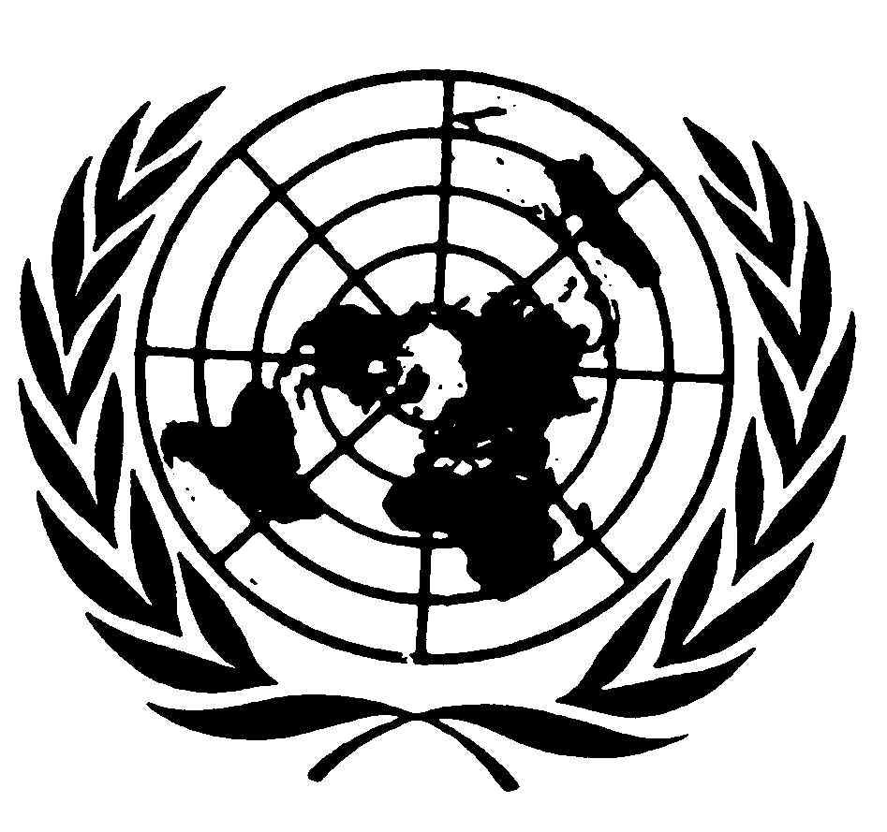

Statement by Mr. SAAD ALFARARGI,
Special Rapporteur on THE RIGHT TO DEVELOPMENT

7th Asia-Pacific Adaptation Forum (APAN)
Enabling Resilience for All: The Critical Decade to Scale-up Action

Supporting Human Rights-Based Inclusive Resilience for All
9th March 2021, 14.00 – 15.30 pm

Ladies and Gentlemen,
I am honoured to be with you today in my capacity as United Nations Special Rapporteur on the right to development.
I am happy to participate today in this discussion devoted to achieving human rights-based inclusive resilience for all. I am delighted and inspired that this forum will be looking at climate action and disaster risk reduction from human rights angle. Way too often the human rights perspective is omitted in such discussions. It is my belief that unless issues such as human rights protection and empowerment of local communities are not addressed, the efficiency and effectiveness of efforts to reduce or manage disaster risk and climate change will be diminished. Further, human-rights based approach to resilience has the potential to link sustainable development goals to human rights standards, and to fulfil the promise made in the 2030 Agenda, not to leave further behind groups that have already been marginalised.
Climate change is a global human rights threat multiplier, which already impacts and will increasingly affect, directly and indirectly, a wide range of internationally guaranteed human rights, including in particular all people’s enjoyment of their right to development. We live in a world confronted with ever-increasing global challenges and crises that pose a threat to the economic, social, cultural and political development of current and future generations. A natural or human-made disaster can undo years of development progress in a matter of hours and can stall future development for the next generation. The number of disaster events per year has been increasing since the 1980s and is likely to continue to do so as a result of climate change, population growth, urbanization, an increase in the number of people living in coastal areas and floodplains and the degradation or loss of natural ecosystems.
Data show that developing countries in the Global South are disproportionately affected by disasters – the majority of the countries most exposed to natural hazards and climate extremes are located in South Asia and Africa. You can see ample evidence of that, for example in the World Risk Report of 2019. The cost is even higher with regard to the loss of life. According to the World Bank, over the past 30 years, more than 2.5 million people have been lost to disasters caused by natural hazards. Between 1995 and 2014, 89 per cent of storm-related fatalities occurred in lower-income countries, even though those countries experienced just 26 per cent of the storms. In the Global south, in particular in low- and middle-income countries, where the growth of informal settlements is booming and poor families live in hazard-prone areas with deficient or no infrastructure, a lack of social protection and high levels of environmental degradation exist. Many low-income countries in sub Saharan Africa suffer repeated damage from droughts and floods. Developing countries in the Middle East and Central Asia are also subject to drought, floods and earthquakes, and the Asia-Pacific region is highly exposed to natural disasters, such as cyclones, earthquakes, tsunamis and volcanic activity, with South Asia and the Philippines among the most severely affected.
On this background, building resilience in particular for vulnerable countries and populations is of paramount importance. In 2019, I presented to the United Nations General assembly a thematic report, which explored the explicit link between the right to development and disaster risk reduction and its practical implications.
Disaster risk reduction is an integral part of social and economic development and is essential if development is to be sustainable for the future. In the 2030 Agenda for Sustainable Development, the urgent need to reduce the risk of disasters is recognized and reaffirmed. At the same time, disasters and extreme weather events directly and indirectly affect the enjoyment of a range of human rights, including the right to life, water and sanitation, food, health, housing, self-determination and culture, as well as the right to development. The right to development is explicitly referred to in paragraph 19 (c) of the guiding principles of the Sendai Framework. Disaster risk reduction is therefore closely interlinked with the implementation of the right to development.
In my report I reviewed a number of existing measures in a variety of countries and setting and I came to the following conclusions:
- In order to integrate the right to development into disaster risk reduction efforts, and more generally ensure human rights compliance, Governments should promote channels of participation at all stages of the planning, implementation, evaluation and monitoring of the related policies and programmes on a continuous basis for all relevant stakeholders. Under the Sendai Framework, while disaster risk reduction remains a responsibility of the national government, it also requires the active participation, support and contribution of all relevant stakeholders, such as the government, international organizations, non-governmental organizations, academic institutions, the private sector and the media. There should be opportunities for the equal participation in all relevant planning and decision-making processes of those who are most disadvantaged, including persons with disabilities, women, children and young people, minorities, indigenous peoples and members of other disempowered and marginalized groups.
- National platforms for disaster risk reduction are nationally owned and led multi-stakeholder coordination mechanisms. In my view, national platforms are instrumental in ensuring the integration of the right to development in disaster risk reduction efforts by providing the space for the participation of all relevant parts of society in the planning, evaluation, monitoring and implementation of disaster risk reduction plans and programmes at the State level. I recommend that States endeavour to create favourable conditions for gender-balanced participation in such platforms and for the inclusion of representatives of marginalized groups. I also recommend that, depending on the types of disasters affecting particular countries and their geopolitical structure, similar platforms could be created at the regional and/or community levels.
- Further, under the Sendai Framework, States are required at a minimum to collect data disaggregated by sex, age and disability. Data collected in the context of the implementation of the Sustainable Development Goals and the 2030 Agenda targets may and should also be used for the needs of disaster risk reduction planning and policymaking, and such data need to be supplemented in accordance with the specific needs of the topic. Data disaggregation efforts need to draw on a human rights-based approach to data. States should enhance the international cooperation provided for capacity-building activities aimed at improving data collection in developed and developing countries. Civil society’s capacity to gather disaggregated data should be enhanced, and innovative approaches should be developed to bridge gaps in data collection.
- If policies, plans and programmes related to disaster risk reduction and climate action are to be effective, it is of crucial importance that the individuals and communities concerned be well informed of the processes for their creation and their outcomes. States should establish mechanisms that provide easy access to information related to disaster risk reduction development policies and processes and enact legislation guaranteeing the right to obtain access to information, including information about financing. Legal remedies should be provided to ensure that access to information is not denied. States should provide information in public spaces in relevant languages and accessible formats, such as images and posters, using larger fonts and audio transmission. The gender and diversity dimensions of how and where such information is displayed should be considered. Warning communication technology should be equally accessible to persons of all ages, disabilities and backgrounds. Information on hazards, vulnerabilities and risks and on ways of reducing the impacts thereof should be disseminated to everyone and in formats that are accessible to persons who are deaf or blind or who have a learning disability. States should enhance international cooperation provided for the dissemination of information.
In the report, I also make a number of recommendations aiming to ensure the genuine and informed participation of persons with disabilities in disaster risk reduction efforts and measures to ensure the order to ensure gender-equitable and universally accessible response, recovery, rehabilitation and reconstruction approaches to disaster risk governance.
Lastly, I also wanted to inform you that this year I will be devoting my thematic reports specifically to the subject of climate change and human rights from the right to development perspective, in the context of the Paris Agreement on Climate Change, the 2030 Agenda, and core international human rights treaties. I am in the process of collecting information from key stakeholders and experts regarding good practices on the implementation of climate change-oriented policies that are in line with both the right to development and other commitments made under international environmental agreements, as well as information about challenges and areas for improvement. On my website you can find a more detailed call for information and I hope that you and your networks can collaborate with my mandate in conducting this study.
I thank you all for your kind attention and I am looking forward to the upcoming discussion.
***

