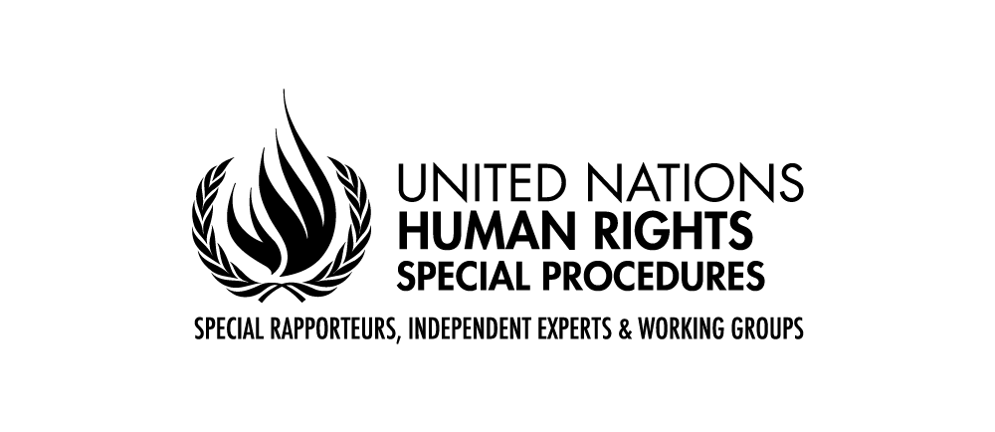

Statement by Mr. Saad Alfarargi
United Nations Special Rapporteur on the right to development

46th Session of the Human Rights Council
Virtual Side Event
“Establishing synergies between human rights and the achievement of Sustainable Development Goals: sharing of experiences and good practices”
23 February 2021, from 2:00 to 3:30pm
Excellencies, Distinguished Delegates, Ladies and Gentlemen
I thank you for the invitation to participate in this virtual side-event and I regret that the circumstances do not allow us to meet in person. It is a great pleasure and honour to address you today in my capacity as United Nations Special Rapporteur on the right to development.
I am particularly happy today to participate in a discussion on how international cooperation, particularly south-south cooperation and capacity building in the field of human rights, can contribute to the implementation of the 2030 agenda.
In 2018, I devoted my thematic report to the UN General Assembly on South-South cooperation because, as someone coming from a southern country, I find South-South cooperation to be a very important form of international cooperation. I believe that South-South cooperation has become a vital element of the international cooperation architecture for sustainable development and an avenue to address global development challenges. In this sense, South-South cooperation is one particular form of international development cooperation that strengthens rather than substitutes North-South cooperation.
In my report, I looked at the links between the right to development and South-South cooperation. Although not a new phenomenon, South-South partnerships have experienced a remarkable expansion in recent years, reflecting the accumulation of experiences, knowledge and resources in the global South. In particular, the internationally agreed policy documents of 2015, namely the 2030 Agenda for Sustainable Development, the Sendai Framework for Disaster Risk Reduction, the Addis Ababa Action Agenda of the Third International Conference on Financing for Development, have provided new momentum for South-South cooperation as a means to realize the right to development. Recognizing its potential contributions, these documents firmly integrate South-South cooperation as a complement to other forms of cooperation for achieving inclusive and sustainable development across the globe.
It is my belief that the conceptual framework of South-South cooperation embodies many of the principles enshrined in the right to development- such as respect for national sovereignty, equality, mutual benefit, inclusiveness, participation and national ownership. However, as South-South cooperation becomes more widespread and institutionalized, policymakers and other stakeholders are faced with challenges that may undermine the founding principles of South-South cooperation if they remained unaddressed. Some of the key challenges I identified in my report relate to unequal power relationships and benefit sharing, as well as difficulties in implementing inclusive and participatory processes; in mitigating adverse human rights impacts; and in monitoring and evaluating South-South cooperation. South-South cooperation seeks to abandon the donor-recipient relationships that often characterize traditional forms of North-South cooperation. However, the diversity of, and the unequal relationships between, countries involved in South-South cooperation are sometimes downplayed. In fact, the global South has been described as an increasingly heterogeneous group of countries with different experiences, interests, needs and levels of development.
Furthermore, there is concern that civil society, affected communities and individuals are sometimes not sufficiently involved in the design, implementation and evaluation of South-South cooperation initiatives. This is particularly the case in countries where civil society lacks capacity or where civic space has increasingly been constrained, thus hindering civil society’s active participation in broader policy discussions and decision-making processes at the national and local levels.
Lastly, some initiatives under the South-South cooperation framework may even pose an obstacle to human rights and sustainable development when they are not implemented in line with the right to development. In particular, large infrastructure projects and initiatives involving the private sector have been criticized for their adverse human rights impacts. Frequently raised concerns relate to labour rights issues, the violation of indigenous rights, lack of transparency and meaningful consultation with affected populations, forced relocation and insufficient resettlement options or compensation packages, negative effects on food security caused by destruction of natural resources and negative health and environmental consequences caused by emissions, oil spills, water and soil pollution.
Despite these challenges, South-South cooperation holds much promise for the future and its potential could be enhanced if States and other stakeholders incorporate a right to development perspective into the design, financing, implementation, monitoring and evaluation of South-South cooperation processes. This equally applies where South-South cooperation is facilitated by triangular cooperation partners.
Let me elaborate on what I mean by a right to development perspective and why I think it would be beneficial to apply it in the context of South-South cooperation. In my understanding, such an approach provides a conceptual framework for sustainable development that is normatively based on international human rights standards and operationally directed towards promoting and protecting the right to development with a view to advancing the realization of all human rights for all nations, peoples and individuals. To achieve that:
- South-South cooperation programmes, policies and projects should promote a holistic understanding of development that is in accordance with the right to development;
- South-South initiatives should empower rights holders while supporting duty-bearers to meet their obligations;
- South-South cooperation processes should be guided by principles and standards derived from international human rights instruments, including those relating to the right to development, throughout the planning, implementation, monitoring and evaluation phases;
- South-South cooperation processes should pay special attention to identifying and addressing discrimination and inequalities that impede the realization of the right to development;
- South-South cooperation should be monitored and assessed in terms of its development outcomes as well as processes; and in light of relevant human rights instruments and standards.

I should highlight at this point that a right to development perspective to South-South cooperation does not prescribe a single method of implementing South-South initiatives. The methods that are best suited for operationalizing such a perspective will depend on the sector, local needs and circumstances, resource availability and the different actors involved. Innovative methods identified when implementing a human rights-based approach to development cooperation -such as participatory budgeting, (namely form of citizen participation in which citizens are involved in the process of deciding how public money is spent), could provide useful ideas that may also be relevant in the context of a right to development perspective to South-South cooperation.
On a different note, I wanted to recall that in September 2017, the Human Rights Council adopted Resolution 36/9, which requested me to hold regional consultations on the implementation of the right to development. The outcome of these consultations is a set of practical Guidelines and recommendations that can serve as a tool in designing, monitoring and assessing the structures, processes and outcomes of human rights-motivated development policies. I presented these guidelines in my report to the Human Rights Council in September (A/HRC/42/38).
The regional consultations have reaffirmed the notion – expressed in Human Rights Council resolution 33/14 – that implementation of the right to development involves adherence to international human rights principles, including those related to non-discrimination and fundamental freedoms, and to internationally agreed frameworks on climate change, financing for development and sustainable development. In addition, just as the Declaration on the Right to Development recognizes that the human person is the central subject of development, these guidelines emphasize that fulfilling the right to development must involve empowering persons, both individually and collectively, to decide their own development priorities and their preferred methods of reaching those priorities.
With that foundational principle in mind, the guidelines highlight the importance of participation as a basis for assessing the interests of rights holders and ensuring that those interests are met. Ensuring participation for the sake of realizing the right to development involves more than merely consulting individuals and communities; it implies meaningfully placing rights holders at the centre of decision-making affecting their own economic, social, cultural and political development.
The view that development is only an economic outcome is incomplete since it is possible for the development priorities of a population to remain unfulfilled despite economic growth. The regional consultations have also demonstrated that development should not be conceived as merely a sequential process whereby economic growth is sought to finance social policies. Rather, the right to development conceptualizes development as a holistic process requiring the input and involvement of diverse stakeholders, including States, international organizations, civil society, academia and the private sector, to achieve sustainable results. Good governance, a just and transparent rule of law and stable institutions that are transparent, responsive and accountable are necessary preconditions.
I hope these references will be useful for our discussion today. I wish good health to you and your families in these difficult circumstances. Thank you for your attention.

To access the popular version of the Guidelines and learn more about the work of the mandate, you can access https://www.ohchr.org/EN/Issues/Development/SRDevelopment/Pages/SRDevelopmentIndex.aspx
A hard copy of the popular Guidelines will be distributed to interested counterparts as soon as feasible

