Check against delivery
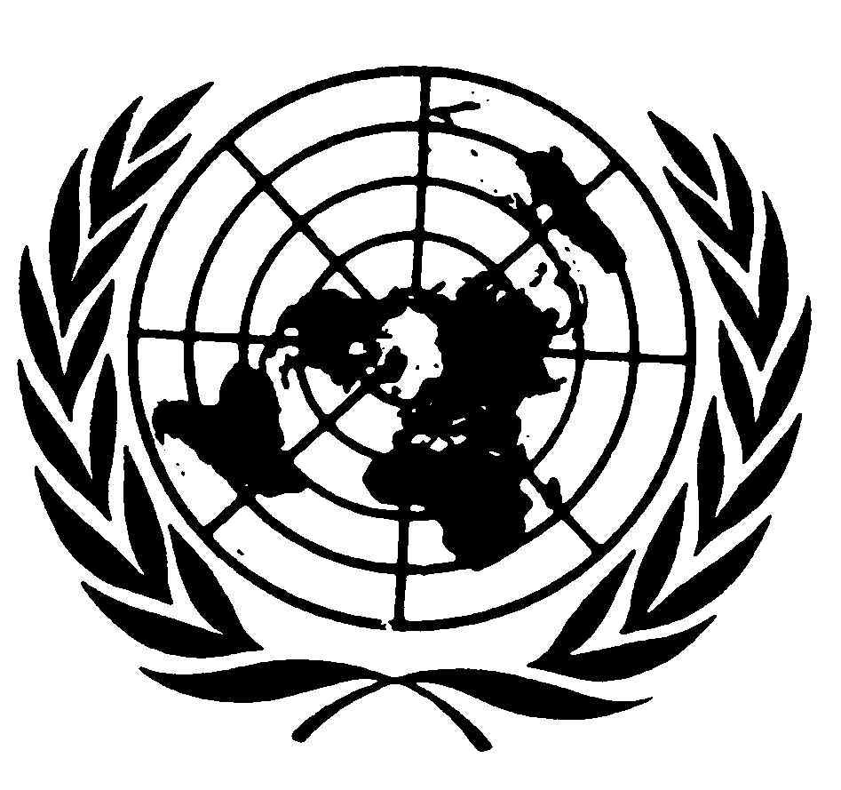

Statement by Mr. SAAD ALFARARGI,
Special Rapporteur on THE RIGHT TO DEVELOPMENT

Seventy-fifth session of the General Assembly
Item 72 (b)

NEW YORK
16 October 2020

Mr. Chairperson, distinguished delegates, representatives of the United Nations, Ladies and Gentlemen,

I am honoured to be with you today in my capacity as United Nations Special Rapporteur on the right to development. The activities of my mandate are outlined in my latest report to the 45nd session to the Human Rights Council (A/HRC/45/15).

I will now turn to the presentation of my thematic report, which explores the international dimensions of financing for development policies and practices from the perspective of the right to development.

In paragraph 2 of the Addis Ababa Action Agenda of the Third International Conference on Financing for Development, States committed to carry out a threefold task: to follow up on commitments and assess the progress made in the implementation of the Monterrey Consensus and the Doha Declaration; to further strengthen the framework to finance sustainable development and the means of implementation for the universal post - 2015 development agenda; and to reinvigorate and strengthen the financing for development follow-up process.

In the present thematic report, I highlight four key areas. The first is participation, consent and access to information in the practices of multilateral development banks and development finance institutions. Key principles such as free, prior and informed consent and practices such as environmental impact assessments and meaningful consultation processes are assessed.

The second key area is domestic and international resource mobilization, which includes such matters as illicit financial flows, official development assistance and public-private partnerships. The challenges of tax evasion and avoidance for developing countries, in particular, and the implications of public finance policies promoted by multilateral development banks and development finance institutions for the achievement of the 2030 Agenda for Sustainable Development are examined.

The third area covered is international cooperation as a key principle in both financing for development and the right to development, with a focus on the intergovernmental dialogues on financing for development being held under the aegis of the United Nations, tax cooperation and financial lending. Implementing effective international tax cooperation to counter the costs of tax avoidance and evasion, scaling up financing for sustainable development from multilateral development banks and development finance institutions on the basis of concessional lending and grants, as well as the human rights principle of extraterritorial obligations, are emphasized.

Fourth, international and multilateral responses to the global economic impacts of the unprecedented COVID-19 pandemic are surveyed. The steps taken thus far by the International Monetary Fund and the World Bank are detailed, as are the concerns over their scale and effectiveness and the urgent need for financing in developing countries stressed by United Nations entities. The circumstances of African countries, which lack the fiscal space for an adequate health and financial response, are underscored.

I conclude my report with recommendations on integrating principles of participation, free, prior and informed consent and access to information into development finance policies and practices, as well as tackling the challenges relating to domestic and international resource mobilization, public-private partnerships and financial assistance in the context of both responding to the global pandemic and implementing the 2030 Agenda. International cooperation can be enhanced through the effective implementation of key multilateral instruments, such as the Guiding Principles on Business and Human Rights of the United Nations and the Conventions of the International Labour Organization. In order to address illicit financial flows, an inclusive and intergovernmental United Nations tax body should be established, with a mandate and resources to ensure cooperation with a view to fostering domestic resource mobilization.

Further, I call for a human rights-based response to the COVID-19 pandemic in order to protect the right to development. That response should include key initiatives, such as sustained increases in the rapid disbursement of budget support by international organizations to developing countries and the employment of the United Nations as an intergovernmental platform to discuss, analyse and coordinate the multilateral responses and policy shifts required to respond to the challenging economic and human rights impacts of the pandemic.

I stand ready to discuss further my recommendations with you. I thank you all for your kind attention.

