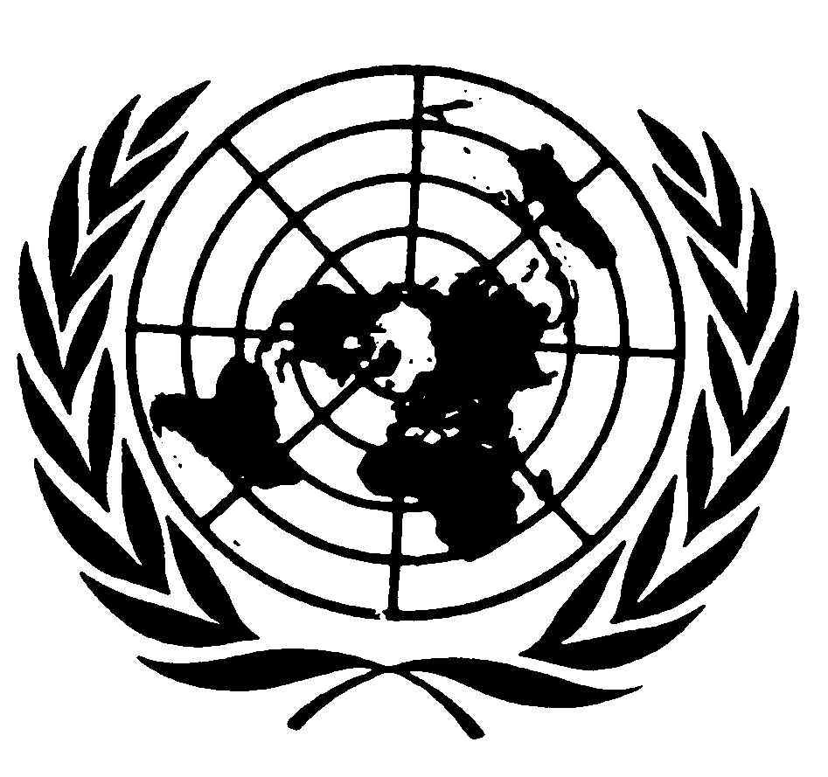

Statement by Mr. Saad Alfarargi
Special Rapporteur on the right to development

46TH Session of the Human Rights Council
Virtual Side Event
“The negative impacts of the non-repatriation of illicit funds
on the enjoyment of human rights”
17 March 2021 (11:30-13:00)

Your excellency, distinguished delegates, ladies and gentlemen,
I thank the organizers of today’s side-event for their invitation, as well as the other speakers and participants.
The topic we discuss today – namely the negative impacts of the non-repatriation of illicit funds on the enjoyment of human rights – is, unfortunately one that has been on the table for a long time. The illicit financial flows are an outstanding systemic problem in the global economy, leading to the outflow of massive sums of financial resources from developing countries, with the effect of constraining their ability to mobilize domestic resources for sustainable development. Illicit financial flows include tax evasion and tax avoidance by transnational corporations, money laundering and the transfer of funds from bribery, corruption and criminal activities. However, the expression “illicit financial flows” has no single, universally accepted definition. In a report (A/HRC/36/52, para. 7), the Advisory Committee of the Human Rights Council states that any useful definition of illicit financial flows would necessitate a broader, two-tiered interpretation of the word “illicit”. In the first, “illicit” would refer to funds that are illegally earned, transferred or utilized and include all unrecorded private financial outflows that drive the accumulation of foreign assets by residents in breach of relevant national or international legal frameworks. In its second sense, “illicit” would refer to funds from legitimate economic activity that become illicit due to their being handled or dealt with subsequently in contravention or circumvention of the law.
Illicit financial flows pose significant obstacles to the mobilization of domestic resources to finance sustainable development, as well as to the enjoyment of human rights, including the right to development. Illicit financial flows have implications for the right to development through the manner in which countries violate their extraterritorial obligations – namely the human rights obligations States have beyond their national borders towards people living in other countries - by continuing to facilitate and allow tax avoidance and evasion. Countering tax evasion and avoidance are therefore not just a political or a budgetary decision, but are rather human rights obligations.
In my remarks today, I will outline some standards applicable to the right to development and the topic of illicit funds. Then I will mention some recommendations from the Guidelines on the practical implementation of the right to development, which I issued in 2019 and which are relevant to addressing the issue.
1. 2030 Agenda and the Sustainable Development Goals
Several of the 2030 Agenda targets relate to the topic of illicit funds. Goal 16 on peace, justice and strong institutions includes the Target 16.4, which commits States to “significantly reduce illicit financial and arms flows, strengthen the recovery and return of stolen assets and combat all forms of organized crime” by 2030. Goal 17 and Target 17.1, call for strengthening domestic resource mobilization, “including through international support to developing countries, to improve domestic capacity for tax and other revenue collection.” Evidently, preventing illicit funds and advancing the repatriation of such funds falls within this target of strengthening domestic resource mobilization. Target 17.9 on capacity building also applies to our discussion because it calls for enhancing “international support for implementing effective and targeted capacity-building in developing countries to support national plans to implement all the sustainable development goals, including through North-South, South-South and triangular cooperation.”
The inclusion of these targets represents an improvement from the Millennium Development Goals, but they remain vague. In this respect, I concur with the Independent Expert on the effects of foreign debt when he argues for the elaboration of more specific measures to operationalize these targets to ensure that progress is achieved, and that such progress can be tracked and measured.

2. Addis Ababa Action Agenda
Turning to the Addis Ababa Action Agenda, States pledged to “redouble efforts to substantially reduce illicit financial flows by 2030, with a view to eventually eliminating them, including by combating tax evasion and corruption through strengthened national regulation and increased international cooperation.” The Agenda recognizes the need to scale up international tax cooperation as a complement to national tax policy and administration reform. The globalization of financial activities and the advances in technology that reduce barriers to goods and financial flows necessitate countries working together on tax matters and combating illicit finance.

3. Declaration on the Right to Development
The Declaration on the Right to Development (UN General Assembly resolution 41/128) outlines the principles that should guide policy decisions at the national and international levels with respect to financing for development. For example, the Declaration states that communities should have full sovereignty over their natural wealth and resources (art. 1) and that the benefits of development should be fairly distributed (art. 2). It calls on States to take all necessary measures for the realization of the right to development and to ensure equality of opportunity for all (art. 8). In addition, at the international level, the Declaration places a duty on States to cooperate with each other, both to promote more rapid development of developing countries, and to remove obstacles to comprehensive development (arts. 3 (3) and 4 (2)).
These standards and principles underscore the existing international commitments linking the right to development, financing for development and combatting illicit funds.

4. Guidelines and recommendations on the practical implementation of RTD
- Transparency and Access to Information
During the regional consultations, I held in 2018-2019, in preparation for the Guidelines on the practical implementation of the right to development, I repeatedly heard one overarching concern, namely the difficulty in ensuring the effective participation and inclusion of all stakeholders in development processes at the local, national, regional and international levels. The lack of access to reliable, timely, and easy to comprehend information on development financing policies represents an obstacle to meaningful participation.
I urge states and other relevant stakeholders to work to ensure greater transparency and wider access to information about local, national, regional and international efforts to address illicit funds. By making information about illicit funds more available and by assisting communities and civil society organizations, stakeholders, such as development banks and NGOs, can help to widen support for much needed action on illicit funds. Encouraging participation in this way will also help with monitoring and evaluating the distribution of illicit funds to increase their effectiveness and efficiency. Finally, increasing transparency and access to information about actions on illicit funds would lead to greater accountability and the chance to tackle endemic issues connected to illicit funds, such as corruption and the lack of good governance. In this regard, I note an initiative of the United Nations Environment Programme initiative, the Principles for Responsible Banking, which the UN Secretary-General launched at the General Assembly on 23 September 2019. Participating banks agreed, inter alia, to align their strategies with the SDGs, promote responsible governance and to increase transparency and accountability. This example could be a model for sharing information about illicit funds and facilitating accountability.

B. Other recommendations from the Guidelines
i. At national level:
- States should guarantee that communities are meaningfully involved in setting the terms for – and sharing the benefits of – all development ventures, including public-private partnerships (paragraph 61).
- Tax authorities should enhance accountability in the private sector by publishing taxation rates and revenues generated by major economic actors. Fiscal authorities should have a legal obligation to monitor the taxation of major economic operators and publish information in that regard (paragraph 65).
- States should provide transparent access to information about public financing, tax collection and oversight processes (paragraph 66).
- States should empower and protect civil society organizations and defenders fighting corruption and financial crimes, seeking social justice, investigating illicit financial flows and documenting the adverse impacts of development policies and projects (paragraph 158 (b)).

ii. At regional and international levels:
- States should shift from a donor-recipient paradigm to a genuine partnership with developing countries, as is envisaged in the Declaration on the RTD and in Goal 17 of the SDGs (paragraph 73).
- States should increase their international cooperation in tax matters, for example by exchanging information about tax payments, publicizing tax rates and revenues generated by major economic actors and ensuring that financial intermediaries do not accept illicit assets (paragraph 80).
- States should share good practices through South-South and triangular cooperation, informing the general population of the outcome of such exchanges. Given the diversity of, and the unequal relationships between, countries in the South, a rights-based approach to such cooperation is required (see A/73/271).
- North-South cooperation should be strengthened (paragraph 87).

Furthermore, I wanted to note a recommendation I made in my 2020 report to the General assembly, which focused on development finance at international level. On the matter of international cooperation in tax matters, I recommended the establishment of an inclusive and intergovernmental United Nations tax commission, with mandate and resources to ensure cooperation with a view to fostering effective domestic resource mobilization. Such a commission should also address all issues related to illicit financial flows, including tax avoidance and evasion. Universal membership, which implies that all countries would participate on an equal basis, could facilitate the remedying of harmful tax policies and practices and the elimination of tax havens and secrecy jurisdictions and other elements facilitating illicit financial flows.

I also encourage you to read the February 2021 report of the High Level Panel on International Financial Accountability, Transparency and Integrity for Achieving the 2030 Agenda, entitled Financial Integrity for Sustainable Development, which contains very relevant recommendations on addressing IFFs and financing the sustainable development agenda.
I thank you for our attention and I am looking forward to the discussion.

Final study on illicit financial flows, human rights and the 2030 Agenda for Sustainable Development of the Independent Expert on the effects of foreign debt and other related international financial obligations of States on the full enjoyment of all human rights, particularly economic, social and cultural rights, A/HRC/31/61, (January 15, 2016) para. 76.
UNEP, “Principles for Responsible Banking,” https://www.unepfi.org/banking/bankingprinciples/

