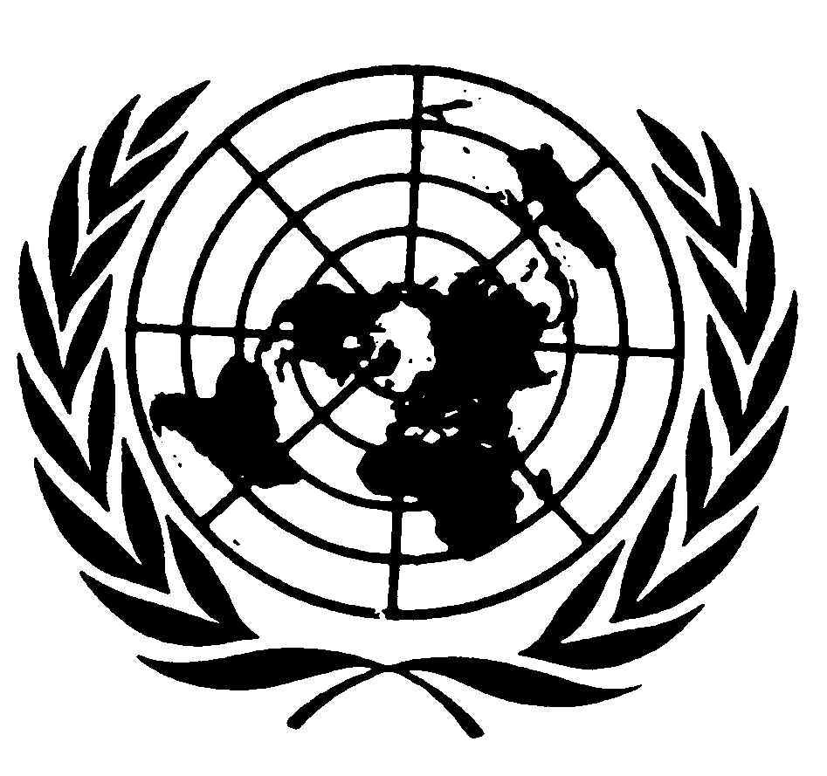

Keynote speech by Mr. Saad Alfarargi
Special Rapporteur on the right to development
Open-ended Discussion on the right to development and possible ways in achieving its practical implementation
12 February 2020

Your Excellences, distinguished delegates, ladies and gentlemen.
Today, I have the honour to participate in this Open-ended Discussion on the right to development and possible ways in achieving its practical implementation. I would like to thank His Excellency Ambassador Vaqif Sadiqov, who convened this Discussion in his capacity of a Chair on the Geneva Chapter of the Non- Aligned Movement, and provided all supporters of the right to development with the excellent opportunity to get together and discuss and hopefully plan the way forward to ensure the promotion and fulfilment of the right to development.
This discussion comes at a very important moment in time. In May this year, the Inter-governmental Working Group on the right to development will start discussing the initial draft of a new legally binding instrument on the right to development. The distinguished Chair-Rapporteur of the Working Group, who is one of the panellists today and who is leading the drafting will certainly provide you with more details and insights into this process. I only appeal to you to engage in this process and to invest the necessary resources. It is only the beginning of the road and reaching the goal is likely to take a considerable time and commitment.
In September 2019, the Human Rights Council also established a subsidiary expert mechanism to provide the Council with thematic expertise on the right to development in searching for, identifying and sharing best practices with Member States and to promote the implementation of the right to development worldwide (see Resolution 42/23, 27 September 2019). I am looking forward to cooperating with the above expert mechanism and to work towards our common goal.
In my keynote address to you, I will attempt to look at the broader picture and outline some of the challenges we must address in order to come closer to the practical implementation of the right to development.
Thirty-three years after the adoption of the Declaration on the Right to Development, the right to development is far from being universally recognised and even further from its full implementation. The right to development is not just a declaration or a topic for political debate within the United Nations or academic and political forums. The reality outside these forums is that of billions of people who are in need of improvements in their lives and who are entitled to have their human rights, including the right to development, realized. The particular value of the right to development is that it shifts the focus away from statistics and goods to the well-being of people. Only when people have access to education, when they are allowed to work in a profession of their choice with decent working conditions, when they have access to financial services, health care and housing, when they can fully and fairly participate in shaping the policies that govern their lives, only that are they able to lead their lives to their full potential. To recall the words of the Declaration (article 1.1), this would only be possible when every human person and all peoples are entitled to participate in, contribute to, and enjoy development in its economic, social, cultural and political dimensions.
There is an urgent need to reinvigorate the advocacy process for the implementation of the right to development. Business as usual will not be sufficient to achieve progress.
As you know, when establishing my mandate, in Resolution 33/14 (A/HRC/RES/33/14, 29 September 2016), the Human Rights Council emphasized the urgent need to make the right to development a reality for everyone. Since the beginning of my mandate, I aimed to ensure that the right to development remains a focus in the global discourse on the post-2015 development agenda and that the right to development, and indeed all human rights, are recognized as an integral part of the sustainable development discourse, while emphasizing that development should happen in accordance with human rights principles and with the goal of achieving the realization of the right to development for all, rather than simply for economic growth. While economic growth is important, it is a quantitative and value-neutral concept that can have both negative and positive impacts on people’s lives. Development, on the other hand, is a qualitative concept; including the human rights dimension is crucial to assessing the actual success of human development. Accordingly, the vision contained in the Declaration on the Right to Development, namely that it entitles everyone to participate in, contribute to and enjoy development in its economic, social, cultural and political dimensions, must be the guiding force in the implementation of the post-2015 development framework.
As recently as the Sustainable Development Goals (SDGs) summit in September 2019, the world leaders confirmed their commitment to the 2030 Agenda, pledging to boost local action to speed up the delivery of the goals, and promising to empower and support cities, local authorities and communities, which have a critical role to play. The 2030 Agenda is explicitly grounded in the Charter of the United Nations, the Universal Declaration of Human Rights and international human rights treaties. Importantly, the Agenda is to be implemented in a manner that is consistent with the rights and obligations of States under international law. The key principles of the Declaration on the Right to Development are reaffirmed throughout the Agenda, which recognizes the need to build peaceful, just and inclusive societies that provide equal access to justice and that are based on respect for human rights (including the right to development), on effective rule of law and good governance at all levels and on transparent, effective and accountable institutions. The 2030 Agenda is a major contemporary policy document, that makes a tangible link between the right to development and sustainability. The right to development can and should be used as a guiding concept when measuring progress in the implementation of the new policy framework for sustainable development. The Sustainable Development Goals provide an opportunity to galvanize global and local action and resources to implement universal goals and targets that could contribute substantially to the promotion and implementation of the right to development.
In September 2017, the Human Rights Council adopted resolution 36/9 (A/HRC/RES/36/9, 28 September 2017), in which it requested me to hold regional consultations on the implementation of the right to development. Accordingly, I convened a series of regional consultations in 2018 and 2019. When initiating the regional consultations I decided to focus on identifying and promoting good practices in the practical implementation of the right to development, including with regards to the design, implementation, monitoring and evaluation of policies and programs devised to advance human development through the human rights-based approach. The outcome of the consultations is a set of practical guidelines and recommendations that can serve as a tool in designing, monitoring and assessing the structures, processes and outcomes of human rights-motivated development policies.
The regional consultations have reaffirmed the notion – expressed in the Human Rights Council Resolution, which established my mandate – that implementation of the right to development involves adherence to international human rights principles, including those related to non-discrimination and fundamental freedoms, and to internationally agreed frameworks on climate change, financing for development and sustainable development. In addition, just as the Declaration on the Right to Development recognizes that the human person is the central subject of development, these guidelines emphasize that fulfilling the right to development must involve empowering persons, both individually and collectively, to decide their own development priorities and their preferred methods of reaching those priorities.
With that foundational principle in mind, participation becomes an important basis for assessing the interests of rights holders and ensuring that those interests are met. Ensuring participation for the sake of realizing the right to development involves more than merely consulting individuals and communities; it implies meaningfully placing rights- holders at the centre of decision-making processes affecting their own economic, social, cultural and political development.
In the context of the implementation of the Sustainable Development Goals, one of the avenues to achieve that is the Voluntary National Review (VNR) process before the High-Level Political Forum. As part of its follow-up and review mechanisms, the 2030 Agenda for Sustainable Development encourages member states to "conduct regular and inclusive reviews of progress at the national and sub-national levels, which are country-led and country-driven" (paragraph 79). These national reviews are expected to serve as a basis for the regular reviews by the high-level political forum (HLPF), meeting under the auspices of ECOSOC. As stipulated in paragraph 84 of the 2030 Agenda, regular reviews by the HLPF are to be voluntary, state-led, undertaken by both developed and developing countries, and involve multiple stakeholders.
Building on the consensus framework of the 2030 Agenda, the above process is an occasion for States to inquire from constituents at all levels about progress towards implementing the Sustainable Development Goals. This institutionalization of participation is a positive development, since it means feedback from individuals and communities is continuous and can be effectively streamlined into national policies. In addition, the VNR process provides an opportunity for States to gather the experiences of those furthest behind and to share those experience at the international level. In so doing, the VNR process can help address the fact that agreements and decisions made at the international level greatly affect individual rights-holders on the ground, and should therefore be informed by them.
The voluntary national review process is one way for States to hear from communities about policies that affect them. In addition to enabling participation, the process provides an avenue for accountability. For example, the process provides opportunities for individuals and communities at the national level to communicate their concerns to the very authorities charged with implementing development policies on their behalf. At the same time, by sharing national-level development challenges with the international community, States can mobilize international cooperation efforts to meet these challenges.
The view that development is only an economic outcome is incomplete since it is possible for the development priorities of a population to remain unfulfilled despite economic growth. The regional consultations have also demonstrated that development should not be conceived as merely a sequential process whereby economic growth is sought to finance social policies. Rather, the right to development conceptualizes development as a holistic process requiring the input and involvement of diverse stakeholders, including States, international organizations, civil society, academia and the private sector, to achieve sustainable results. Good governance, a just and transparent rule of law and stable institutions that are transparent, responsive and accountable are necessary preconditions.
In my report to the Human Rights Council in 2018 (A/HRC/39/51), I explored the connection between the right to development and equality, and the consequences of inequalities within countries on the enjoyment of the right to development. In the consultations, which led to the preparation to that report, several States provided information on participatory mechanisms, either for designing policies to implement the Sustainable Development Goals or drafting voluntary national reviews. In that report, among others I put forward the recommendation that States should systematically and coherently assess their progress towards implementing Sustainable Development Goals 10 (Reduce inequality within and among countries) and 5 (Achieve gender equality and empower all women and girls) and other targets related to progressing towards equality in their voluntary national reviews. To this recommendation, I would like to add today that assessing the progress cannot realistically happen without involving the communities concerned. One of the ways in which we should step up our efforts to leave no one behind is to ensure the genuine involvement in the VNRs preparation of those groups and members of our societies whose right to development had been neglected for so long.
The VNR process is just one example of an avenue that can be used to promote the right to development. In my work, for example, I have examined the link between South-South cooperation, sustainable development and the right to development (see my report to the UN General Assembly, A/73/271) and link between the right to development and disaster risk reduction and its practical implications (see A/74/163). This year I am focusing on the application of the right to development to financing for development and I am planning to present reports on these issues to the Human Rights Council and the UN General Assembly). We have to keep an open mind and explore new ways to promote the right to development in all international fora, such as, for example, the Universal Periodic Review.
I hope that today’s discussion will help contribute to the advancement of the right to development. I am looking forward to hearing your ideas and your plans and to working together so that we can come a step closer towards implementing the right to development.
I thank you all for your kind attention.

