Namibia
Question 1:
The duty bearers and the right holders of the R2D are made up of the developed countries, developing countries and least developed countries. We find this at three levels of responsibility, namely: (a) States acting collectively in global and regional partnerships; (b) States acting individually as they adopt and implement policies that affect persons not strictly within their jurisdiction; and (c) States acting individually as they formulate national development policies and programmes affecting persons within their jurisdiction.
At national level, Namibia went to great extend to implement and realize the right to development within the context of national and sectoral development frameworks as set out in subsequent answers.
At regional level, Namibia as part of the African family, seeks to join others in our resolve to alleviate poverty, instability and underdevelopment. The Common African Position (CAP) on the Post 2015 Development Agenda; which is Africa’s contribution to global efforts at building a successor development framework to the expired MDG’s, developed under guidance of a 10-member group of States an AU high level Committee of the Post 2015 Development Agenda, to which Namibia is a member was adopted in Addis Ababa, Ethiopia. The CAP, widely consulted, starts from the premise that the continent’s most pressing priority is poverty eradication achieved within a nexus of inclusive development and transformative sustainable growth.
At international level we acknowledge the efforts to date, but note that no significant progress was made to implement the Declaration on the right to development. Given the high levels of poverty and underdevelopment in the developing and least developed countries, we cannot deny the low level of implementation of this right at international level. We are however hopeful that the outcomes of the various multilateral development-related negotiations in the year 2015, including the COP21, FFD3 and Sendai outcomes on disaster risk reduction will propel the implementation of the R2D at international level.
Question 2:
Namibia believes that one of the most controversial elements of the R2D lies in the international implementation of the right.
Most of the opposition to the right to development is clear from expressed opinions, which reflects that developed countries are reluctant to embrace the notion of international obligations in United Nations forums and documents because the limits of national responsibility and international responsibility are vague. It is clear however that international obligation is not a substitute for national responsibility. International action, however, is indispensable for addressing obstacles that are beyond the capacity of national Governments to tackle on their own. The inability of national Governments to overcome implementation challenges as a result of lack of capacity spills over onto the regional mechanisms.
In terms of the Declaration on the Right to Development, which is now 30 years old, it is clear that there is indeed a very prominent role to be played by stakeholders at an international level and not only at domestic level. There are actions, which constitutes international cooperation, which include: technology transfer, support for the payment of domestic debt and cancellation of international debt. Development of post-colonial societies, which continues to bear the brunt of poverty as a result of inequality and underdevelopment, bears a moral obligation upon the former colonizers. One of the objectives of the Declaration on the Right to Development is to effect equitable sharing of the profits and benefits of industrialization with former colonies. This needs to be implemented, not only at national level, but more so at international level.
The framework on the Right to Development, as contained in the Declaration on this right, sets out, in the absence of a legally binding instrument, the best strategy for implementing this transfer of technology and mutually beneficial trade opportunities. The focus should be on development instead of benevolence as development is a right and its implementation can alleviate and eventually end poverty.
Question 3:
In our efforts to combat the challenges of low economic growth, a high rate of poverty, inequitable distribution of wealth and income, and high unemployment, our Government acknowledged the importance of planning as an integral part of economic and social development. To this end in the first five years after independence, the Government adopted a Transitional Development Plan. In 1995, the first formal National Development Plan (NDP) had been implemented, known as NDP1. The NDP1 focused on only four goals: boosting and sustaining economic growth, creating employment, reducing inequalities in income distribution, and reducing poverty. Twelve years later, in 2007/8, NDP3 came into effect. By then, the number of goals to be reached had increased to 21, including the eradication of poverty. The NDP4, currently underway adds another dimension, namely focusing on the execution of development strategies as well as monitoring and evaluating development. The Government recommits itself to its social contract with the Namibian people to achieve the intended national objective.
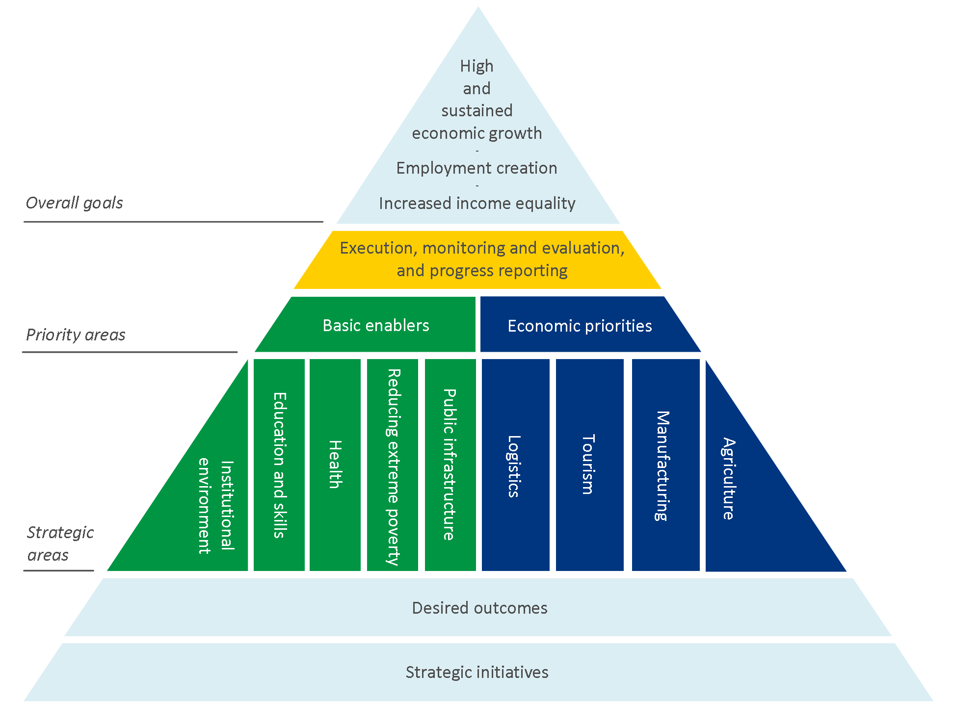

The above table sets out the structure of the 4th National Development Plan, which is linked to our Vision 2030. We fully embrace the notion of sustainable development as set out in our NDP4, i.e. the type of development that meets the needs of the present without limiting the ability of future generations to meet their own needs. To this end, we encourage people not only to take responsibility for their own development, but also to promote development activities that address the actual needs of the people. The principle of sustainable development is a cornerstone of Namibia’s long-term vision 2030 at any scale. Without capacity, partnership and good governance, there can be no sustainable development.
We cherish our national sovereignty and it must be preserved at all costs. Great value is attached to Namibia’s traditions and cultures. However, traditional ideas and practices that tend to inhibit progress towards national development targets are to be sacrificed in the interests of the nation. At the center of everything we do are the people of Namibia: ideally a nation that is healthy, brave, empowered, innovative, fully employed, confident and determined to succeed.
Namibia attaches great importance to strengthening and promoting human rights for all in the country. We remain committed to deliver on the promises we make to build upon the progress we have made during our era of peace and stability and move onto the era of economic emancipation and prosperity for all, where no Namibian shall be left behind.
As indicated in our NDP4, we believe in creating an environment that is conducive to working together as a key to economic progress and social harmony. This is the essence of partnership. It entails partnership between Government, communities and other members of civil society; between different branches of Government cooperating with the private sector, non-governmental organizations, community-based organizations, and the international community; between urban and rural societies; and ultimately, between all members of Namibian society.
Our NDP4 further subscribes to the notion of peace and security as set out in our Constitution. Namibia is a peaceful and safe country, and we are committed to continuing to uphold the principles of domestic and regional peace and security, being an indispensable condition for the country’s socio-economic development.
Question 4:
No.
Question 5:
Trade Agreements and Arrangements:
Namibia is a member of the World Trade Organization, the African Union, Southern African Customs Union (SACU) and Southern African Development Community (SADC).
WTO:
Namibia has been a Member of the WTO since 1995. It extends at least Most Favored Nation (MFN) treatment to all its trading partners. The WTO Agreements have been incorporated into Namibia's domestic legislation and thus can be invoked before national courts. The Marrakesh Agreement can equally be invoked.

Regional and preferential agreements:
In addition to its membership in SACU and SADC and their RTAs with third parties, Namibia maintains a bilateral FTA with Zimbabwe that entered into force in 1992. The agreement provides for duty-free treatment for goods grown, produced or manufactured in one of the parties when exported to the other party. Manufactured goods qualify for duty-free treatment if they have at least 25% local content and the last process of manufacture (which must take place in one of the parties) is substantial and sufficient to change the nature of the product and give it a new, essential and distinct characteristic and the final product presents a completely new product or at least an important stage in the manufacturing process.

Question 6:

The challenges faced by the Government of the Republic of Namibia as a result of lack of the full realization of the right to development has been raised in various meetings and discussions of the Human Rights Council, the United Nations Conference on Trade and Development and the World Trade Organization amongst others. It has also been indirectly enumerated in the reports submitted to the various Treaty Body Committees.

Question 7:

In terms of Article 95 of the Namibian Constitution, the implementation of social economic rights is progressive and depends on government resources. The effect is clear: unlike the fundamental freedoms enshrined in Chapter 3, social and economic rights cannot be enforced under all circumstances. Their enforcement is dependent upon the availability of state resources. Namibia has ratified the Covenant on Economic and Social Rights and although the provisions thereof forms part of Namibian law, it will be difficult for an aggrieved citizen to obtain a court order compelling the state to grant the social and economic rights emanating from that Covenant.
In 2004, Namibia adopted Vision 2030, which spells out the country's medium-term development programmes and strategies to achieve its national objectives. Its goal is to improve the quality of life of the people of Namibia to the level of their counterparts in the developed world by 2030, with an unemployment rate of less than 5%, and the manufacturing and services sectors constituting 80% of GDP. The National Planning Commission is responsible for managing Vision 2030.

The Targeted Intervention Programme for Employment and Economic Growth (TIPEEG) was introduced during the 2011/12-2013/14 Medium-Term Expenditure Framework period with the objective of creating 104,000 direct and indirect jobs between 2011 and 2014. The primary objective of the programme is to create employment opportunities, both permanent and temporary, by focusing on selected economic sectors and public works, ensure speedy implementation, by introducing suitable conditions and modalities under which capital projects are implemented, and put in place the required infrastructure necessary for economic growth.

In 2011, the New Equitable Economic Empowerment Framework (NEEEF) was introduced in Parliament. The objective of NEEEF is to encourage firms to bring previously disadvantaged Namibian shareholders on board, to train and promote them into senior management positions, to use procurement to stimulate more local businesses, and to promote the well being of the communities in which they operate. Companies wanting to do business with Government or requiring licenses from Government would have to be scored on each of NEEEF's five pillars, three of which are mandatory (ownership, management control and employment equity, and human resources and skills development). Under-performance in any pillar can be compensated by over-performance in others. The NEEEF will be in force for 25 years.

The Bank of Namibia formulates monetary policy with the primary objective of price stability in order to support sustainable economic growth and financial stability.

Question 8:
No.
Question 9:
None to date.
Question 10:
Yes. The latest period reports submitted to the Treaty Body Committees for the International Covenant on Economic, Social and Cultural Rights as well as the International Covenant on Civil and Political Rights contains detailed information on the implementation of the right to development in its various dimensions. The report submitted to the African Commission on Human and Peoples’ Rights contains the same information.
Question 11:
National Development Plans (NDPs) are the main vehicles for translating the Vision into action and an overview of the successes achieved and challenges experienced is provided by the National Planning Commission at the end of each NDP period.
The Statistics Act No. 9 of 2011 provides for the development of the National Statistics System and provide for its components and objectives; to establish the Namibia Statistics Agency and the Board of the Namibia Statistics Agency and provide for their powers and functions.

Functions of the Namibia Statistics Agency:
- To constitute the central statistical authority for the State;
- To collect, produce, analyse and disseminate official and other statistics in Namibia
- Facilitate the capture, management, maintenance, integration, distribution and use of spatial data;
- To develop and coordinate the National Statistics System and the NSDI; and
- To advise the Minister (DG of National Planning Commission) on matters related to official and other statistics, whether of its own accord or at the request of the Minister.

